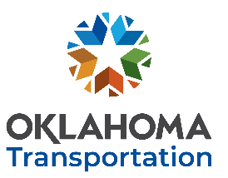
OKLAHOMA DEPARTMENT OF TRANSPORTATION https://www.oklahoma.gov/odot
RESEARCH PROBLEM STATEMENT
Please submit no later than November 30th, 2023 to be considered for FFY2025 funding.
Your submission grants ODOT permission to post a request for proposal open to all researchers.
Click here to enter text. Click here to enter text. Click here to enter text.
YOUR NAME YOUR TITLE DATE
Click here to enter text. Click here to enter text. Click here to enter text.
YOUR INSTITUTION YOUR EMAIL YOUR PHONE NUMBER
BRIEF DESCRIPTION OF PROBLEM ENCOUNTERED: (THOSE WHO SUBMIT THIS FORM MAY BE CONTACTED BY ODOT PERSONNEL FOR FURTHER CLARIFICATION)
Click here to enter text.

WHAT EVENT OR SITUATION SEEMS TO BE THE SOURCE OR CAUSE OF THE PROBLEM?
Click here to enter text.

STATEMENT OF HOW SOLVING THE PROBLEM WILL SAVE LIVES, TIME, MONEY and/or the ENVIRONMENT ?:
Click here to enter text.

WHAT EXISTING SPECIFICATIONS and/or PROCEDURES MAY REQUIRE REVISION IF A SOLUTION IS FOUND ?:
Click here to enter text.

ADDITIONAL COMMENTS:
Click here to enter text.

SUBMIT COMPLETED FORM
AS AN EMAIL ATTACHMENT
AND SEND TO: ODOT-spr@odot.org
Address email to:
Ron F. Curb, PE Engineering Manager
Research & Implementation
Office of Innovation Form RPS-R1

