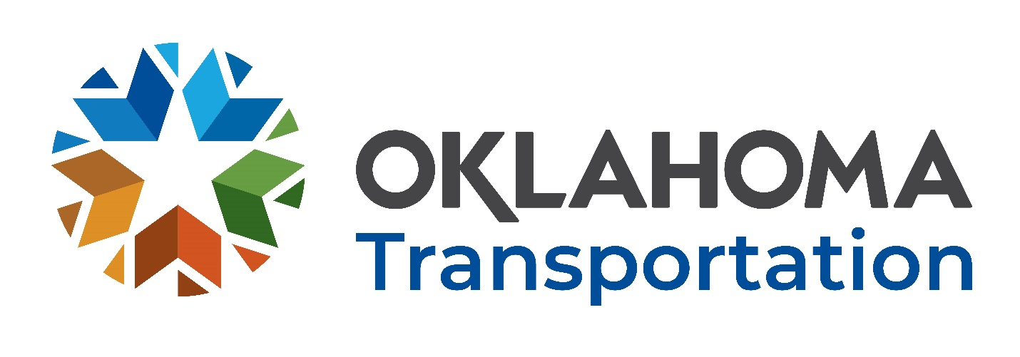

Office of Research and Implementation

FFY 2022 Request for Proposals

  - Research Problem Statement Title:
  - Adapting ODOT Radar Traffic Monitoring System to Automatically Track Real Time Traffic Flow
  - Problem Statement:
The Oklahoma Department of Transportation is in the process of installing 150 radar sites across the State, with most radars deployed on major highways and roadways in the OKC and Tulsa metropolitan areas. The radar units monitor traffic flow and collect information including volume, speed, and vehicle classification. High resolution cameras are installed on the radar and can be configured to take a picture at regular intervals.

  - Proposed Research:

This project is comprised of three major activities. First is to develop an interface to the radar data to allow real-time sharing of data and pictures with the Intelligent Transportation System group in ODOT Maintenance Division. The system will report speed information as well as pictures. Second is to compare the collected speed data with that obtained from commercial companies. Currently, the State spends large sum of funds to secure annual contract with such companies. Third is to investigate the use of speed data to rapidly detect roadway incidents.

  - Suggested Tasks (to include but not limited to):
Following outlines research activities to be accomplished during this project.

- Build an interface to make radar data available to share with okroads.org
- Assign each radar site to an HPMS and TMC OK National Highway System segments.
- Collect traffic data from HERE, NPMRDS, AVC, Radar Camera’s, and Radar systems.
- Compare the four sets of data in terms of speed, vehicle class, and volume.
- Compare NOAA data with radar weather data and camera images of road conditions. Provide radar and camera images to OKRoads.org system.
- Spatially and temporally Investigate the difference among the four sets. Show differences based on location and time.
- Evaluate multiple machine learning algorithms to develop a travel time prediction model that uses Radar, and NPMRDS data. Select the model with best accuracy.
- Provide travel time parameters to OKRoads.org and OKTraffic.org to use in their systems to improve their prediction and inform driving motorist.
- Develop performance measures reports online comparing all four data sets and their accuracy.
- Develop a website integrating all four data sets, showing the spatial and temporal differences in the four data sets.

  - Implementation:
- Maintenance Division - Strategic Asset and Performance Management - Traffic Engineering Division

  - Benefits:
- The developed system will be used to validate the accuracy of the real-time speed data provided by the contracted commercial company.
- The system could be used to augment the commercial data to improve its accuracy and overall usability.
- The system will be used to provide the capability to acquire pictures and stream videos for close human examination of traffic flow.

  - Deliverables:
All projects require the submission of the following reports:
- Monthly Progress Reports
- Multi-Year Projects require a Year-end Annual Report
- Copies of the project Draft Final Report in Microsoft Word and ADA accessible Adobe Acrobat pdf electronic formats
- Copies of the project Final Report in Microsoft Word and ADA accessible Adobe Acrobat pdf electronic formats
The Year-end Annual Report, Draft Final Report, Final Report and Color Article should be submitted to satisfy all federal and state requirements pertaining to the accessibility of documents including but not limited to:
- Oklahoma State Statute 62 § 41.5e and the Americans with Disability Act (ADA) of 1990, 42 USC 12.01 et seq.
The PI must also participate in the following project meetings:
- New project initiation meeting
- Semi-annual project meeting
- Close-out project meeting
- Continuing project meeting
- Estimated completion time twelve months.

  - Existing Research found in separate attached file.

