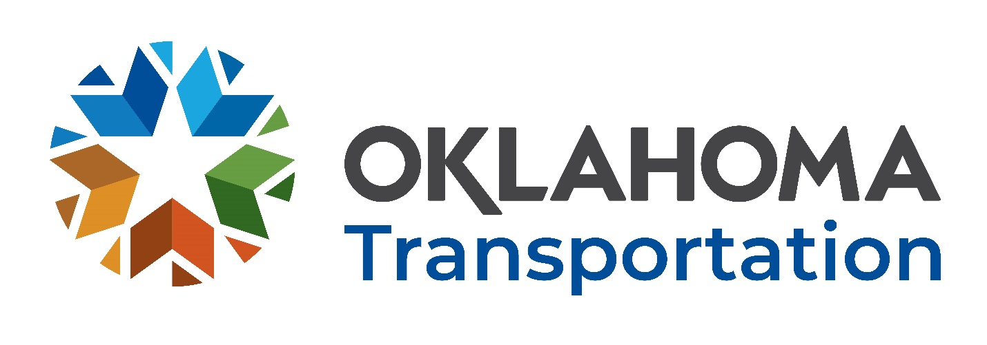

Office of Research and Implementation

FFY 2022 Request for Proposals

  - Research Problem Statement Title:
  - Bond Behavior of Epoxy Coated Reinforcing Bars in Non-proprietary UHPC
  - Problem Statement:
Ultra-high performance concrete (UHPC) is a promising material for bridge deck joints and connecting precast bridge elements. UHPC is able to develop reinforcing bars with a much smaller amount of concrete than conventional concrete; a value as low as 8 times the bar diameter is often used for lap splices and making connections. These design values are primarily based on tests of proprietary UHPC materials with compressive strengths greater than 22 ksi. Non-proprietary UHPC is becoming more common for use in bridge construction and repair as it allows for more flexibility for use in small amounts for repairs and is often significantly cheaper. However, in many cases non-proprietary UHPC does not achieve the high compressive strengths of typical UHPC materials, even though it exhibits high tensile strength and durability. Previous research sponsored by ODOT and the Accelerated Bridge Construction University Transportation Center (ABC-UTC) has shown that non-proprietary UHPC produces similar bond performance to proprietary UHPC for uncoated reinforcing bars even with a smaller compressive strength. There are however, measurable differences in bond performance and substantial variation for different steel fiber contents. More information is needed on the bond behavior of epoxy coated reinforcing bars cast in non-proprietary UHPC to ensure adequate designs. Epoxy coated reinforcing bars are typically used in UHPC connections even though UHPC typically has sufficient durability to protect the reinforcing steel from significant corrosion since those bars extend into the rest of the deck slab.

  - Proposed Research:
The proposed project will consist of extending the bond testing program already completed as part of ODOT and ABC-UTC sponsored research examining bond behavior of No. 3, No. 5, and No. 8 bars embedded in non-proprietary UHPC with varying steel fiber content. Pullout tests will be conducted to examine comparative performance of No. 3, No. 5, and No. 8 epoxy coated reinforcing bars cast in non-proprietary UHPC with varying steel fiber content and beam splice tests will be conducted using No. 5 bars. Results of the proposed testing will be compared to results of the previously completed work to develop design values applicable to non-proprietary UHPC.

  - Suggested Tasks (to include but not limited to):
1: Conduct pullout tests on varying bar diameters and fiber contents. 2: Construct beam splice specimens. 3: Conduct beam splice tests. 4: Analyze data and compare to results for uncoated bars. 5: Document the results of the investigation in a final report.

  - Implementation:
Bridge design, repair, and rehabilitation.

  - Benefits:
Be UHPC has significant potential for creating more durable bridge deck joints and ODOT has sponsored a significant amount of external research focused on UHPC over the last 4 years. This project could help further assess the performance of non-proprietary UHPC used for bridge deck joints and connections and could provide design recommendations for required reinforcing bar embedment.

  - Deliverables:
All projects require the submission of the following reports:
- Monthly Progress Reports
- Multi-Year Projects require a Year-end Annual Report
- Copies of the project Draft Final Report in Microsoft Word and ADA accessible Adobe Acrobat pdf electronic formats
- Copies of the project Final Report in Microsoft Word and ADA accessible Adobe Acrobat pdf electronic formats
The Year-end Annual Report, Draft Final Report, Final Report and Color Article should be submitted to satisfy all federal and state requirements pertaining to the accessibility of documents including but not limited to:
- Oklahoma State Statute 62 § 41.5e and the Americans with Disability Act (ADA) of 1990, 42 USC 12.01 et seq.
The PI must also participate in the following project meetings:
- New project initiation meeting
- Semi-annual project meeting
- Close-out project meeting
- Continuing project meeting
- Estimated completion time eighteen months.

  - Existing Research found in separate attached file.

