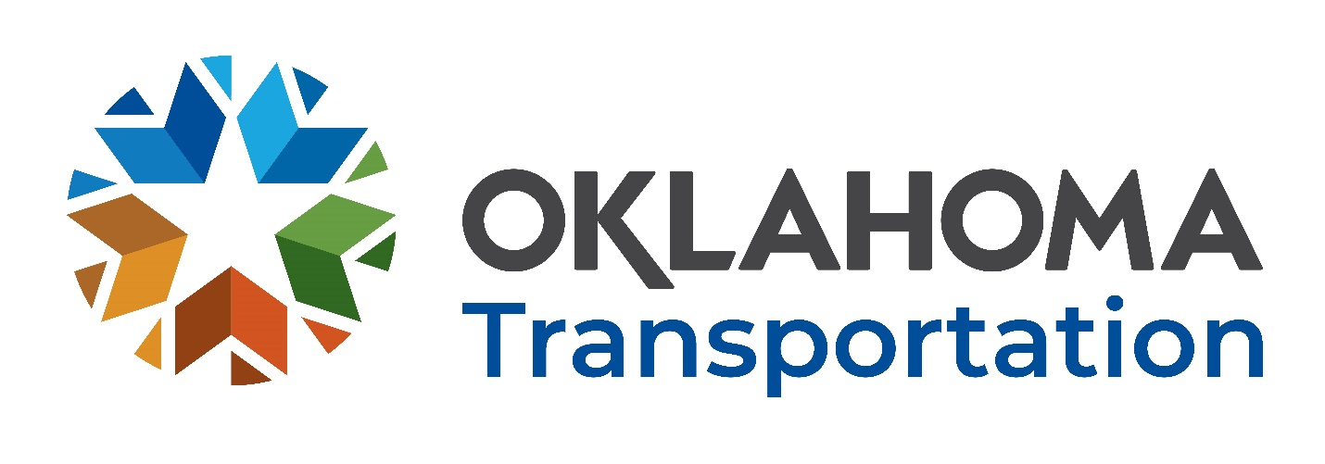

Office of Research and Implementation

FFY 2023 Request for Proposals

  - Research Problem Statement Title:
  - Incorporate Automated Connected Electric and Shared Vehicle Considerations into Travel Demand Analysis
  - Problem Statement:
Human mobility in recent times is deeply influenced by new technology advancements. Recent advances in communication and information technologies have played a major role in shifting how we live and travel. Smartphones and rapidly evolving mobile applications have contributed to the quick expansion of vehicle sharing, ride-sourcing, and various other on-demand services worldwide. Likewise, connected and autonomous vehicle (CAV) technologies are expected to bring a paradigm shift in how we define mobility. It is essential to incorporate ACES considerations into long-term transportation planning efforts, which usually extends to the next 20 to 30 years. Moreover, many uncertainties emerged in regard to user acceptance, regulations, and technology development that make it even more challenging to draw conclusions on how AVs and shared mobility may affect daily travel patterns and the potential implications on the society as a whole.
  - Proposed Research:
The goal of this research is to develop a framework to incorporate automated, connected, electric, and shared (ACES) vehicle considerations into the travel demand analysis and long-term planning process for the State of Oklahoma. From a systematic approach, this research will identify major aspects of travel behavior that may be influenced by ACES, provide a modeling approach for behavioral analysis, develop underlying assumptions and critical scenarios, and reveal the likely outcomes of these technologies on travel demand. The framework will also identify the interrelationships between technology features, lifestyle and behavioral shifts, system and network performance, and mobility outcomes based on market penetration considerations. Additional modeling capabilities to fully address the potential impacts of ACES considerations in Oklahoma will also be recommended.

  - Suggested Tasks (to include but not limited to):
  - 1. Perform a comprehensive review of ACES research conducted by ODOT and other state DOTs
2. Develop an agent-based modeling framework for ACES behavioral analysis
3. Design and conduct a stated preference (SP) survey on ACES vehicle considerations
4. Monitor trends of public attitude towards ACES on social media platforms
5. Analyze impacts of ACES vehicle considerations on travel demand and system performance
  - Implementation:
This will assist in future traffic planning and modeling
  - Benefits:
The proposed research will allow enhanced modeling capabilities to address ACES considerations, better decisions in long-term planning, and congestion relief with increased safety. A recent report from Energy Security Leadership Council also indicated that Americans will be able to save about $800B each year by embracing driverless systems.
  - Deliverables:
All projects require the submission of the following reports:
- Monthly Progress Reports
- Multi-Year Projects require a Year-end Annual Report
- Copies of the project Draft Final Report in Microsoft Word and ADA accessible Adobe Acrobat pdf electronic formats
- Copies of the project Final Report in Microsoft Word and ADA accessible Adobe Acrobat pdf electronic formats
The Year-end Annual Report, Draft Final Report, Final Report and Color Article should be submitted to satisfy all federal and state requirements pertaining to the accessibility of documents including but not limited to:
- Oklahoma State Statute 62 § 41.5e and the Americans with Disability Act (ADA) of 1990, 42 USC 12.01 et seq.
The PI must also participate in the following project meetings:
- New project initiation meeting
- Semi-annual project meeting
- Close-out project meeting
- Continuing project meeting
- Estimated completion time eighteen months.
  - Existing Research found in separate attached file:

