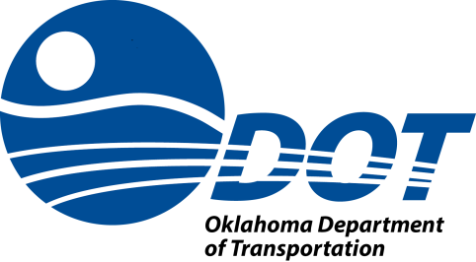

An Application to the
Oklahoma Department of Transportation
Office of Mobility & Public Transit
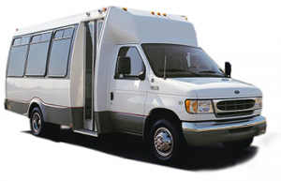
for the
Oklahoma Public Transit Revolving Fund
FOR THE
PROGRAM YEAR
2021
Submitted by
INSERT DIRECTOR NAME
Signature:____________________
INSERT CONTRACTOR NAME
INSERT TRANSIT NAME
INSERT MAILING ADDRESS
INSERT CITY, STATE AND 9-DIGIT ZIP CODE
SFY-2021

Public Transit Revolving Fund Application and Agreement Check List

The following revolving fund application documents must be submitted to ODOT’s Office of Mobility & Public Transit by 3:00 pm July 31, 2020:
_____ Transit Agency Contact Information Form
_____ Detailed description of the transportation services provided, to include services to elderly and disabled.
_____ Trip Statistics Certification.
_____ Availability to the General Public Certification.
_____ Service to the Elderly and Disabled Certification.
_____ A proposed SY2021 budget and justification depicting the use of revolving funds received for SY2021 (use your FY2020 funds received as your allocated budget)
_____ An independent audit report stating that the mileage reported is exact and accurate.

The following documents are to be included along with signed contract to ODOT for execution
_____ Workers Compensation Insurance Certificate
_____ Liability Insurance Certificate

Transit Agency Contact Information
SFY- 2021
(Please fill out all fields and return with application)
Revolving Fund Contracting Agency (Agency Entering into an Agreement with ODOT):
Agency phone number:

Agency physical address (Agency’s office location):

Agency mailing address (Location where documents should be mailed to by ODOT):

Primary Contact Information (Person to send Contract and Invoices to):
Name (First & Last):
Title:
Phone:
( ) XXX-XXXX
Email address:

Secondary Contact (Back up person for primary contact):
Name (First & Last):
Title:
Phone:
( ) XXX-XXXX
Email address:

TRIP STATISTICS CERTIFICATION

_______________________________________________
(Contractor Name)

_______________________________________________
(Transit Agency Name)

Public transportation vehicle revenue miles for the period of July 1, 2019 to June 30, 2020.

Total Revenue Miles Provided: ______ Total Passenger Trips: ______

Elderly Passengers Trips: ______

Disabled Passenger Trips Provided: ______

Elderly/Disabled Passenger Trips Provided:___

I certify that the above amounts are true and correct.

_________________________________ _________________________________
Print Name of Authorized Official Signature of Authorized Official

________________________________ __________________________________
Title of Authorized Official Date

State of: OKLAHOMA ) ss:
County of: COUNTY )
Subscribed and sworn to before me this _______ day of ____________________, 20__
________________________________ ___________________________________
Notary Public Commission Expiration Date
affix seal _________________________________
Commission Number
AVAILABILITY TO THE GENERAL PUBLIC CERTIFICATION

The ___________________________________ hereby certifies that the transportation
(Contractor Name)
Service provided by its public transportation program is open to the public. The level of service is based on the travel demands of the public as well as public comments and suggestions regarding service available. The _____________________________also (Contractor Name)
certifies that all vehicles participating in the program will be clearly marked with block lettering no smaller than 2" in height, as "Open to Public Use" and that a phone number for inquiring about the public transportation will be clearly displayed on all vehicles participating in the program.

_________________________________ _________________________________
Print Name of Authorized Official Signature of Authorized Official

________________________________ ___________________________________
Title of Authorized Official Date

State of: OKLAHOMA ) ss:
County of: COUNTY )
Subscribed and sworn to before me this _______ day of ____________________, 20__
________________________________ ___________________________________
Notary Public Commission Expiration Date
affix seal __________________________________
Commission Number

SERVICE TO THE ELDERLY AND DISABLED CERTIFICATION

The ________________________________________________ doing business as
(Contractor Name)

_______________________________________________, hereby certifies that a
(Transit Agency Name)

minimum 50% of the funds for SFY 2021 the Public Transit Revolving Fund will be used to provide transportation services to the elderly and disabled. In SY 2020 we received $___________ of which $____________ went to provide services for the elderly and disabled.

_________________________________ _________________________________
Print Name of Authorized Official Signature of Authorized Official

________________________________ __________________________________
Title of Authorized Official Date

State of: OKLAHOMA ) ss:
County of: COUNTY )
Subscribed and sworn to before me this _______ day of ____________________, 20__
________________________________ ___________________________________
Notary Public Commission Expiration Date
affix seal _________________________________
Commission Number

