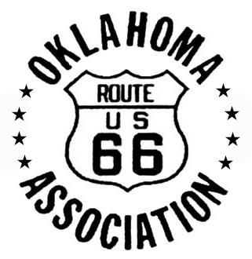 

Oklahoma Route 66 Association

P.O. Box 446

Chandler, OK 74834  
www.oklahomaroute66.com

(405) 258-0008

The Honorable Elaine L. Chao

U.S. Secretary of Transportation

U.S. Department of Transportation

1200 New Jersey Ave SE

Washington, D.C. 20590

RE: Better Utilizing Investments to Leverage Development (BUILD) funding for the

US-281/Route 66 Bridgeport Bridge in Caddo and Canadian Counties

Honorable Secretary Chao:

On behalf of the Oklahoma Route 66 Association, I am writing to voice our organization’s strong support of the Oklahoma Department of Transportation's (ODOT) application for a Better Utilizing Investments to Leverage Development (BUILD) grant to assist with the US-281/Route 66 Bridgeport Bridge in Caddo and Canadian Counties. The proposed improvements to this Bridge are both necessary and urgent to provide for motorist safety, better facilitate traffic and improve freight movement and to meet the strategic goals of both ODOT and the region.

The Oklahoma Route 66 Association strongly supports the US-281/Route 66 Bridgeport Bridge project for its vital contribution to the region, state and nation. The proposed project supports a network that strongly impacts Oklahoma's economy and freight movement, as well as upholds a significant cultural and historical attraction along our Nation’s famous Route 66. We strongly urge your support of full funding for the project. Thank you for your consideration and please feel free to call on us should you have questions or if you require additional information.

Sincerely,

Rhys Martin

President

Oklahoma Route 66 Association

**June 11, 2019**