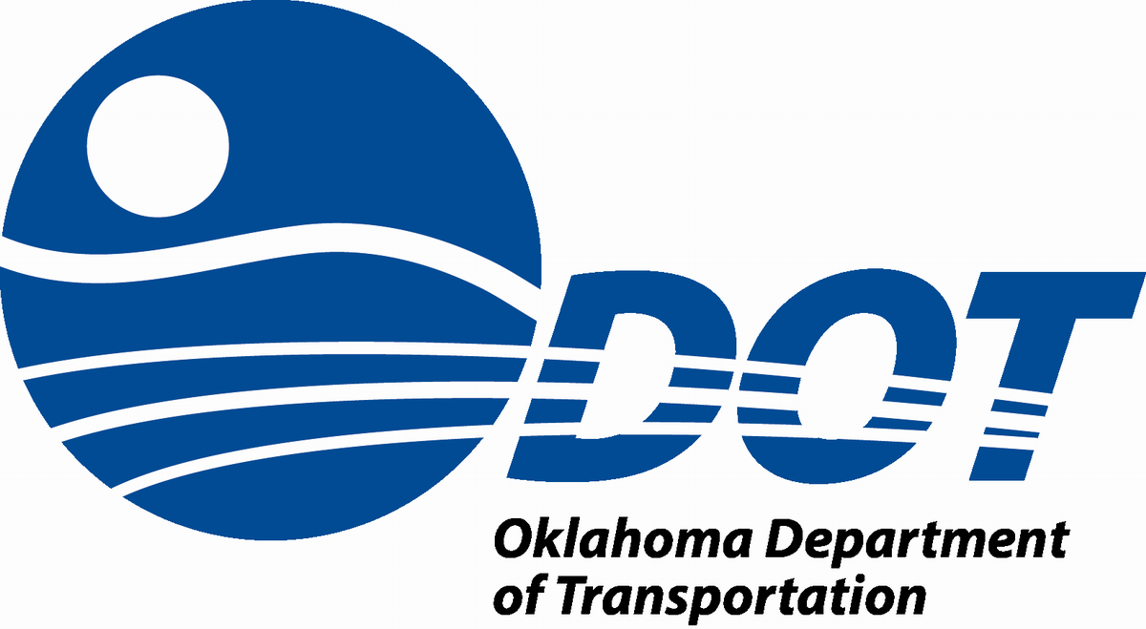
History of Rail in Oklahoma

Rail began in Oklahoma with the establishment of the Missouri Kansas & Texas (KATY) Railroad on June 6, 1870. The Atlantic & Pacific Railroad (A&P) reached Vinita on September 1, 1871. Construction continued on various lines of railroad, reaching Tulsa in 1881, crossing the Arkansas River in 1886, and finally leading into Oklahoma City by 1898.
Construction of railroads in Oklahoma maintained its rapid pace throughout the late 1940s and into the early 1950s. During that time, at least 6,500 miles of railroad lines were laid.
In the late 1970s and early 1980s, however, railroad lines began to be abandoned. One notable case was the Chicago, Rock Island, & Pacific failure in late 1970. 2,800 miles of rail lines had been abandoned by the late 1980s. Nearly 50% of railroad lines were in danger of abandonment.
In1978, Oklahoma Legislation passed the Railroad Revitalization Act, House Bill #1623. In connection with this Act, a Railroad Maintenance Revolving Fund was created, which included the Oklahoma Freight Car Tax. This created a tax equivalent to 4% of the gross earnings of a freight car operating within the State.
The Revitalization Act preserved 18% of the 4,991 miles of railroad line serving Oklahoma in 1978. This number was reduced to 8% in 2013.
Throughout its history, Oklahoma Department of Transportation (ODOT) has used its funding for a variety of needs. One of those needs is the purchase of rail line in danger of abandonment, followed subsequently by leasing or selling it to railroad companies, or in some cases, the salvage of materials.
Another important factor in Oklahoma’s Rail History is the formation of its passenger rail service. The Heartland Flyer was re-established in March 19, 1998, after thirty years.
Its inaugural run was on June 14, 1999, after the Tax Relief Act of 1997 provided funding to Amtrak. It currently is the only passenger rail service in Oklahoma.
Currently the Heartland Flyer runs from Oklahoma City, Oklahoma to Fort Worth, Texas daily. It makes stops throughout its journey to the following cities: Oklahoma City, Norman, Purcell, Pauls Valley, Ardmore, Gainesville, and Fort Worth.
With improvements, travel time from OKC to Texas is hoped to be reduced to just under 4 hours. Other considerations are extending the Heartland Flyer to reach Tulsa and some Kansas cities.
Railroads are an important part of the transportation infrastructure in Oklahoma, transporting people and freight all over the State and across the country. ODOT hopes to continue to provide this essential service to our great State.

