How to obtain Soil Survey information

- Go to http://websoilsurvey.sc.egov.usda.gov/App/HomePage.htm and select the green “START WSS” button.
Click START WSS
- Zoom to your area by using the zoom and pan buttons or by selecting from the Quick Navigation choice list on the left.
Zoom and Pan
Quick Navigation list

- Define the Area of Interest (AOI) by drawing a rectangle or polygon using a map tool.
Draw rectangle or polygon around AOI
AOI map tools

- To print the soil map, select the Soil Map tab. Click on Printable Version and then click View. You can save or print the pdf document.
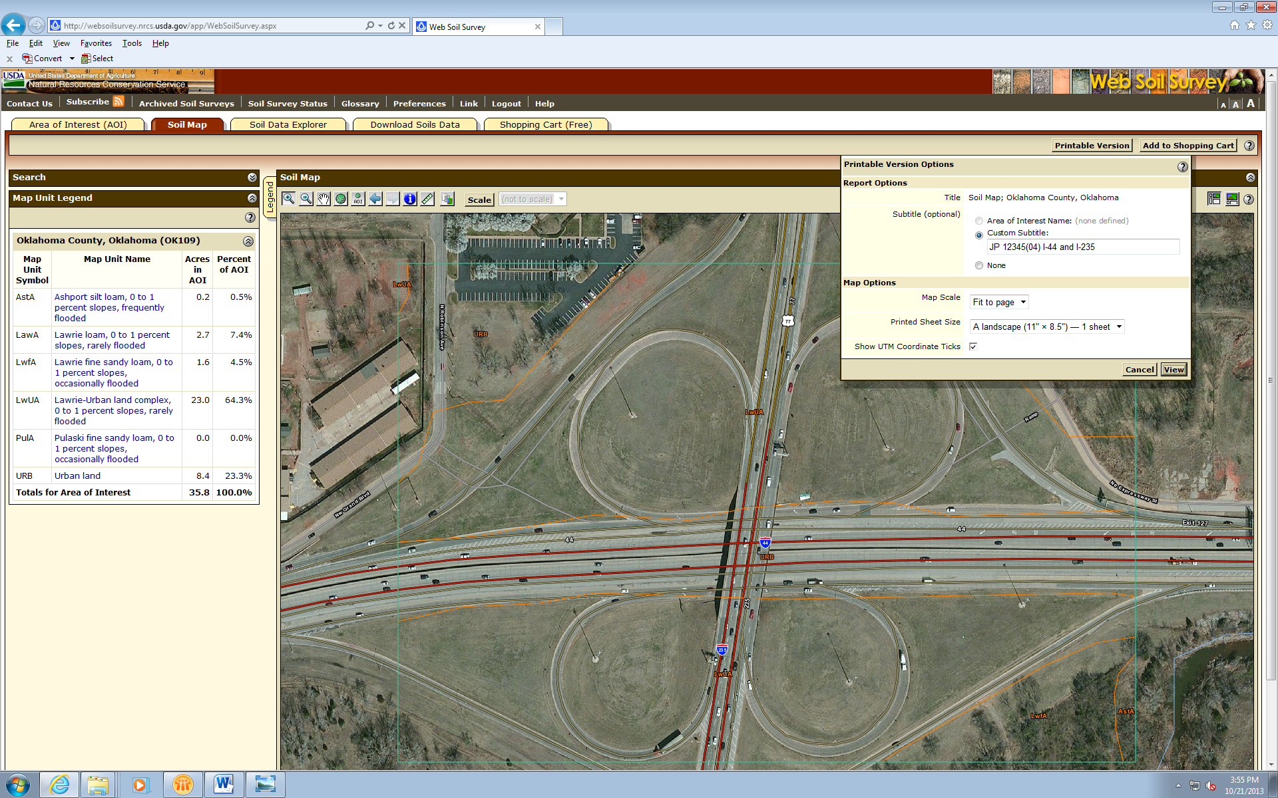
Click Printable Version then View
Click Soil Map
- To obtain the Soil Report, select the Soil Data Explorer tab and then the Soil Reports tab.
Click Soil Data Explorer
Click Soil Reports
- On the left menu click Soil Physical Properties then select Engineering Properties when it appears.
Click Soil Physical Properties then Engineering Properties

- Check Include Minor Soils and select View Soil Report and the report will be shown below the soil map. 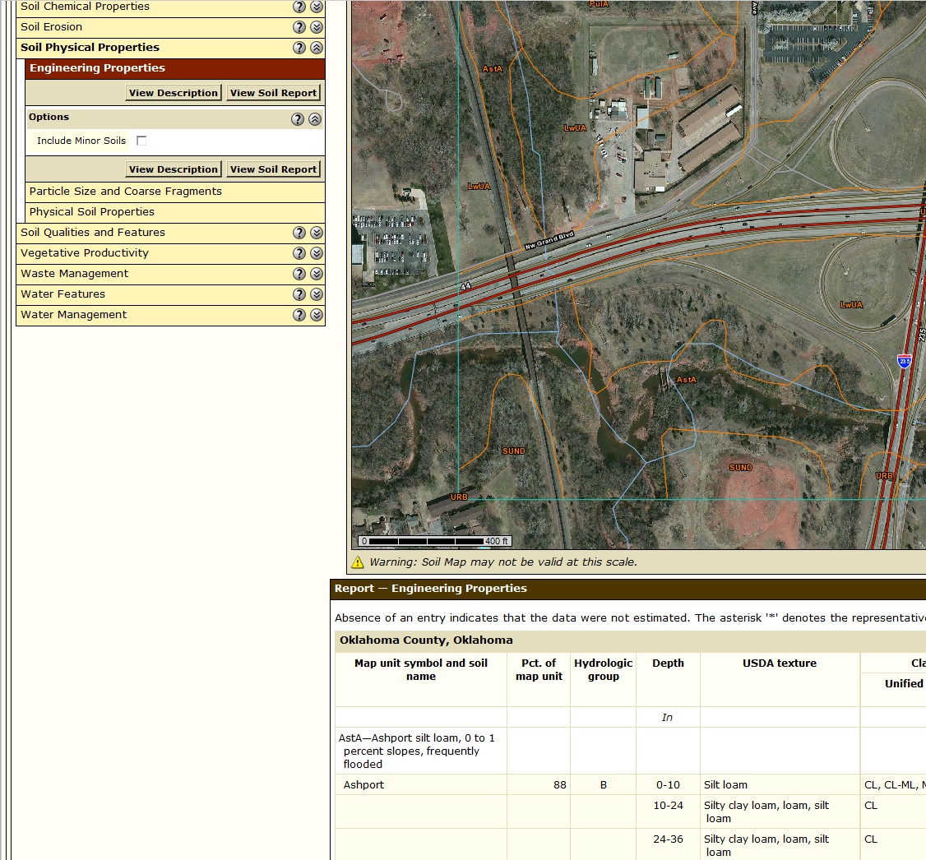
First check Include Minor Soils
Select View Soil Report

- To print the soil report, click on Printable Version and then click View. You can save or print the pdf document.
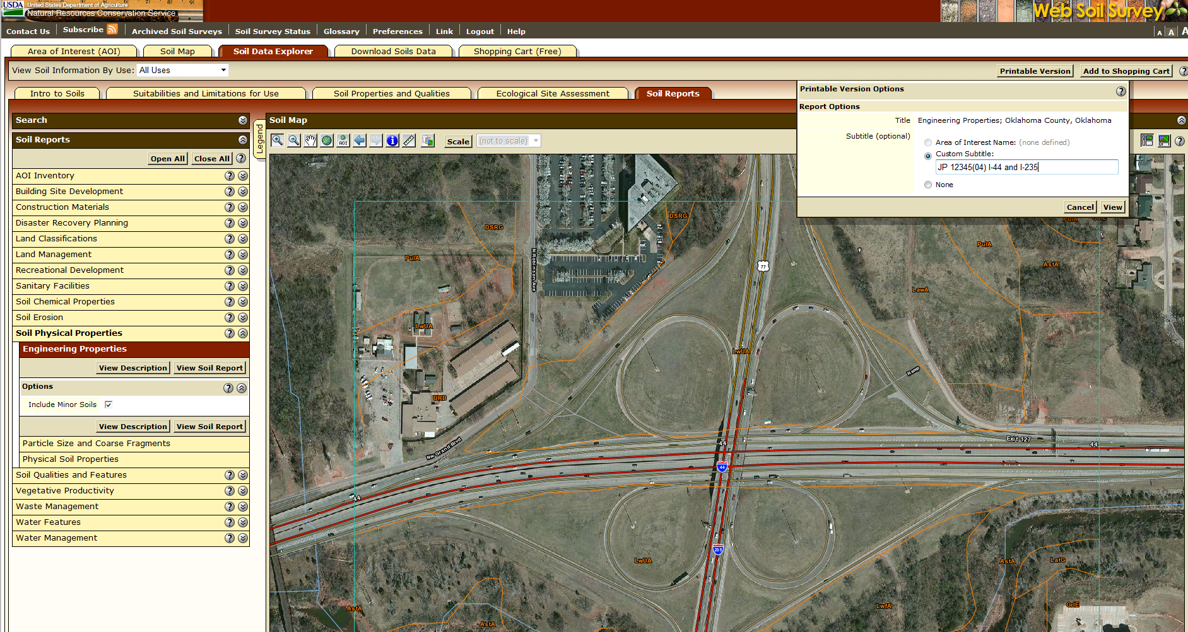
Click Printable Version then View

