Jennifer Han, Ph.D.
Community Epidemiology and Evaluation
Community and Family Health Service
5/11/2012
The State of Obesity in Oklahoma

The State of Obesity in Oklahoma
According to data from the Behavioral Risk Factor Surveillance System (BRFSS)¹ on adults aged 18 years and older, obesity has increased in the United States at an alarming rate. In the 1980’s, most states had obesity rates of less than 15%. Currently, every state in the union has an obesity rate that exceeds 20%. While 36 states have rates exceeding 25%, 12 of those states, including Oklahoma, that have obesity rates higher than 30%.
This report assesses the prevalence of obesity in Oklahoma using data from the Oklahoma BRFSS. Obesity prevalence by demographic are presented for 2000 and 2010, along with percent change in obesity from 2000 to 2010. County rates and percent change are shown for data years 2000-2004 and 2005-2010 (the large time span ensures more stable statistics for smaller counties). Select health behaviors and outcomes are presented with the current obesity prevalence to assess the relationships that may exist between obesity and the select health indicator using Chi-Square analysis (data presented in tables with significance set at α = 0.05). Indicators included in this assessment are fruit and vegetable consumption, recent physical activity, diabetes, quality of life, inadequate sleep, and life satisfaction.
A Look at Obesity across the Oklahoma Population
Current trends in Oklahoma demonstrate that the obesity rate fluctuates by demographic, though the general patterns are consistent from 2000 to 2010 (Table 1).² For example, obesity rates in 2000 were highest among Blacks, American Indians, and those with less education and income, and rates continued to be the highest among those same demographics in 2010. While patterns were similar, the magnitude of change differed by group. Some of the greatest rate increases occurred among groups that had some of the lowest rates in 2000, such as males, Whites, and those aged 55-64 years.
Table1. Percentage of the Oklahoma Adult Population who are Obese, by Demographic, OK BRFSS.
 |  | 2000 | 2010 | % Increase
Total | Total | 19.7 | 31.3 | 58.9
Sex | Male | 19.0 | 31.9 | 67.9
 | Female | 20.3 | 30.6 | 50.7
Race/Ethnicity | White non-Hispanic | 18.5 | 29.3 | 58.4
 | Black non-Hispanic | 26.6 | 41.8 | 57.1
 | American Indian non-Hispanic | 28.1 | 40.2 | 43.1
 | Hispanic | 22.8 | 31.9 | 39.9
Age Group | 18 to 24 | 12.9 | 20.7 | 60.5
 | 25 to 34 | 20.0 | 29.4 | 47.0
 | 35 to 44 | 24.0 | 35.6 | 48.3
 | 45 to 54 | 25.7 | 35.6 | 38.5
 | 55 to 64 | 18.2 | 35.6 | 95.6
 | 65 and older | 14.7 | 26.1 | 77.6
Education | Less than high school | 24.2 | 36.9 | 52.5
 | High school graduate/GED | 19.8 | 33.3 | 68.2
 | Some post-secondary school | 19.0 | 32.3 | 70.0
 | College graduate | 17.7 | 25.6 | 44.6
Household Income | < $15,000 | 24.5 | 38.7 | 58.0
 | $15,000 – 24,999 | 23.1 | 37.4 | 61.9
 | $25,000 – 34,999 | 20.1 | 33.4 | 66.2
 | $35,000 – 49,999 | 19.6 | 29.6 | 51.0
 | ≥ $50,000 | 17.3 | 27.8 | 60.7

Rates of obesity differ by county, and tend to be lower in the counties with the most populous cities (Oklahoma, Tulsa, and Cleveland Counties). Hughes (21.2%), Woods (21.7%), and Grant (24.2%) Counties had the lowest obesity rates in the state, while Noble (39.1%), Jefferson (39.3%), and Latimer (42.2%) Counties had the highest rates. The most populous counties experienced great increases in obesity rates from 2000 to 2010 (Oklahoma County, 72.6%; Tulsa County, 61.2%; and Cleveland County, 71.5%).
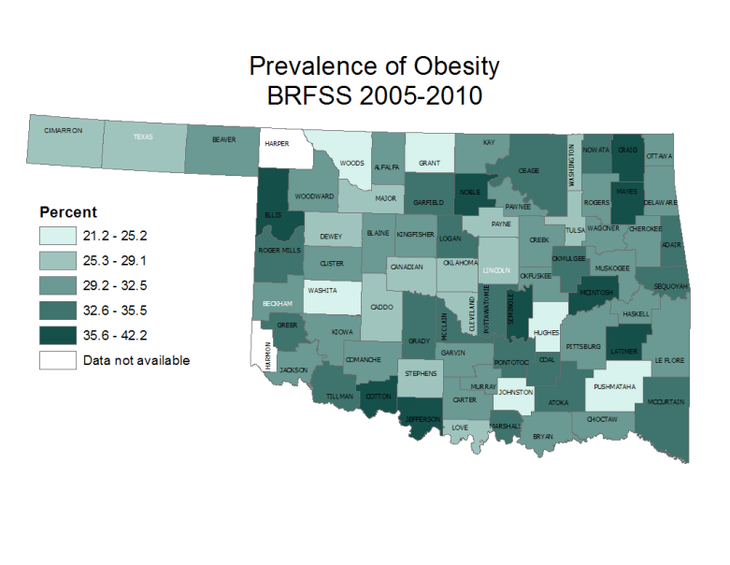
Comparing county data from 2000-2004 and 2005-2010 (Table 2), the counties of Ellis, Craig, and Atoka experienced the greatest increases in obesity rates (134.4%, 90.7%, and 90.6%, respectively). Rates in 12 Oklahoma counties declined, with the largest declines occurring in Major, Hughes, and Lincoln Counties (declines of 37.1%, 13.1%, and 10.5%, respectively).

Table 2. County Obesity Rates and Percent Change between 2000-2004 and 2005-2010.
County Name | 2000-2004 | 2005-2010 | % Change | County Name | 2000-2004 | 2005-2010 | % Change | County Name | 2000-2004 | 2005-2010 | % Change
Adair | 30.2 | 35.4 | +17.2 | Grant | 26.5 | 24.2 | -8.7 | Nowata | 29.7 | 33.1 | +11.4
Alfalfa | 33.7 | 31.9 | -5.3 | Greer | - | 34.9 | - | Okfuskee | 19.7 | 31.7 | +60.9
Atoka | 18.1 | 34.5 | +90.6 | Harmon | - | - | - | Oklahoma | 21.1 | 28.4 | +34.6
Beaver | 25.3 | 29.5 | +16.6 | Harper | - | - | - | Okmulgee | 29.0 | 33.7 | +16.2
Beckham | 22.3 | 32.5 | +45.7 | Haskell | 25.4 | 31.1 | +22.4 | Osage | 30.0 | 32.8 | +9.3
Blaine | 32.0 | 31.5 | -1.6 | Hughes | 24.4 | 21.2 | -13.1 | Ottawa | 25.1 | 32.2 | +28.3
Bryan | 17.6 | 30.4 | +72.7 | Jackson | 24.7 | 31.7 | +28.3 | Pawnee | 23.6 | 32.3 | +36.9
Caddo | 28.8 | 29.1 | +1.0 | Jefferson | 21.5 | 39.3 | +82.8 | Payne | 20.1 | 27.4 | +36.3
Canadian | 20.7 | 26.4 | +27.5 | Johnston | 26.2 | 24.7 | -5.7 | Pittsburg | 25.4 | 30.2 | +18.9
Carter | 20.0 | 30.6 | +53.0 | Kay | 24.9 | 31.3 | +25.7 | Pontotoc | 25.3 | 35.0 | +38.3
Cherokee | 25.4 | 31.1 | +22.4 | Kingfisher | 24.5 | 30.5 | +24.5 | Pottawatomie | 25.0 | 34.2 | +36.8
Choctaw | 22.1 | 30.0 | +35.7 | Kiowa | 29.7 | 31.1 | +4.7 | Pushmataha | 26.1 | 25.2 | -3.4
Cimarron | - | 26.2 | - | Latimer | 25.6 | 42.2 | +64.8 | Roger Mills | - | 35.5 | -
Cleveland | 19.2 | 26.5 | +38.0 | Le Flore | 23.2 | 31.0 | +33.6 | Rogers | 21.6 | 29.4 | +36.1
Coal | 36.3 | 33.6 | -7.4 | Lincoln | 31.3 | 28.0 | -10.5 | Seminole | 30.8 | 37.7 | +22.4
Comanche | 21.3 | 31.4 | +47.4 | Logan | 25.1 | 32.7 | +30.3 | Sequoyah | 28.7 | 32.9 | +14.6
Cotton | - | 37.9 | - | Love | 23.9 | 25.6 | +7.1 | Stephens | 28.0 | 27.6 | -1.4
Craig | 19.3 | 36.8 | +90.7 | McClain | 22.9 | 34.8 | +52.0 | Texas | 17.4 | 27.5 | +58.0
Creek | 25.6 | 32.3 | +26.2 | McCurtain | 29.3 | 33.4 | +14.0 | Tillman | 33.1 | 34.5 | +4.2
Custer | 21.6 | 29.8 | +38.0 | McIntosh | 23.4 | 37.4 | +59.8 | Tulsa | 20.8 | 27.2 | +30.8
Delaware | 23.5 | 30.6 | +30.2 | Major | 42.8 | 26.9 | -37.1 | Wagoner | 23.8 | 31.2 | +31.1
Dewey | 30.0 | 29.1 | -3.0 | Marshall | 36.5 | 33.8 | -7.4 | Washington | 19.8 | 26.7 | +34.8
Ellis | 15.7 | 36.8 | +134.4 | Mayes | 21.1 | 36.9 | +74.9 | Washita | 20.8 | 24.5 | +17.8
Garfield | 27.7 | 33.7 | +21.7 | Murray | 16.9 | 32.1 | +89.9 | Woods | 17.2 | 21.7 | +26.2
Garvin | 26.0 | 29.8 | +14.6 | Muskogee | 27.1 | 29.6 | +9.2 | Woodward | 26.2 | 32.5 | +24.0
Grady | 24.5 | 34.5 | +40.8 | Noble | 21.6 | 39.1 | +81.0

Obesity and Select Health Outcomes and Behaviors
Nutrition and Physical Activity
Poor nutrition and lack of physical activity are two primary behaviors that contribute to excess weight.³ BRFSS assesses poor nutrition via a proxy measure of fruit and vegetable consumption, and physical activity is assessed as any leisure-time physical activity performed in the past 30 days. In 2009, Oklahoma as a state ranked last in the country for fruit and vegetable consumption, with 14.6% of its adult population having consumed the recommended 5 servings of fruits and vegetables daily in 2009.⁴ From data combined for 2005, 2007, and 2009, fruit and vegetable consumption was least common in the eastern part of the state, with Okfuskee, Marshall, and Adair Counties having the lowest rates at 4.1%, 6.9%, and 7.2%, respectively.² Conversely, almost 30% of adults in Choctaw County consumed at least 5 servings of fruits and vegetables daily.
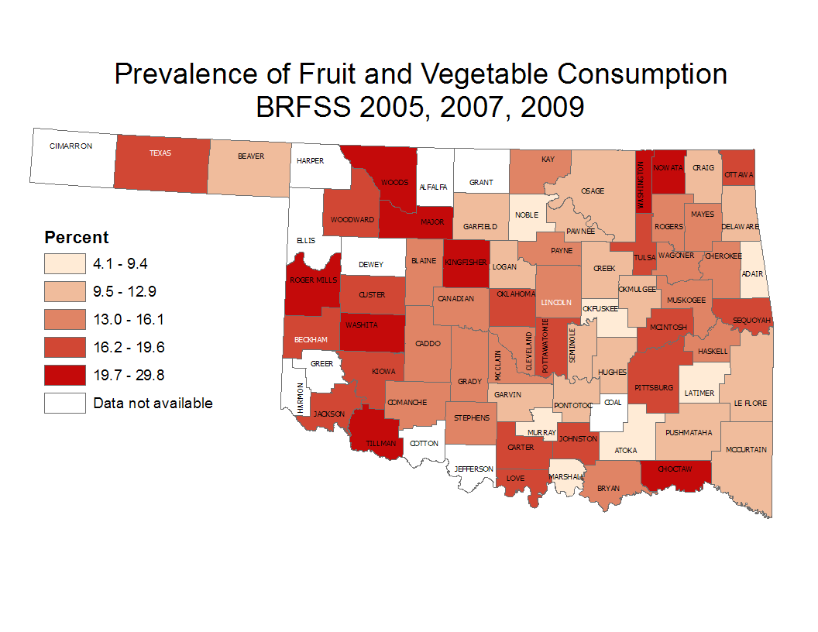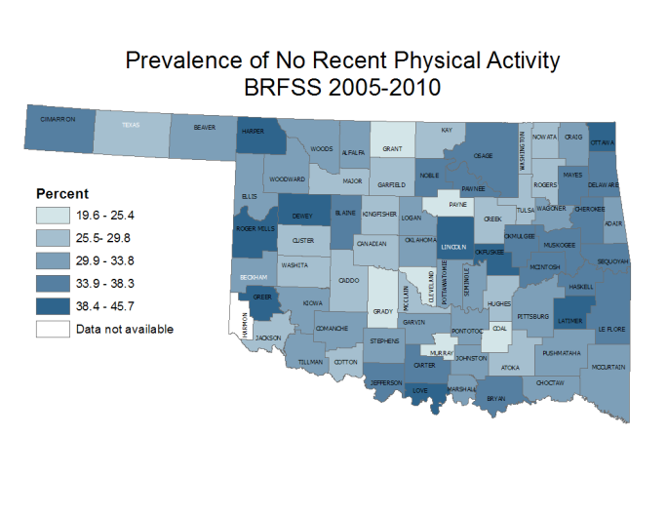
In 2010, Oklahoma ranked 47th in the country for lack of physical activity, with 29.9% of its adult population reporting no recent physical activity.⁴ Data from 2005 to 2010 demonstrate that Grant County had the lowest rate of inactivity (19.6%), compared with Greer County on the high end (45.7%).² These data also show that those who were obese had significantly lower rates of fruit and vegetable consumption and recent physical activity (Table 3).
Table 3. Nutritional and Physical Activity Statuses of Obese and Non-obese Oklahoma Adults,
BRFSS 2005-2010.
 | Obese | Not Obese | p-value (α = .05)
Not eating 5 servings of fruits and vegetables | 85.6% | 84.1%
Eating 5 servings of fruits and vegetables | 14.4% | 15.9% | 0.0381
No physical activity in the past 30 days | 37.8% | 26.8%
Some physical activity in the past 30 days | 62.2% | 73.2% | < 0.0001

Diabetes
While Oklahoma’s adult obesity rate increased 60% in the past decade, adult diabetes rates almost doubled, from 5.5% in 2000 to 10.4% in 2010.² Only 5 states in the nation had adult diabetes rates higher than Oklahoma’s.¹ Rates varied across the state, with higher prevalences generally occurring in the eastern part of the state. Data from 2005 to 2010 demonstrate that diabetes was least common in Texas (4.0%), Grady (6.3%), and Grant (6.4%) Counties and most prevalent in Tillman (17.1%), Harper (17.4%), and Love (18.0%) Counties.² These data also demonstrate that obese adults had more than double the rate of diabetes compared with non-obese adults (Table 4). Weight loss is a recommended strategy for preventing and/or managing diabetes.⁵
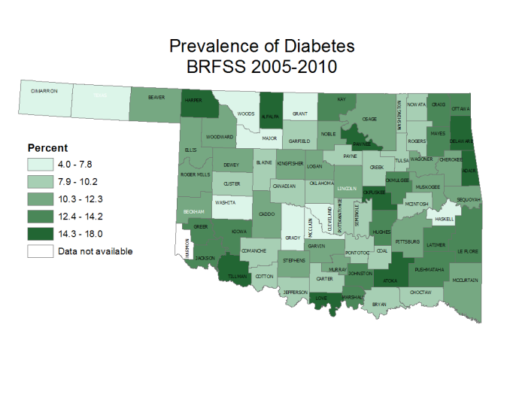
Table 4. Diabetes Prevalence among Obese and
Non-obese Oklahoma Adults, BRFSS 2005-2010.
 | Obese | Not Obese | p-value (α = .05)
Diabetes | 17.9% | 6.8%
No diabetes | 82.1% | 93.2% | < 0.0001

Quality of Life
Obese individuals may suffer poorer quality of life (QoL) than non-obese individuals.⁶ The BRFSS asks adults to rate their health status as a measure of QoL. In 2010, 1 in 5 Oklahoma adults rated their health as being fair or poor.² Only 5 other states in the nation had poorer health reported.¹ Oklahoma’s poorest health rates occurred in the southeastern part of the state. Data from 2005 to 2010 show that 1 in 3 adults experienced fair or poor health in Kiowa, Pushmataha, and Latimer Counties.² Conversely, fewer than 12% of adults in Texas County reported fair to poor health. These data also demonstrate that obese adults had significantly higher rates of poor health status compared with non-obese adults (Table 5). In fact, 10% more of obese than non-obese adults reported poor health.
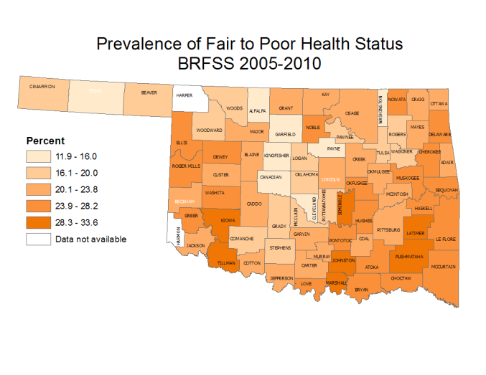
Table 5. Self-reported Health Status among Obese and Non-obese Oklahoma Adults, BRFSS 2005-2010.
 | Obese | Not Obese | p-value  (α = .05)
Fair or poor | 26.6% | 16.3%
Good or better | 73.4% | 83.7% | < 0.0001

Inadequate Sleep
Inadequate sleep may increase the risk of obesity because inadequate sleep changes the production and action of hormones involved in energy regulation.^{7,8} In BRFSS, inadequate sleep is defined as not having enough rest or sleep on more than 13 of the past 30 days. This rate increased slightly in Oklahoma from 2000 to 2010, with 28.2% of adults reporting inadequate sleep in 2000 and 30.3% reporting in 2010. Only 3 states in the nation had inadequate sleep rates that were worse than Oklahoma’s rate in 2010.¹ For the 3-year period of 2008-2010, Major County had the lowest rate (9.9%) and Jefferson County had the highest rate (52.6%) of inadequate sleep. These data also demonstrate that obese adults had significantly higher rates of inadequate sleep compared with non-obese adults (Table 6).
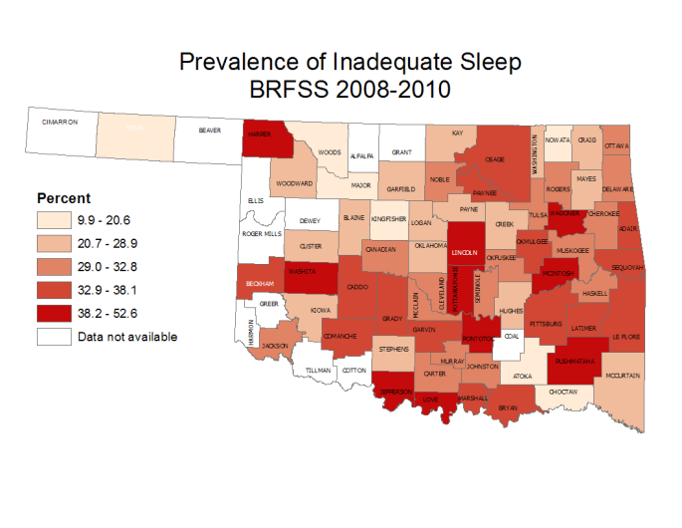
Table 6. Prevalence of Inadequate Sleep among Obese and Non-obese Oklahoma Adults, BRFSS 2008-2010.
 | Obese | Not Obese | p-value  (α = .05)
Inadequate sleep | 35.2% | 28.8%
Adequate sleep | 64.8% | 71.2% | < 0.0001

Life Satisfaction
Studies have shown that individuals who are obese may be less satisfied with their life than individuals who are not obese.^{9,10} The BRFSS asks respondents to rate how satisfied they are with their life in general. In 2010, 6.0% of Oklahoma adults were dissatisfied with their life, with the highest rates occurring among residents in the eastern part of the state.² From 2005 to 2010, residents of Texas County were the most satisfied (only 2.3% were dissatisfied); conversely, Atoka, Pushmataha, Love, and Cimarron Counties had the highest rates of life dissatisfaction in the state, with more than 1 in 10 adults not satisfied with their life. These data also show that obese adults were significantly less satisfied with their lives compared with non-obese adults (Table 7).
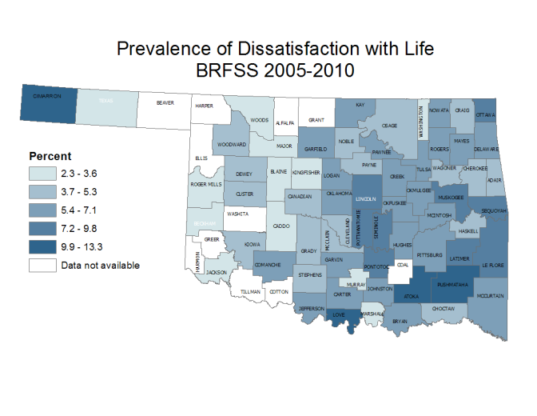
Table 7. Life Satisfaction among Obese and Non-obese Oklahoma Adults, BRFSS 2005-2010.
 | Obese | Not Obese | p-value  (α = .05)
Not satisfied with life | 7.5% | 5.1%
Satisfied with life | 92.5% | 94.9% | < 0.0001

Summary
Obesity has increased almost 60% across the Oklahoma population since 2000. During the same time period, Oklahomans have experienced worsening quality of life and life satisfaction, almost double the rate of diabetes, and greater engagement in unhealthy nutrition, physical activity, and sleep behaviors. Some of these factors contributed to Oklahoma’s poor ranking (48th in the nation) in the 2011 edition of America’s Health Rankings.¹¹
The Oklahoma State Department of Health (OSDH) has been mobilizing efforts to improve the health and quality of life of Oklahoma residents. Some of the most recent initiatives include the Oklahoma Health Improvement Plan, the Shape Your Future campaign, and establishment of the Center for the Advancement of Wellness.
The Oklahoma Health Improvement Plan¹² was developed in collaboration with health professionals, government agencies, and community members to focus on key priorities and outcomes which will greatly impact the health of Oklahomans. One of the key priorities is obesity, and several objectives are outlined in the plan to enhance access to and opportunities for healthy nutrition and physical fitness for all Oklahomans.
Shape Your Future¹³ was launched in early 2011 in conjunction with the Tobacco Settlement Endowment Trust and partner organizations as a social marketing campaign to provide Oklahomans with information and resources for eating better, moving more, and being tobacco-free. Individuals, organizations, and communities can implement these policies and practices, thus improving quality of life of residents. The idea is that if Oklahoma’s health status was similar to the national average, 5,320 lives would be saved each year.
Most recently, the Center for the Advancement of Wellness was established as a means of strategically aligning resources within OSDH that address obesity and tobacco prevention. The Community Development Service (CDS) now works alongside the Center. Several ongoing programs within CDS include Turning Point, Certified Healthy Oklahoma, and CATCH. The Turning Point Initiative, begun in 1998, consists of community partnerships whose focus is to enhance the health status of Oklahomans. While their activities vary, many communities have developed plans that target obesity reduction and prevention. The Certified Healthy Oklahoma Programs began in 2003 as a means of encouraging and recognizing businesses that were committed to improving the health of their employees. The Certified Healthy programs have since expanded to recognize restaurants, schools, campuses, and communities who are also doing their part to promote healthy lifestyles among their respective populations. CATCH, or Coordinated Approach to Child Health, is a healthy nutrition and physical activity program that is in its fifth year in after-school programs across the state.
There are a plethora of programs aimed at reducing and preventing obesity across the state of Oklahoma. Programs are utilizing a variety of approaches to promote healthy behavior change, including individual, organizational, community, and policy strategies. OSDH is leading the way to Create a State of Health.
References
¹Centers for Disease Control and Prevention, National BRFSS data reference (for sleep and satisfaction, used dataset and not stats on wonder)
²Center for Health Statistics, Oklahoma State Department of Health, OK BRFSS data reference
³Reference for food and exercise causing obesity
⁴State of the State’s Health report, 2011
⁵The Diabetes Prevention Program Research Group (2002). The Diabetes Prevention Program (DPP). Diabetes Care. 25:2165-2171.
⁶Kolotkin, Meter, and Williams (2001). Quality of Life and Obesity. Obesity Reviews. 2:219-229.
⁷National Sleep Foundation. Obesity and Sleep. Available at http://www.sleepfoundation.org/article/sleep-topics/obesity-and-sleep
⁸Gangwisch, Malaspina, Boden-Albala, and Heymsfield (2005). Inadequate sleep as a risk factor for Obesity: Analyses of the NHANES I. Sleep. 28(10):1289-1296.
⁹Ball, Crawford, and Kenardy (2004). Longitudinal relationships among overweight, life satisfaction, and aspirations in young women. Obesity Research. 12(6):1019-1030.
¹⁰Strine, Chapman, Balluz, Moriarty, and Mokdad (2007). The associations between life satisfaction and health-related quality of life, chronic illness, and health behaviors among U.S. community-dwelling adults. Journal of Community Health. 33:40-50.
¹¹United Health Foundation (2011). America’s Health Rankings. A Call to Action for Individuals & Their Communities. 2011 Edition. Available at http://www.americashealthrankings.org/sitefiles/reports/ahr%202011edition.pdf.
¹²Oklahoma Health Improvement Planning Team (2010). Oklahoma Health Improvement Plan. Available at http://www.ok.gov/health/documents/OHIP-viewing.pdf.
¹³Oklahoma State Department of Health and Tobacco Settlement Endowment Trust. Shape Your Future website. Available at http://www.shapeyourfutureok.com.

