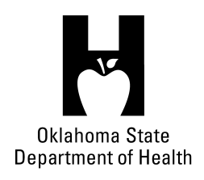
AGENDA
FOOD SERVICE ADVISORY COUNCIL
September 13, 2017
9:30 A.M.
Posted under Food Service Advisory Council at http://food.health.ok.gov

- Open Meeting Act: Announcement of Filing of Meeting and Posting of Agenda in Accordance with the Open Meeting Act.

- Call to Order: Roll Call and Announcement of Quorum – Bill Ricks

- Introductions – All

- Review and Possible Action on Approval of June 14, 2017 Meeting Minutes – Bill Ricks

- Department Report – OSDH Staff
- Licensing & Inspection Update
- Appointments/Re-appointments
- Update on Department Actions following OAC 310:250 Revision
- Update on Plan Review Efforts
- Update on Department Budget

- Discussion Concerning Simply Cool Fans – Phillip Jurina & Troy Skow

- Discussion on Self-Inspection Programs – All

- Review and Possible Action on Meeting Locations and Dates for 2018 – Bill Ricks

- Old Business:

- New Business:

- Announcements:

- Next Meeting Date: December 13, 2017 at OSU in Stillwater

- Adjournment – Bill Ricks

The September 13, 2017 Food Service Advisory Council Meeting will be held at:

Oklahoma City-County Health Department
2600 NW 63rd Street
Oklahoma City, OK 73111

