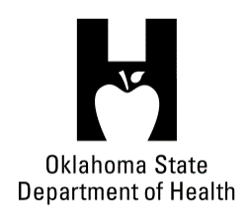
AGENDA
FOOD SERVICE ADVISORY COUNCIL
SPECIAL MEETING
September 12, 2018
9:30 A.M.
Posted under Food Service Advisory Council at http://food.health.ok.gov

- Open Meeting Act: Announcement of Filing of Meeting and Posting of Agenda in Accordance with the Open Meeting Act.

- Call to Order: Roll Call and Announcement of Quorum – Bill Ricks

- Presentation by Lindsay Goodon Concerning the Blue Zones Project – Brenda Potts

- Discussion and Possible Action Regarding Election of Council Vice Chair – Bill Ricks

- Review and Possible Action on Approval of February 6, 2018 Meeting Minutes – Bill Ricks

- Review and Possible Action on Approval of June 20, 2018 Meeting Minutes – Bill Ricks

- Review and Possible Action on Meeting Places and Dates for 2019 – Bill Ricks

- Presentation and Discussion on FDA Food Code 2017 – Marsha Allmon

- Department Report – OSDH Staff
- Licensing & Inspection Update
- Staffing
- Quality Improvement Project – Food Inspections
- Update on Department Budget
- New Food Products
- Proposed Program Rule Updates

- Next Meeting Date: December 12, 2018, OSU Tulsa Campus, Tulsa Room

- Adjournment – Bill Ricks

The September 12, 2018 Food Service Advisory Council Meeting will be held at:

Citizen Potawatomi Nation, South Reunion Hall
1702 S Gordon Cooper Drive
Shawnee, OK 74801

