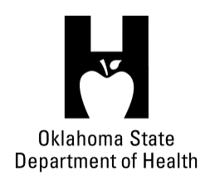
AGENDA
FOOD SERVICE ADVISORY COUNCIL
June 20, 2018
9:30 A.M.
Posted under Food Service Advisory Council at http://food.health.ok.gov

- Open Meeting Act: Announcement of Filing of Meeting and Posting of Agenda in Accordance with the Open Meeting Act.

- Call to Order: Roll Call and Announcement of Quorum – Bill Ricks

- Welcome DeBrena Hilton as Tulsa Health Department Representative – Bill Ricks

- Review and Possible Action on Approval of February 6, 2018 Meeting Minutes – Bill Ricks

- Department Report – OSDH Staff – Lynnette Jordan
- Licensing & Inspection Update
- Update on Department Budget
- Risk Frequency Update to Board of Health & Transition Plans for High Risk Operations
- Senior Management Changes

- Legislative Discussion – Bill Ricks

- Old Business:

- New Business:

- Announcements:

- Next Meeting Date: September 12, 2018, Citizens Pottawatomie Nation Tribal Center, Shawnee

- Adjournment – Bill Ricks

The June 20, 2018 Food Service Advisory Council Meeting will be held at:

Oklahoma City-County Health Department
2600 NE 63rd Street
Oklahoma City, OK 73111

