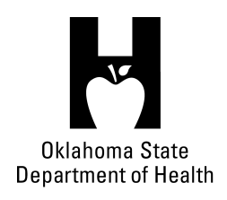
AGENDA
FOOD SERVICE ADVISORY COUNCIL
June 14, 2017
9:30 A.M.
Posted at https://food.health.ok.gov

- Open Meeting Act: Announcement of Filing of Meeting and Posting of Agenda in Accordance with the Open Meeting Act.

- Call to Order: Roll Call and Announcement of Quorum – Bill Ricks

- Signage Rules – Don Maisch

- Boil Orders – Don Maisch

- Review and Possible Action on Approval of January 18, 2017 Meeting Minutes – Bill Ricks

- Review and Possible Action on Approval of February 9, 2017 Meeting Minutes – Bill Ricks

- Department Report
- Licensing & Inspection Update – Lynnette Jordan
- Appointments/Re-appointments – Lynnette Jordan
- Update on Department Budget – Lynnette Jordan

- Update regarding Proposed Changes to Oklahoma Administrative Code (OAC) 310:250. Consumer Health Service – Fee Schedule – Lynnette Jordan

- Discussion on possible modification to retail food inspection frequency schedule – self-inspection program - All

- Old Business:

- New Business:

- Announcements:

- Next Meeting Date: September 13, 2017 – OCCHD 2600 NW 63rd Street, OKC

- Adjournment – Bill Ricks

The June 14, 2017 Food Service Advisory Council Meeting will be held at:

Tulsa Health Department
5051 S 129th East Avenue
Tulsa, OK 74134

