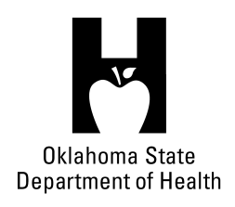
AGENDA
FOOD SERVICE ADVISORY COUNCIL – SPECIAL MEETING
March 2, 2016
9:30 A.M.
Posted at https://food.health.ok.gov

- Open Meeting Act: Announcement of Filing of Meeting and Posting of Agenda in Accordance with the Open Meeting Act.

- Call to Order: Roll Call and Announcement of Quorum – Bill Ricks

- Review and possible action on approval of December 2, 2015 meeting minutes – Bill Ricks

- Update of proposed 310:257 Food Code Changes – Lynnette

- Discussion on Legislative agenda items possibly impacting the food industry – All

- Update on procedures that relate to food/Truck wreck procedures - Phillip

- Update on Department Staff/Personnel changes – Lynnette

- One Stop Shop on Licensure in OKC – Phil

- Review and possible action on Examples and Templates to Properly Clean Up Vomit - Debbie

- Discussion concerning vacancy on the Food Service Advisory Council – Lynnette

- Discussion concerning Boil-Water Advisory and Boil-Water Order – Phillip

- Old Business:

- New Business:

- Announcements:

- Next Meeting Date: June 8, 2016 – Marshall brewing Company, Tulsa

- Adjournment – Bill Ricks

The March 2, 2016 Food Service Advisory Council Meeting will be held at:

Santiago’s McDonald’s
14927 Bristol Park BLVD
Edmond, OK 73013

MapQuest link for Santiago’s McDonald’s http://mapq.st/1KpKyrJ

