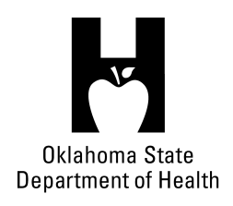
AGENDA
FOOD SERVICE ADVISORY COUNCIL
February 6, 2018
9:30 A.M.
Posted under Food Service Advisory Council at http://food.health.ok.gov

- Open Meeting Act: Announcement of Filing of Meeting and Posting of Agenda in Accordance with the Open Meeting Act.

- Call to Order: Roll Call and Announcement of Quorum – Bill Ricks

- Review and Possible Action on Approval of December 13, 2017 Meeting Minutes – Bill Ricks

- Review, Discussion and Possible Action on Risk Frequency Recognition – All

- Update and Discussion on Department’s Food Inspection Workgroup – All

- Service Report – OSDH Staff
- Licensing & Inspection Update
- Update on Department Budget
- Quality Improvement Project – Food Inspection Process

- Discussion on Legislative Agenda Items Possibly Impacting the Food Industry – All

- Old Business:

- New Business:

- Announcements:

- Next Meeting Date: June 20, 2018, Oklahoma City-County Health Department

- Adjournment – Bill Ricks

The February 6, 2018 Food Service Advisory Council Meeting will be held at:

OSU School of Hospitality & Tourism MGMT
Human Sciences Building
122 N Monroe
Stillwater, OK 74078

