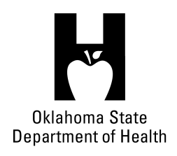
AGENDA
FOOD SERVICE ADVISORY COUNCIL
December 13, 2017
9:30 A.M.
Posted under Food Service Advisory Council at http://food.health.ok.gov

- Open Meeting Act: Announcement of Filing of Meeting and Posting of Agenda in Accordance with the Open Meeting Act.

- Call to Order: Roll Call and Announcement of Quorum – Bill Ricks

- Presentation by Adam Gribben for 1907 Meat Company – Roy Escoubas

- Presentation by Andrea Graves and Renee Albers-Nelson for Baker’s Training at OSU FAPC – Roy Escoubas

- Review and Possible Action on Approval of September 13, 2017 Meeting Minutes – Bill Ricks

- Department Report – OSDH Staff
- Licensing & Inspection Update
- Appointments/Re-appointments
- Update on Department Actions following OAC 310:250 Revision
- Update on Plan Review Efforts
- Update on Department Budget

- Discussion on Self-Inspection Programs – All

- Review and Possible Action on Meeting Locations for 2018 – Bill Ricks

- Old Business:

- New Business:

- Announcements:

- Next Meeting Date: February 6, 2018, location TBD

- Adjournment – Bill Ricks

The December 13, 2017 Food Service Advisory Council Meeting will be held at:

Food and Ag Products Center
320 N Monroe
Stillwater, OK 74078

