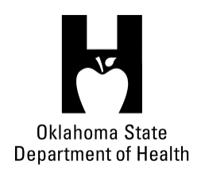
AGENDA
FOOD SERVICE ADVISORY COUNCIL
December 12, 2018
9:30 A.M.
Posted under Food Service Advisory Council at http://food.health.ok.gov

- Open Meeting Act: Announcement of Filing of Meeting and Posting of Agenda in Accordance with the Open Meeting Act.

- Call to Order: Roll Call and Announcement of Quorum – Bill Ricks

- Review and Possible Action on Approval of September 12, 2018 Meeting Minutes – Bill Ricks

- Department Report – OSDH Staff
- Licensing & Inspection Update
- Council Appointments
- Quality Improvement Project – Food Inspections
- Update on Online Licensing Systems
- Update on Department Budget
- Update on Agency Rule Process

- Review, Discussion and Possible Action Regarding Proposed Changes to OAC 310:250 – Bill Ricks

- Discussion and Possible Action Regarding Micro-Markets – Bill Ricks

- Review and Possible Action Regarding Meeting Locations for 2019 – Bill Ricks

- Old Business:

- New Business:

- Announcements:

- Next Meeting Date: February 5, 2019 – Location TBD

- Adjournment – Bill Ricks

The December 12, 2018 Food Service Advisory Council Meeting will be held at:

OSU Tulsa Campus, Tulsa Room
700 N Greenwood Avenue
Tulsa, OK 74106

