Oklahoma FTAC

Tax Credit Packet
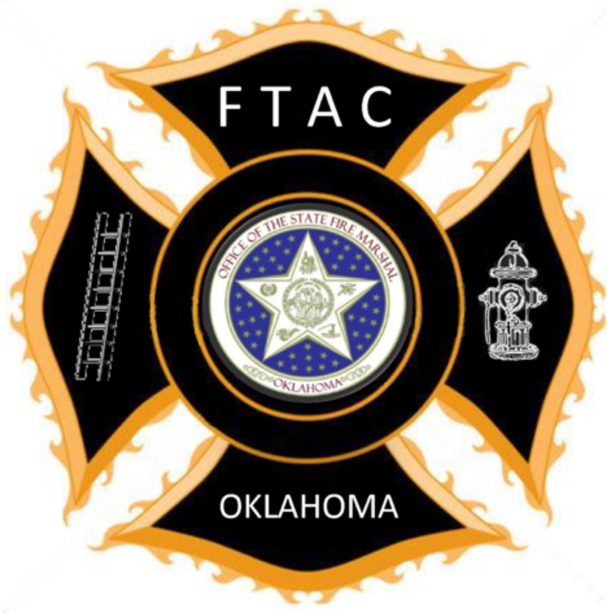

Web Page: www.ftac.ok.gov Phone: 405-522-5005
FAX: 405-522-5028
Email Address: ftac@fire.ok.gov Facebook Account: Search for FTAC Tax Credit Form: www.ftac.ok.gov

Revised 1/2024

Oklahoma Volunteer Firefighter Tax Credit
Tax Year:

Supporting Documentation

For Volunteer Firefighter Use Only.
STATE LAW requires all first-time participants to apply for the $300 tax credit for their first year.
First year? If so, you should list eligible firefighter training taken in current Tax Year as well as those taken in previous years. If you have previously completed a $300 tax credit, you may be eligible for the $600 tax credit, which has different requirements.
- Recognizing the importance of volunteer firefighters and the challenges they face, Title 68 O.S. Sec. 2358.7 provides the opportunity to receive a tax credit for firefighter training.
Type or print. Please make a copy of approved form for your records.
Your Information: |  | M M D D Y Y Y Y  Birth Date:
Print first name and middle Initial Last name
For more information, see instructions available at www.ftac.ok.gov or call (405) 522-5005.
Please enter $300 or $600 on the applicable line for Firefighter Training Tax Credit on OTC Form 511CR or your Oklahoma state tax return. Then, transfer the totals of your tax credits to the applicable line for Other Credits on OTC Form 511.
Mailing Address (include apartment number or rural route)
City, State, ZIP
Under penalties of perjury I declare the information presented here is true and correct to the best of my knowledge.
In accordance with the Family Education Rights and Privacy Act, I hereby give my permission for my information showing eligibility to be sent to Firefighter Training Advisory Committee (FTAC) and OSU - Fire Service Training.

Date Signature of Volunteer Firefighter
Daytime phone, with area code  ( ) | Evening phone, with area code  ( )
Your email address
Department Affiliation(s):
CURRENTLY serving as a volunteer firefighter with: |  | Training:  For your first year, you will need 12 hours of eligible training. You can list training completed during Current Tax Year and in previous years. If you have been previously approved you only need 6 hours of eligible training  - completed in the Current Tax Year. Please use the Training Informa- tion Form to list the training completed to apply for the tax credit. Or as an option attach training records and relevant certificates.  Please check the box of the tax credit for which you are applying:  I am applying for a $300 tax credit, and this is my first year to apply for the volunteer firefighter tax credit.  I am applying for a $300 tax credit (repeat applicant).  I am applying for a $600 tax credit (must have prior $300 tax credit for approved on file).
Organizational address, including city and ZIP code
Fire Chief cell phone number  ( ) | Fire Chief daytime phone number  ( )
Fire Chief or Fire Department’s email address
List any other Fire Departments under which your training records may be listed:
Department name(s):
Please Check All That Apply:  I am working towards Support and Basic Firefighter or Higher Equivalent.  I have completed (year ) Support and Basic or Higher Equivalent.  I am working towards my Intermediate and Advanced Firefighter or Higher Equivalent.  I have completed (year ) Intermediate and Advanced or Higher Equivalent. (Please keep copies of all training records for your tax records.) |  | **** For Fire Chief Use ****  If $300 credit. I verify that the above listed firefighter is a member in good standing with our department and has completed the submitted training for the dates indicated. The volunteer has been provided and participated in all annual training as required by federal and state authorities.  If $600 credit. I verify that the above listed firefighter is a member in good standing with our department and has completed the submitted training for the dates indicated. The volunteer has been provided and participated in all annual training as required by federal and state authorities.  Date Signature of Fire Chief  Printed Name of Fire Chief
Make a copy for your tax records and department files. (After your Fire Chief approves and signs your form, go to Step 2 below.)
2. ENTER YOUR SSN! You must attach this approved document to the Oklahoma Tax Commission (OTC) Form 511EF or your tax return, then mail to the Oklahoma Tax Commission at:
Oklahoma Tax Commission
P.O. Box 26800
Oklahoma City, OK 73126-0800 Phone: (405) 521-3160
Is it an OSU-FST, Career Tech or other course pre-approved by FTAC?
Yes No
Taxpayer SSN:

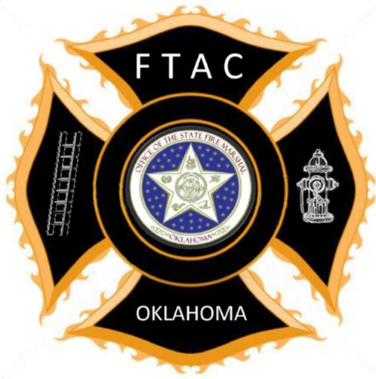

Firefighter Training Advisory Committee

Volunteer Firefighter Training Incentive Program

$300 Training Incentive | $600 Training Incentive
First Time Applicants:  - All volunteers applying for the 1st time in current Tax Year must file for the $300. First year applicants need 12 hours of eligible training completed in current Tax Year or any previous years.  - Repeat applicants for the $300 must:  - Have previously been approved for the $300. Have earned at least 6 hours of continuing education to- wards the completion of Support and Basic Firefighter, or an equivalent program by the end of the year. | Applicant must have been previously approved for the $600 training incentive.  - Applicant must have completed the Support and Basic Firefighter in the 5 Levels of Firefighter program, and equivalent, or higher program and have completed at least 6 hours of qualifying continuing education each year.  - Completion of Firefighter I in a previous year will be considered.

NOTE: All forms must be completed and approval by the Fire Chief before you can apply to the Oklahoma Tax Commission. After your Fire Chief approves your forms, Taxpayers who electronically file their income tax returns should mail the approved form attached to the Form 511EF to the Oklahoma Tax Commission. The Form 511EF is the signature document for an electronically filed return and without it the Firefighter Tax Credit form may not be matched with their income tax return. All other taxpayers should mail the
approved form with their tax return. The addresses are located on the tax form.
All applicants must be a member in good standing with the volunteer fire department on which he/she serves. The applicant must have had the opportunity to attend and participated in all annual training as required by federal and state authorities for Current Tax Year.
(The Fire Chief will verify any and all training information). Additional information about NIMS, IMT and ICS training courses may be found by visiting the following websites:

http://www.homelandsecurity.ok.gov/nims http://www.fema.gov/emergency/nims/

For additional information:
(website) www.ftac.ok.gov (phone) 405-522-5005 (Fax) 405-522-5028

Training Incentive Program Subjects
Structural Firefighting Program - 48 hours
Fire Behavior
Safety
Personal Protective Equipment
Search and Rescue
Ladders
Fire Hose, Appliances
Forcible Entry
Ventilation
Extinguishers
Overhaul
Water Supply
Pump Operations

Volunteer Firefighter Practices (VFFP) 3 Hour Courses
Firefighter Safety
Fire Behavior
PPE
SCBA
ERG
Fire Hose
Ladders
Tools and Equipment
Intro to Wildland Firefighting
Fire Department Organization

Tax Year
For purposes of the volunteer training incentive program, the following program and continuing education courses, or others, can be taken to receive the $300 credit. The volunteer firefighter must complete 12 hours the first year and
6 hours each year after until completion of Support and Basic Firefighter. Any questions regarding tax credit course equivalences contact the Firefighter Training Advisor Committee office, 405- 522-5015. OSU-FST credit and examination challenges should be directed to the Firefighter Coordinator at OSU-FST (800) 304-5727.
Wildland Firefighting
Wildland Fundamentals - 16 hours
Firefighter Safety
Fire Behavior
PPE
Red Card
Tools and Equipment
Strategies and Tactics
Water Supply
Wildland Scenario
Wildland Skills - 16 hours
Firefighter Safety
PPE
Tools and Equipment
Strategies and Tactics
Water Supply
Fire Control
Progressive Hose Lays

Basic Firefighter Skills (BFFS) - 4 Hour Courses
Fire Streams
Pumping Fundamentals
Search and Rescue
Ventilation
Fire Hydrants
Ropes and Knots
Extrication Safety
Water Supply
Forcible Entry
Ground Ladders
SCBA
Fire Hose
PPE
Emergency Scene Safety
Accountability
Tanker Safety
Drafting Fundamentals
Scene Size-up
Protecting Evidence for Fire Cause Determination
Loss Control

Training Incentive Program Subjects

Tax Year
For purposes of the volunteer training incentive program, the following programs/continuing education courses, or others, can be taken to receive the $600 credit. The volunteer firefighter must have completed Intermediate or Advanced
Firefighter or equivalent/higher program. In addition, the firefighter must complete at least 6 hours of continuing education each year until the firefighter completes Advanced Firefighter or its equivalent. Any questions regarding tax credit course equivalences contact the Firefighter Training Advisor Committee office at (405) 522-5005. For OSU-FST credit and examination challenges should be directed to the Firefighter Coordinator at OSU-FST (800) 304-5727.
Basic Fire Academy - Firefighter I
Firefighter Orientation
Fire Behavior
Firefighter Safety and Health
Building and Construction
PPE
Portable Extinguishers
Ropes and Knots
Rescue and Extrication
Forcible Entry
Ground Ladders
Ventilation
Water Supply
Fire Hose
Fire Streams
Fire Control
Fire Detection, Alarms, and Suppression Systems
Loss Control
Protection Evidence for Fire Cause Determination
Fire Department Communications
Fire Prevention and Public Education
Basic Pre-hospital Emergency Medical Care
Hazardous Materials Awareness
Hazardous Materials Operation
(Please note that the above list is not a complete list of Firefighter I courses.)

Continuing Education Training 4-16 Hour Courses
National Incident Management System (NIMS-any course)
Arson Detection for the First Responder
Backfiring Operations
Basics of Search and Rescue
Basics of Water Rescue
Calling the MAYDAY
Emergency Vehicle Driver Training
Extrication Fundamentals
Fire Tanker Safety Operations
Firefighter Survival & Rapid Intervention Crew Ops
Incident Safety Officer
ISO Fire Pumper Service Testing
ISO Fire Pump Service Testing Procedures
Advanced Fire Behavior Simulator
Pump Operations
Rapid Intervention Team (R.I.T)
Rope Rescue Fundamentals
Small Department Engine Company Tactics
Thermal Imaging Cameras-Basic
Training Records and Reports for Small
Departments Vent, Enter, Search
Water Shuttle
Wildland Aviation Operation
Wildland Firefighting: Fundamentals
Wildland Firefighting: Skills
Wildland Fire Origin Recognition
Wildland Foam Firefighting
EVDT
Public Fire Safety Education Course//Field Program
IMT or NIMS Courses
Wildland ICS Tool Box
Wilderness SAR Programs

Tax Year

Training Information Form

For training received while serving as a volunteer firefighter.

To accompany Oklahoma Volunteer Firefighter Tax Credit Form.
Firefighter Name: (please print) Department:

Fire Chief Signature:

Course Title | Hours | Year | Where Taken | Instructor Name
Important Note: This form documents training hours completed for purposes of calculating tax credits. Any questions regarding tax credit course equivalences contact the Firefighter Training Advisor Committee Office, (405) 522-5005. OSU- FST credit and examination challenges should be directed to the firefighter Coordinator at OSU-FST (800) 304-5727.

$300 Volunteer Firefighter Training Incentive
Member in good standing of a Volunteer Fire Department
Yes
No
12 hours of approved training Get in Good Standing

No

Yes
Attain 12 hours of approved training

Tax Form Complete with Chief’s Signature
No
Have Fire Chief sign tax form

Yes

Send Tax Form to Oklahoma Tax Commission. Retain a copy of the tax form along with Training Documentation for your records.

$300 Tax Credit

$600 Volunteer Firefighter Training Incentive
Must have previously received the $200 Volunteer Firefighter Training Incentive
Yes
No
Completed Support and Basic Training in the 5 levels Get in Good Standing
No
Attain Support and Basic Training in the 5 levels

Yes

Completed 6 hours of qualifying continuing education each year

Complete 6 hours of qualifying continuing education

Yes
No

Tax Form Complete with Chief’s Signature
No

Have Fire Chief Sign Tax Form

Yes

Send Tax Form to Oklahoma Tax Commission. Retain a copy of the tax form along with Training Documentation for your records.

$600 Tax Credit

