Effective July 1, 2024
CONTACT INFORMATION
Wrecker Services Administrative Office

Mailing Address: PO Box 53004 Physical Address: 3600 N Martin Luther King Ave.
Oklahoma City OK 73152 Oklahoma City, OK 73111

Telephone Number: 405-425-2312
Fax Number: 405-425-2031

Email: Wrecker@dps.ok.gov

WRECKER SERVICES ADMINISTRATIVE OFFICE CUSTOMER SERVICE REPRESENTATIVES
TERRITORY | TROOPS | CUSTOMER SERVICE REPRESENTATIVE | CONTACT NUMBER
I | A | Christie | 405-425-2295
II | B, C | Michael | 405-425-2311
III | D, E, F, L, | Mary | 405-425-2319
IV | G, H, I, J, K, M | Valarie | 405-425-2356

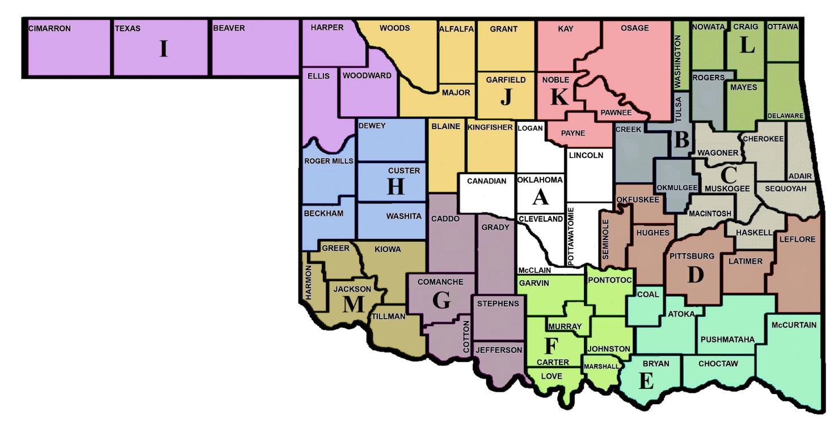

ADMINISTRATIVE TERRITORIES
Territory I |  | Territory II |  |  | Territory III |  | Territory IV
Troop A |  | Troop B |  |  | Troop D | Troop F | Troop G | Troop I | Troop K
Canadian |  | Creek |  |  | Hughes | Carter | Caddo | Beaver | Kay
Cleveland |  | Okmulgee |  |  | Latimer | Garvin | Comanche | Cimarron | Noble
Lincoln |  | Rogers |  |  | LeFlore | Johnston | Cotton | Ellis | Osage
Logan |  | Tulsa |  |  | Okfuskee | Love | Grady | Harper | Pawnee
McClain |  |  |  |  | Pittsburgh | Marshall | Jefferson | Texas | Payne
Oklahoma |  | Troop C |  |  | Seminole | Murray | Stephens | Woodward
Pottawatomie |  | Adair |  |  |  | Pontotoc |  |  | Troop M
 |  | Cherokee |  |  | Troop E |  | Troop H | Troop J | Greer
 |  | Haskell |  |  | Atoka | Troop L | Beckham | Blaine | Jackson
 |  | McIntosh |  |  | Bryan | Craig | Custer | Garfield | Kiowa
 |  | Muskogee |  |  | Choctaw | Delaware | Dewey | Grant | Tillman
 |  | Sequoyah |  |  | Coal | Mayes | Major | Kingfisher
 |  | Wagoner |  |  | McCurtain | Nowata | Washita | Major
 |  |  |  |  | Pushmataha | Ottawa |  | Woods
 |  |  |  |  |  | Washington
TURNPIKES
Territory I |  | Territory II |  |  | Territory III |  | Territory IV
H.E. Bailey (YC) MM103 - MM107 |  | Creek (XE) MM1 - MM34 |  |  | Indian Nation (XC) MM1 - MM83 |  | H.E. Bailey (YC) MM5 - MM30
H.E. Bailey Spur (YC) MM103A - MM107A |  | Indian Nation (XC) MM84 - MM104 |  |  | Chickasaw (YD) Murray Cnty |  | H.E. Bailey (YC) MM47 - MM102
Kilpatrick (YE) MM105 - MM135 |  | Turner (YB) MM183 - MM221 |  |  | Chickasaw (YD) Pontotoc Cnty |  | H.E. Bailey Spur (YC) MM100A - MM102A
Kickapoo (YF) MM130 - MM148 |  | Muskogee (XB) MM1 - MM55 |  |  | Cherokee (XD) MM1 - MM32 |  | Cimarron (YA) MM1 - MM59
Turner (YB) MM136 - MM182 |  | Will Rogers (XA) MM241 - MM264 |  |  | Will Rogers (XA) MM265 - MM329

