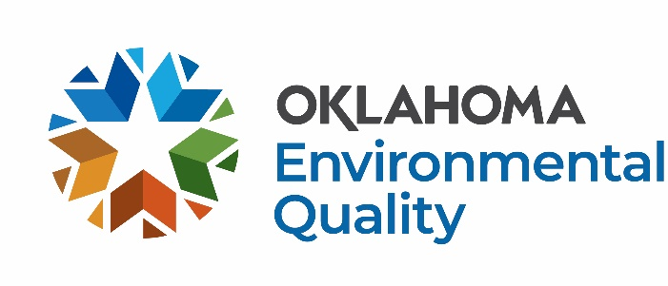

Collection Event Grant Application FY27

Collection event grants are for hosting the collection of household hazardous waste (HHW) and typically also include the collection of electronic waste (e-waste), tires, unwanted residential pharmaceuticals, and used medical sharps, scrap metal, and/or other difficult-to-manage waste streams. These grants are typically provided for one, or a series of, discrete collection events.

For more information and application deadlines, visit the DEQ website at: https://oklahoma.gov/deq/divisions/land-protection/sust-materials-management/funding-opportunities/funding-opportunities-for-communities.html
Basic Information:
- Funding is limited, grant money is not guaranteed.
- Grantees must enter into a formal Agreement with DEQ and register as a Payee at Oklahoma Supplier Portal.
- No funds are available until a fully executed Purchase Order and Contract is issued.
- Funds spent prior to the execution of the formal agreement are not reimbursable.
- All awarded funding must be spent in the fiscal year granted.
- Agreements expire June 30, 2027.
- Final invoices are due by August 31, 2027, invoices submitted after August 2027 may not be reimbursed.
- DEQ does not reimburse buildings, vehicles, laptops, or drones.
- DEQ will reimburse 80% of equipment costing $5,000-$50,000.
Process for Receiving Funds
- Application is submitted.
- The application is reviewed and scored through committee; additional information is requested as needed.
- Award notices are sent out.
- DEQ drafts the Agreement and sends it to the Awardee to sign and return.
- After signature is received, a copy of the executed Agreement and Purchase Order is sent to the Awardee.
- The Awardee may begin to spend funds intended for reimbursement.
- Funds spent prior to a fully executed Agreement and Purchase Order (between steps 1-5) are not reimbursable.
- The Awardee is required to submit monthly invoices, metrics, photos, and descriptions of each month’s work.
- DEQ reimburses invoices within 45 days.

Application Submittal Instructions
Return by e-mail to:

SWGrants@deq.ok.gov with the subject line,
“[Organization] FY27 [grant type] Grant Application DEQ”
e.g., Oklahoma County FY27 Professional Services Grant Application DEQ

Or send a hard copy to:

Oklahoma Department of Environmental Quality
ATTN: Libby McCaskill, Land Protection Division
P.O. Box 1677
Oklahoma City, OK 73101-1677

Application Information:
- Visit DEQ’s event guide to help plan your collection event Community Collection Event Guide.
- For all collection events, the Awardee must utilize vendors that are compliant with DEQ rules.
- For electronic waste (e-waste) collection events:
  - The Awardee shall use an R2 or e-Steward certified electronics recycler.
    - Find a Recycler - e-Stewards
    - Find An R2 Certified Facility - SERI - Sustainable Electronics Recycling International
  - Often, HHW collection services partner with a certified electronics recycler
- For pharmaceutical collection, the Awardee shall coordinate with the Oklahoma Bureau of Narcotics for coordination on pharmaceuticals.
  - Beau Ratke: (918) 446-1616: BRatke@Obn.ok.gov
- Used tires may be collected for recycling for free using DEQ’s Tire Program.
  - Kole Kennedy: (405) 702-5177: Kole.Kennedy@deq.ok.gov
- The Awardee shall ensure medical sharps are safely collected and properly disposed.
  - This can be done through coordination with the HHW collection vendor and a regulated medical waste disposal facility. Sharps collection may also be arranged directly through appropriate vendors.
  - For a list of sharps disposal vendors that service Oklahoma, see Figure 5 on page 26 of the Oklahoma Meds and Sharps Disposal Committee’s (OMSDC) “Building a Municipal Program for Home-Generated Medical Sharps” guide. You can find the guide on the OMSDC website: Safe Disposal of Pharmaceuticals and Medical Sharps in Oklahoma (oksafemeddisposal.org)-
- After each collection event, the contractor shall provide an invoice including a description of the event, photos, and the types and amounts of waste collected.
- Oklahoma Clean Community Program
If you collect tires at a collection event, you may be eligible to become an Oklahoma Clean Community. For more information, e-mail okcleancommunity@deq.ok.gov, or click here for the application Clean Communities Application.

Collection Event Grant Application FY27

The following information must be provided before a contract for reimbursement is considered. Scoring will be based on the following categories: types of materials being collected, environmental improvement, feasibility, collaboration, scope of work, budget, quality of proposal, and past performance, if applicable. This form has been prepared to be applicable to a wide range of projects and as a result some of the questions may not seem directly applicable to what you propose. Please answer the questions to the best of your ability based on the information you have.

Date:

1. Applicant Name:

2. Dollar Amount Requested:

3. Contact Information:
Name/Title:
Phone Number:
E-mail Address:

4. Signatory Authority for Organization with Legal Authority to Sign Contract with DEQ:
Name/Title:
Phone Number:
E-mail Address:

5. Physical Address:
Reimbursements will go to this address*:
*The address provided here must be registered with the State in the Oklahoma Supplier Portal.

6. Attach a detailed scope of work and detailed budget for the project.

7. Project Description:

- What type of solid waste will be collected: HHW, electronic waste, medical pharmaceuticals, medical sharps, tires, scrap metal, green waste, others?
- When do you anticipate holding the event(s)? Please provide an estimated time of year, or specific date.
- Describe your plans for advertising the event(s).
- Who will be served by the program (municipalities, counties, regions, estimated population)?
- What is the total cost of the program?
- Are you partnering with anyone else to implement this program? If so, describe.
- Have you received a previous grant from DEQ? If yes, what year(s), what dollar amount(s) of funding was provided, and how much of that funding did you spend?
- Do you host collection events regularly? Provide details (annually/bi-annually, time of year, name of event, items collected, participating communities, partnerships, etc.).
- Is there any other information that you would like to share?
- How did you hear about DEQ’s Solid Waste Management Grant Program?

