AGENDA
DEPARTMENT OF ENVIRONMENTAL QUALITY
SOLID WASTE MANAGEMENT ADVISORY COUNCIL

A PUBLIC MEETING

January 8, 2026, at 10:00 AM
Oklahoma Department of Environmental Quality
707 N. Robinson
1st Floor, Multi-Purpose Room
Oklahoma City, Oklahoma

To conserve resources, no hard copies of public documents associated with this council agenda were copied for distribution at this meeting. Documents, including copies of proposed rules, are accessible electronically by following the QR code below.
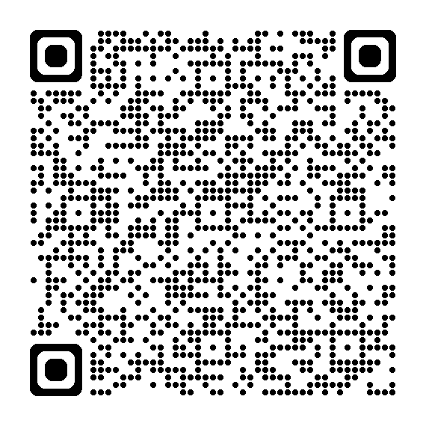
1. Call to Order – Jim Linn, Chairman

2. Roll Call – Quiana Fields

3. Approval of the Minutes for the September 11, 2025, Solid Waste Management Advisory Council Meeting. Roll Call Vote by the Council.

4. Director’s Report

5. Used Tire Recycling Program Report
Presentation by Used Tire Recycling staff summarizing their report to the Governor and Legislature detailing the administration of the Oklahoma Used Tire Recycling Act and its effectiveness in bringing about the cleanup of existing used tire dumps and in preventing the development of new dumps as required by Oklahoma Statute 27A-2-11-401.6

I. Presentation–Emily Pilgrim, DEQ
II. Questions and discussion by Council
III. Questions and discussion by Public

6. NORM Workgroup Summary
Presentation summarizing results of workgroup meetings to review solid waste regulations, pertaining to disposal of Naturally Occurring Radioactive Material (NORM) in Subtitle-D permitted landfills.

I. Presentation–Linzi Bhatta, DEQ
II. Questions and discussion by Council
III. Questions and discussion by Public

7. Closure and Post-closure 5-year Review
Consideration of the formation of a workgroup to participate in the five-year update of unit cost worksheets for estimating closure and post-closure financial assurance required by OAC 252:515-27-4(a).

I. Presentation –Patrick Riley, DEQ
II. Questions and discussion by Council
III. Questions and discussion by Public
IV. Roll Call Vote by Council regarding workgroup formation

8. Public Forum – Open Discussion

9. New Business
Limited to any matter not known or which could not have been reasonably foreseen prior to the time of posting the agenda (24 hours prior to the meeting).

10. Adjournment
The next regularly scheduled meeting of the Solid Waste Management Advisory Council is April 16, 2026, 10:00 am at DEQ, 1st Floor, Multi-Purpose Room, Oklahoma City, Oklahoma.

If you have a disability and need accommodation, please notify the DEQ three days in advance at (405) 702-5213. For hearing impaired, the TDD Relay Number is 1-800-722-0353. Current and proposed rules are available at the Land Protection Division office located at 707 N. Robinson, Oklahoma City, and available through the DEQ website at: www.deq.ok.gov.

