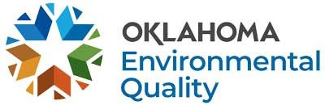
STATE ENVIRONMENTAL LABORATORY SERVICES DIVISION FIELD PROGRAM LABORATORY ACCREDITATION FEES
July 2026 – June 2027
Oklahoma Administrative Code 252:302
Adjusted to correspond with Consumer Price Index of 1.027.
*The annual assessment fee will be invoiced along with the annual renewal application fee.
Payment Type Notes:
•
Credit or debit card transactions will be responsible for the additional charges:
- Merchant fee of 2.25% of the amount paid.
- Portal fee of $2.00 per transaction.
Electronic check/ACH transactions will incur a merchant fee of $1.00 per transaction.
•
All payment information should be sent directly to ARHelpDesk@deq.ok.gov for processing.
All questions regarding transaction fees or payment options should be directed to ARHelpDesk@deq.ok.gov or (405) 702-1130.
Initial Application Fee: $502.00
Interim Application Fee: $287.00
Renewal Application Fee: $502.00
Amendment Fee: $101.00
Assessment Fee – Initial/Interim: $1,100.00
Assessment Fee – Annual*: $551.00

