The Weekly Wiggle

“Pocket Hugs” (or Comfort Scent Hearts)

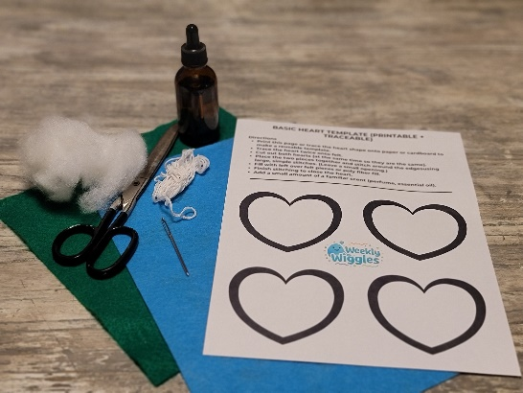

What It Supports / Who It Helps:
This simple craft supports children who experience separation anxiety, school transitions, or emotional dysregulation throughout the day.

“Pocket Hugs” provide a tangible reminder of connection and safety, helping children self-soothe using both touch (soft texture) and smell (comfort scent).
This activity is especially helpful for:
- Children starting school or daycare
- Children with anxiety or separation challenges
- Children with sensory needs
- Any child who benefits from a physical reminder of comfort

Why Meske Recommends It:
This is more than a craft—it’s a connection tool. It gives children:
- a sense of control
- a physical reminder of safety
- a simple, portable coping strategy
It also helps caregivers:
- ease transitions without long goodbyes
- support emotional regulation in a quiet, respectful way
Sometimes the smallest things, like a soft heart in a pocket, can make the biggest difference in a child’s day.

MATERIALS NEEDED:
- Felt sheets (any color)
- Scrap felt or fiber fill
- Scissors
- Large eyed Needle
- Yarn or embroidery floss (or fabric glue as an alternative)
- Fragrance oil, essential oil, or familiar perfume/cologne
- Small baggie (optional for storage)

HOW TO MAKE IT:
- Cut two pocket-sized heart shapes out of felt.
- Place the two pieces together.
- Begin stitching around the edges using large, simple stitches (this is great for beginner sewing skills).
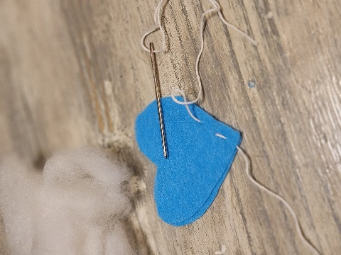
- Leave a small opening.
- Fill the heart with scrap felt or stuffing to make it soft and slightly puffy.
- Finish stitching to close the heart completely.
- Lightly apply fragrance (a drop of oil or a spray of a familiar scent).
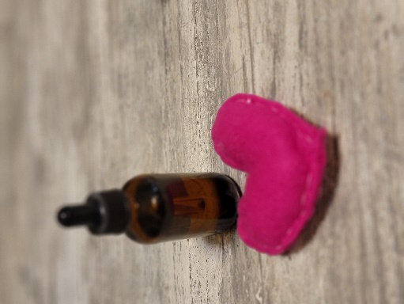
- Let it dry if needed, then place in a small bag until ready to use.

HOW TO USE IT:
Before school, a special trip or a transition, give the heart a meaning:
- Tell your child:
“This is a pocket hug. Whenever you miss me, you can hold it and remember I’m still with you.”
- Place it in their pocket, backpack, or desk.
- Encourage them to:
  - squeeze it
  - smell it
  - hold it when they feel overwhelmed
This gives them a private, safe way to regulate without needing adult intervention every time.

ACCESSIBILITY NOTES:
- For children with fine motor challenges: use fabric glue instead of sewing
- For sensory sensitivities:
  - use unscented or very mild scents
  - allow the child to choose the texture and smell
- For younger children: pre-cut shapes and assist with assembly
- For children who mouth objects: supervise use and avoid small loose materials

