The Weekly Wiggle
The Weekly Wiggle is a sensory series by Meske Owens, offering simple, low-cost tools that support connection, regulation, and participation. Shaped by her lived experience and her work supporting families and communities across Oklahoma, the series shares adaptable activities that help build calm and confidence for people of all ages.

The Textured Pathway

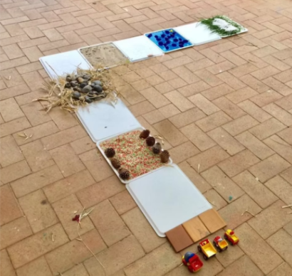

What It Supports / Who It Helps:
A texture pathway supports sensory integration, regulation, and participation by offering structured tactile input through different surfaces. It can be especially helpful for:
- Kids who seek tactile input or benefit from “hands-on/feet-on” sensory experiences
- Kids who get overwhelmed by sensory input and need an organized way to engage their senses
- Kids who need support with balance, coordination, and body awareness (gross motor skills)
- Students who need a quick reset between activities to improve focus and attention

Materials Needed:
Use what you have. Options include:
- Cardboard or a plastic tablecloth (base)
- Textured mats (doormats)
- Bubble wrap (crinkly, bumpy texture)
- Sandpaper (various grits for a gritty, changing surface)
- Sponges or foam pieces (soft, squishy texture)
- Artificial grass or turf (grassy feel)
- Smooth stones or pebbles (cool, uneven surface)
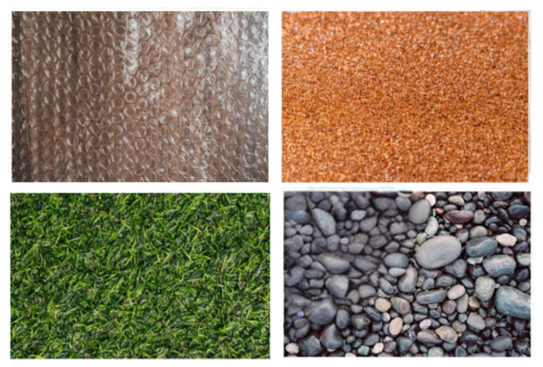
- Fabric swatches (velvet, felt, fleece)
- Plastic bottle caps or lids (bumpy, stimulating step)
- Velcro strips (rough, prickly texture)
- Tape or glue
- Scissors

How to Make It
- Create your base using cardboard squares or a plastic tablecloth.
- Lay out your texture pieces along the base, alternating between rough, hard, soft, and smooth surfaces.
- Secure each texture with tape or glue—either on individual cardboard pieces or directly on the tablecloth. (I like using cardboard for materials like sandpaper, bubble wrap, foam, and felt, but you can set it up in whatever way works best for your child.)
How to Use It:
- Set the pathway on a flat surface
- Invite the child to move step-by-step across each section, noticing how it feels (barefoot or with socks—whatever is most comfortable).
- Keep it short and predictable: 1–2 passes is usually enough for a reset.
- Use it during transitions (before schoolwork, after recess, before bedtime) or when you see signs of overwhelm.
Accessibility Notes:
Adjust intensity: Start with softer options (sponges/foam, fleece, felt) and add stronger textures (Velcro, sandpaper, bottle caps) gradually.
Offer multiple ways to participate:
- Standing walk (feet)
- Seated exploration (hands)
- One-step-at-a-time support with an adult for balance
Use socks or shoes if needed: Great for kids who want input but find certain textures too intense on bare skin.
Customize the route: Shorten it, widen it, or space sections out depending on mobility and comfort.
Choice and control: Let the child choose the order, repeat preferred sections, or remove “nope” textures (that control is often the regulating part).
Sensory preferences: If a child is tactile-avoidant, keep textures predictable and limit scratchy materials at first. If they seek input, add more bumpy/uneven sections (doormat, bubble wrap, caps).
Why I Recommend It:
- A texture pathway is a low-cost, flexible way to give the nervous system clear, organized sensory feedback. It can support regulation during overwhelm, build body awareness and coordination through safe movement, and provide a quick reset that helps kids return to learning, routines, and transitions with more focus and confidence.

Safety Notes / Adult Guidance
- Secure everything: Tape or glue edges flat so nothing lifts, slides, or curls (especially bubble wrap, fabric, and turf).
- Avoid choking hazards: Bottle caps/lids and small pebbles should be firmly attached and used with close supervision—skip them for toddlers or anyone who mouths objects.
- Watch skin sensitivity: Sandpaper, Velcro, and rough doormats can irritate—offer socks/shoes and keep exposure brief.
- Keep surfaces clean and dry: Wipe down materials regularly and replace anything that tears, sheds, or becomes sticky.
- Prevent falls: Place the pathway away from stairs, use it on non-slip flooring, and supervise kids who have balance needs.
- Check for sharp edges: Smooth stones/pebbles should be rounded; avoid anything sharp, cracked, or splintered.

