The Weekly Wiggle #3: RAINBOW CLOUD DOUGH (Or No-Cook Sensory Dough)
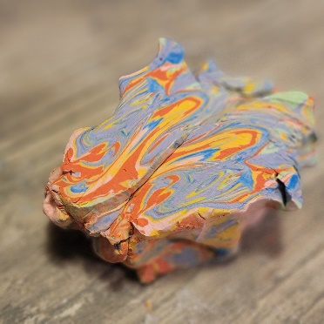
WHAT IT SUPPORTS / WHO IT HELPS: Rainbow cloud dough supports sensory regulation, fine motor development, and creative play. It’s especially helpful for children who benefit from hands-on, calming input and for those who need a safe way to explore texture without overwhelming stimulation.
MATERIALS NEEDED:
- Cornstarch
- Shaving cream foam (NOT gel)
- Food coloring (optional)
- Mixing bowl
- Spatula for mixing
- Gloves
- Airtight container for storage

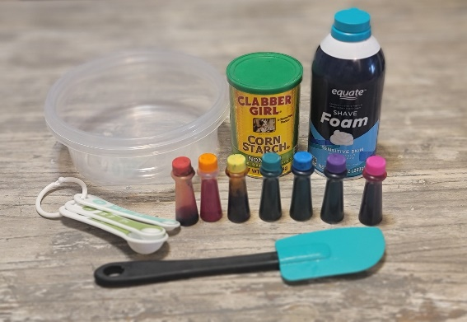

HOW TO MAKE IT:
- Shake the can of shaving foam and spray into the bowl (enough to cover the bottom)
- Add 3 1/2 Tablespoons of cornstarch and slowly mix with a spatula.
- Make sure to scrape the bottom and sides of the bowl while mixing and continue to add cornstarch a sprinkle at a time until the shaving foam loses its “fluff” which will happen suddenly.
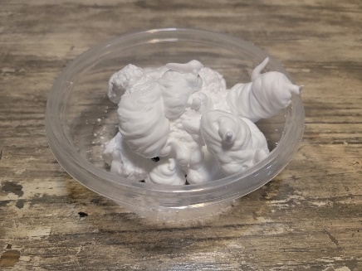
- Then cover your hands in cornstarch and begin kneading the dough in your hands, adding small amounts of cornstarch if it starts to stick to you. When it no longer sticks to your hands, continue kneading for 1 more minute.
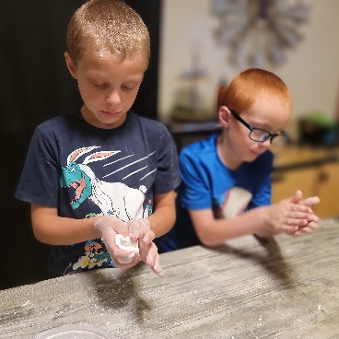
- When the dough is not sticky, not crumbly AND you can pull it apart and it doesn’t break apart…. it’s ready!
- Separate into equal sized balls- one for each color.
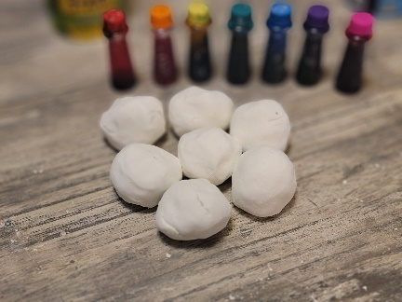
- Put on your gloves and add 3-4 drops of food coloring and knead in your hands until the color is almost mixed in completely.
- (repeat for each color)
- Roll into long “worms” and lay them side by side.
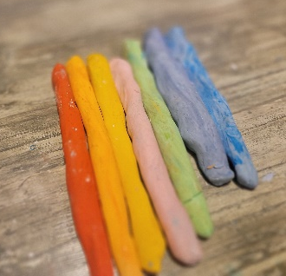
- Push them together and then fold the “worms” in half to combine into one ball.
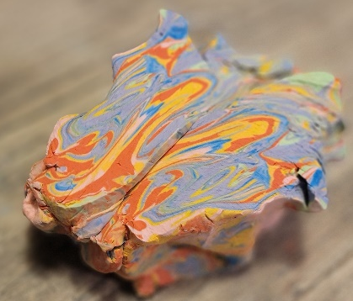
HOW TO USE IT:
- Squeeze and mold into shapes
- Hide small toys inside for a sensory “search and find”
- Create simple builds, patterns, or pretend play scenes
- Use with sand molds
ACCESSIBILITY NOTES:
- Use unscented shaving cream for children sensitive to smell.
- Adjust texture as needed:
- Too crumbly → add a small amount of shaving cream
- Too sticky → add a small amount of cornstarch
- For children with low dexterity, keep the dough slightly softer
WHY MESKE RECOMMENDS IT:
This is one of those activities that looks simple but it checks a lot of boxes.
- It provides calming sensory input, encourages creativity, and gives kids something they can control and manipulate safely.
- It also allows for easy adjustment, which matters, because sensory needs are not one-size-fits-all.
- And realistically? It’s low-cost, quick to make, and easy to reset when life gets chaotic.
STORAGE TIP:
Store in an airtight container or sealed bag to prevent drying. If it dries out, add a small amount of shaving cream and knead to restore texture.
SAFETY NOTES / ADULT GUIDANCE:
- This activity is not taste-safe. While small accidental exposure to shaving cream is typically not harmful, it is not intended for consumption.
- Close supervision is recommended, especially for younger children or those who may mouth materials.
- Use non-gel, basic shaving cream Avoid use with children who have known skin sensitivities or
- allergies to fragranced products.
- Keep away from eyes. If contact occurs, rinse thoroughly with water.
- Discontinue use if skin irritation occurs.
- Not recommended for children who are likely to intentionally ingest sensory materials — consider a taste-safe alternative in those cases

