The Weekly Wiggle: Sensory Bins!

Sensory Play Without the Pressure:

Sensory Bins Made Simple

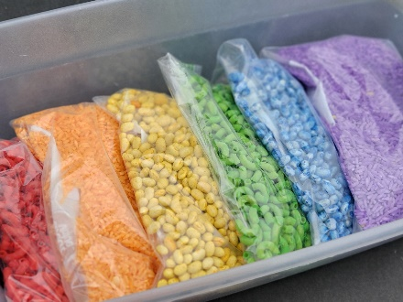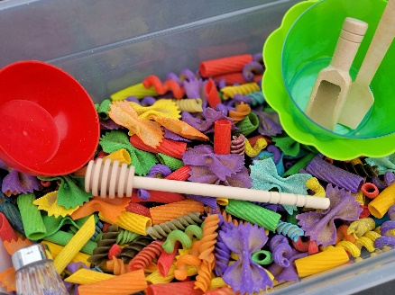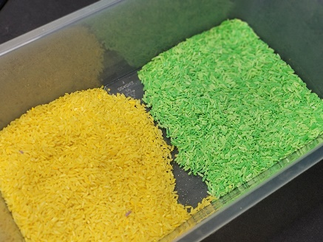

Before We Begin… A Quick Truth About Sensory Play. If I’m being honest, sensory bins used to intimidate me. I would see beautiful setups online filled with expensive fillers, themed toys, and perfectly organized materials and think: "That looks amazing… but mine wouldn’t ever look like that." I believed sensory play had to look a certain way to be helpful.

But over time, I learned something important: Sensory play does not need to be fancy to be effective. In fact, some of the most meaningful sensory experiences happen with the simplest materials: A bowl of water, Dry pasta, Scoops and measuring cups, A container of rice on the porch. What matters most is not what fills the bin, what matters most is the connection happening around it.
Sensory play becomes powerful when it creates opportunities for:
- shared attention
- conversation
- co-regulation
- laughter
- quiet presence
- trust
- relationship-building
And that connection doesn’t only happen between parents and children.
It can happen between:
- teachers and students
- therapists and clients
- daycare providers and children
- grandparents and grandchildren
- older adults sharing time, stories, and wisdom with younger generations

The truth is: Sensory play often helps both people involved.
For children, it offers regulation, exploration, and learning.
For adults, it creates space to slow down, engage, and reconnect.
This week’s Weekly Wiggle is about taking the pressure out of sensory play and bringing it back to what matters most:

“Connection Over Perfection”

Why Meske Recommends Sensory Bins:
Sensory play does not need to be perfect to be meaningful.
Children rarely remember whether the rice was rainbow-colored or if the setup looked Pinterest-worthy. They remember:
- who sat with them
- who laughed with them
- who slowed down enough to join them

Sensory bins are not about creating a perfect activity.
They are about creating moments of connection.
And sometimes, connection is the most regulating tool of all.

Sensory Bins Helps/Supports: Sensory bins give children a safe and engaging way to explore textures, build fine motor skills, regulate emotions, and participate in play without pressure. They can support:
- sensory exploration
- calming and regulation
- fine motor development
- language development
- imaginative play
- social interaction
- attention and focus

Sensory bins can help:
- children with sensory needs
- children who seek movement or touch
- children who need calming activities
- children learning through hands-on play
- mixed-age groups and shared family experiences

Materials Needed:
You only need a few things:

A Container! This can be:
- plastic storage bin
- baking tray
- dish tub
- shoebox container
- large bowl
- water table
- outdoor bucket or tote

- Sensory Fillers! Simple filler ideas include:

Dry Fillers:
- dry rice
- colored rice
- dry beans
- colored beans
- pasta
- colored pasta
- oats
- birdseed
- pom-poms
- shredded paper
- cotton balls
- kinetic sand

Water Fillers
- plain water
- warm water
- bubbles
- floating toys
- cups and funnels
- ice cubes
- flower petals
- leaves or rocks

Now just add some tools to your bins:
- measuring cups
- scoops
- spoons
- funnels
- tongs
- muffin tins
- toy animals
- small containers
- toy cars
- plastic letters or numbers

How to Set Up your bins:
- Choose a container.
- Add one filler.
- Add a few tools for scooping, sorting, pouring, or pretend play.
- Place a towel underneath if needed.
- Invite the child to explore.
That’s it. You do not need themes, expensive supplies, or complicated setups.

How to Use your sensor bins:
Sensory bins can be used for:
- calm-down time
- transition support
- independent play
- shared play between child and adult
- outdoor exploration
- quiet time activities
- classroom stations
- therapy sessions

Encourage children to:
- scoop and pour
- bury and find objects
- sort colors or textures
- pretend and imagine
- describe what they feel

Sometimes the best sensory play happens when adults simply sit beside a child and join in.

Accessibility Notes:
- Offer tools for children who dislike touching textures directly.
- Start with one texture at a time for children who become overwhelmed.
- Use larger fillers for children who mouth items.
- Consider scent-free options for children sensitive to smells.
- Water bins can be a great alternative for children who dislike dry textures.
- Position bins at accessible heights for wheelchair users or children with mobility needs.

Next up for the Weekly Wiggle: Meske will explore outdoor sensory play and simple ways to turn spring and summer materials into meaningful sensory experiences.

