2026 JUSTICE ASSISTANCE GRANT
LOCAL LAW ENFORCEMENT (JAG-LLE) PROGRAM
Notice of FUNDING OPPORTUNITY

Applicants who wish to apply for equipment under the Justice Assistance Grant – Local Law Enforcement (JAG-LLE) Program need to read the ENTIRE document.

AVAILABILITY OF FUNDS
The District Attorneys Council, in conjunction with the Justice Assistance Grant Board, announces approximately $500,000 is available for eligible local law enforcement jurisdictions to apply for funding. The maximum award amount is $10,000.00.

ELIGIBLE APPLICANTS

To apply for a JAG-LLE award through the District Attorneys Council, a jurisdiction must: 1) be ineligible for a direct JAG grant with the Bureau of Justice Assistance (BJA), and 2) must report Uniform Crime Reporting (UCR) information. Oklahoma State Statute # 74 O.S. Chapter 5 § 150.10 requires all state, county, city and town law enforcement agencies to submit crime reports to the Oklahoma State Bureau of Investigation. To review this statue, go to: http://www.oscn.net/applications/oscn/DeliverDocument.asp?CiteID=101436.

For more information on reporting UCR information, contact the OSBI Field Services at 405-878-2533.

If a jurisdiction is ineligible to apply directly to BJA, and is reporting UCR information, that jurisdiction is eligible to apply for a JAG-LLE award through the District Attorneys Council.

Police departments and sheriffs’ offices must apply through their county commission or city council. Private/nonprofit organizations, campus security departments, jails, and state agencies are NOT eligible to apply for this funding.

BOARD PRIORITIES
The JAG Board, comprised of 13 voting and non-voting members, is charged with determining priorities for funding, reviewing grant proposals, and determining awards for the grant funds. The Board has limited applications to procuring equipment approved by the Department of Justice. The maximum award amount is $10,000.

Approved equipment includes, but is not limited to:
Camera/Surveillance Equipment In-Car Cameras
Body Worn cameras
Surveillance Equipment
Undercover Equipment
Computer Equipment Mobile Data Terminals
Other Computers (desktops, laptops, tablets)
Wireless Access Equipment (aircards)
Duty Equipment Soft Body Armor
Clothing/Uniforms
Duty Belts and Non-Weapon Duty Equipment i.e. Flashlights
Portable Radios and Accessories
Technology Mobile Fingerprint ID Equipment
Breath Testing Equipment
Electronic Ticketing Equipment
Offender Tracking Equipment
Radar Guns
Cell Site Simulators i.e. StingRay
Medical Emergency Medical Supplies (EMS)
First-Aid Kits
Vehicles Marked Patrol Vehicles (not undercover vehicles)

Equipment not allowed includes, but not limited to:
Aircraft
Armored Vehicles of Any Sort
Command and Control Vehicles of Any Sort
Explosives and Pyrotechnics
Breeching Apparatus
Riot Batons, Riot Helmets, and Riot Shields

The following items have additional requirements for approval.

- Body Worn Cameras* (see additional requirements below)
- In-Car Mobile Data Systems (Laptop or Tablet)** (see additional requirements below)
- Radios – In Car and Hand Held/Portable*** (see additional requirements below)
- Vehicles – Up to a max of $10,000**** (see additional requirements below)
- Ballistic-resistant officer protection equipment, limited to daily wear ballistic vests***** (see additional requirements below)

Equipment can only be awarded for full-time Law Officers.

Priority may be given to those who have not received significant funding in the past five years from this grant program.

*REQUESTS FOR BODY WORN CAMERAS
According the Bureau of Justice Assistance (BJA), law enforcement agencies across the country have begun equipping their officers with body-worn cameras (BWCs) over the past several years. The important benefits of BWCs and the challenges in implementing BWC programs are highlighted in the BJA Body Worn Camera Toolkit.

The BJA https://bja.ojp.gov/program/bwc provides model BWC policies, resources, and best practices to assist departments in implementing BWC programs.

Applicants using JAG funds to purchase BWC equipment or to implement or enhance BWC programs must certify that they have policies and procedures in place related to equipment usage, data storage, privacy, victims, access, disclosure, training, etc. Officers, prosecutors, defenders, victims and privacy advocates, and community groups should be consulted early in the BWC policy development process to guide and inform policy and procurement decisions. The body-worn camera policy certification must be attached to the submitted application.

**REQUESTS FOR IN-CAR MOBILE DATA TERMINAL SYSTEMS
Requests for in-car mobile data terminal systems (MDTs) should include a quote designating the mobile data system, mounting hardware, docking station, mode of IP connectivity, and computer that ensures that the equipment is designed for use in a vehicle to withstand use in a harsh environment. Requests must specify a semi-ruggedized or ruggedized laptop or tablet.

In order to receive this funding, the applicant must specify the software system (such as MobileCop) which allows law enforcement agencies to access vehicle tag and driver’s license files and allows for seamless messaging between individual law enforcement officers across the state, integration of law enforcement records including mugshot photos, and tools utilized by law enforcement officers in a mobile environment.

If you need information on MobileCop or for system access for an in-car laptop computer, contact Capt. David Baisden at 405-615-0242 or via email at sodavbai@oklahomacounty.org for information and guidance with your application.

***REQUESTS FOR IN-CAR RADIOS and HANDHELD PORTABLE RADIOS
For agencies located within the Oklahoma Wireless Information Network (OKWIN) coverage area, all requests made to the Board by law enforcement agencies for radio communication equipment must be consistent and compatible with the OKWIN 800 MHz Trunked Radio System (see the coverage map below).

To determine if a jurisdiction is in the 800 MHz Trunked Radio Communication System coverage area, or for more information, visit: https://www.ok.gov/okwin.

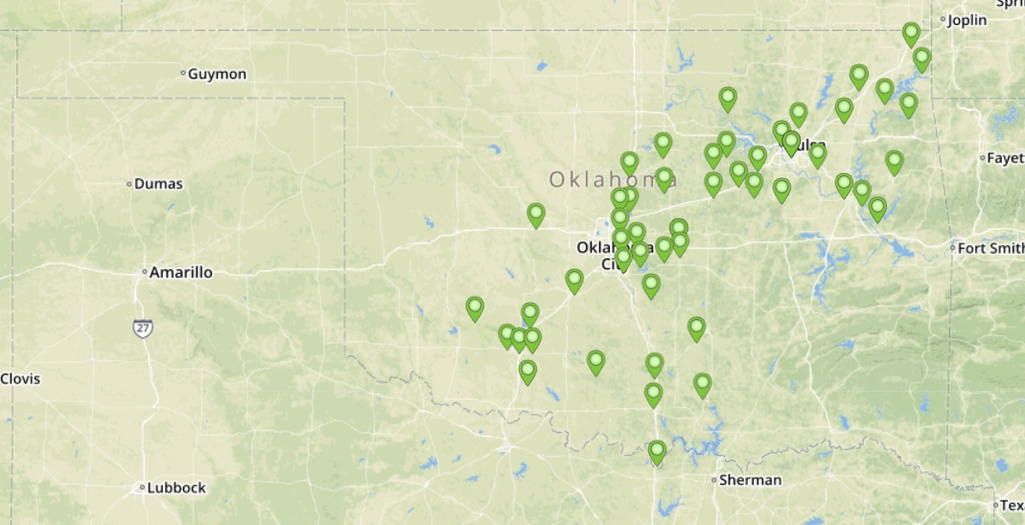

****REQUESTS FOR VEHICLES
The JAG Board approved funding for the purchase of marked patrol vehicles only. Other equipment for a vehicle, such as light bars, etc., may not be requested. Agencies requesting vehicles that cost over the $10,000 maximum limit of this grant, must state in the narrative that the agency agrees to providing the balance of the cost of the vehicle as well as what funds will be used to pay for the remaining cost of the vehicle. Undercover or unmarked patrol vehicles are prohibited. If purchased unmarked, it must be marked at the earliest possible opportunity.

*****REQUESTS FOR BALLISTIC-RESISTANT OFFICER PROTECTION EQUIPMENT
The JAG Board approved funding for ballistic-resistant officer protection equipment. This is limited to daily wear ballistic vests only. Any ballistic equipment purchased with JAG funds may be purchased at any threat level, make, or model from any distributor or manufacturer, as long as the vests have been tested and found to comply with the latest applicable National Institute of Justice (NIJ) ballistic or stab standards. Law enforcement agencies receiving ballistic-resistant and stab-resistant body armor must have a written “mandatory wear” policy in effect. In addition, body armor purchased must be American made. Information on the NIJ standards can be found at:
https://www.nij.gov/topics/technology/body-armor/Pages/welcome.aspx.

Body armor purchased with JAG funds must be “uniquely fitted vests,” which means protective (ballistic or stab-resistant) armor vests that conform to the individual wearer to provide the best possible fit and coverage, through a combination of: (1) correctly sized panels and carrier, determined through appropriate measurement and (2) properly adjusted straps, harnesses, fasteners, flaps, or other adjustable features. The requirement that body armor be "uniquely fitted" does not necessarily require body armor that is individually manufactured based on the measurements of an individual wearer.

MATCH REQUIREMENT

There is no match requirement for this grant.

REIMBURSEMENT OF FUNDS
In order to receive the funds, the subgrantee must order and pay for all approved equipment and submit all required close-out documents prior to receiving payment. Upon receipt and approval of the close-out documents, reimbursement will be forwarded to the subgrantee in approximately one month.

PERSONNEL REQUIREMENTS
The Oklahoma State Auditor and Inspector’s Office and the federal granting agency requires that there be sufficient internal controls within the applicant agency to reduce the risk for mismanagement, error, and/or fraud. No one person should control all aspects of procuring and payment of the requested equipment.

The Agency Administrator/Project Director is the contact person for all project activities and is responsible for meeting the goals and objectives of the award. The Financial Officer/Fiscal Officer is responsible for reporting the financial activity related to the award. The Agency Administrator/Project Director and Financial Officer/Fiscal Officer may NOT be the same person or have full corresponding access in OGX.

The Authorized Official/Chief Executive Officer is the person with official signature authority to make financial and programmatic commitments on behalf of the applicant agency. The Authorized Official/Chief Executive Officer must be the mayor, city manager, chairperson of the County Commission, or an authorized tribal leader.

AWARD PERIOD

The award period for this grant is January 1, 2027, to June 30, 2027.

TO APPLY
The Federal Grants Division uses a web-based Grants Management System, Oklahoma Grant Exchange (OGX), to manage this grant. Applications must be completed and submitted online. The entirety of the grant will be conducted through OGX. The website address is: https://ogx.ok.gov/

The application process will be available beginning on September 18, 2026, and must be completed and submitted through OGX by 11:59 p.m., by November 2, 2026.

TRAINING FOR APPLICANTS ON THE OGX SYSTEM
DAC will provide web-based training for potential applicants. Attendance is not mandatory but encouraged if you are new to OGX and this award.

OGX Application Training Webinar Dates - please register PRIOR to the meeting date.

-September 30, 2026 @ 10:00 a.m.
GoToWebinar: https://event.gotowebinar.com/event/2a4c58f8-c267-48a1-890f-25d738c44259

For those awarded a JAG-LLE grant, award document and reimbursement training will be held online: date and time to be determined.

DEADLINE FOR SUBMISSION OF AN APPLICATION
The deadline to submit the application is 11:59 p.m., November 2, 2026. The OGX online system will not allow an application to be submitted after this date and time. Proposals received via mail, hand delivery, fax machine, or flash drive will not be reviewed.

AWARD DECISION
The JAG Board will meet on November 12th 2026, to make funding decisions for the 2026 JAG-LLE applications. There will be an option for a 5-minute presentation. This is optional and will not impact the award decision. Decisions will be posted on the DAC website, https://www.ok.gov/dac/ by the following business day.

ADDITIONAL INFORMATION
For further information contact Sara Gnau, Grant Programs Specialist, at 405-264-5008, or via email at sara.gnau@dac.ok.gov

