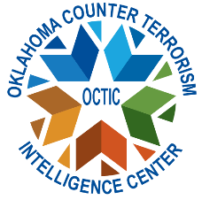

Class: Threat Liaison Officer (TLO) course
Location: 1 C Tree Road, McAlester, Oklahoma 74501
Building #36, Armed Forces Reserve Center
Parking: Building is North of C tree road and before the gate of the Installation and will not require entry to MCAAP. Building is accessed through an electronic gate. Parking is opposite the building.

Dates: Tuesday, October 14th, 2025. 9:00 AM start time.
Course length: 8 hours
Target audience: A TLO is any peace officer, firefighter, state investigator, federal agent, military investigator or security services, or anyone working closely within the public safety/homeland security community. If applicable, 8 hours of CLEET credit awarded.
Description: The Basic TLO Certification Course will train individuals in suspicious activity reporting, intelligence collection requirements, and provide a basic understanding of threats nationwide and current threat patterns to Oklahoma. During the TLO course, the students receive an overview of the program and core capabilities of certified TLOs. The capabilities introduced throughout the class are Suspicious Activity Report (SAR), Special Even Threat Assessments, Behavioral Threat Assessment Program, Criminal Analysts Roles, Role of the Fusion Center.
Costs: Course is provided free by OCTIC. For further information, contact Fusion@dps.ok.gov. Additional questions, email Radeana.rumpl@dps.ok.gov

