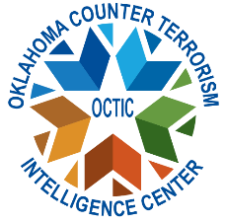

Class: Threat Liaison Officer (TLO) course
Location: Enid Police Department Training Center
401 W. State Ave, Enid, OK 73701
Parking: Students need to park in the lot on the east side of the training center. Main Entrance is on the northeast corner of the building.
Dates: Tuesday, August 12th, 2025. 8:30 AM start time.
Course length: 8 hours
Target audience: A TLO is any peace officer, firefighter, state investigator, federal agent, military investigator or security services, or anyone working closely within the public safety/homeland security community. If applicable, 8 hours of CLEET credit awarded.
Description: The Basic TLO Certification Course will train individuals in suspicious activity reporting, intelligence collection requirements, and provide a basic understanding of threats nationwide and current threat patterns to Oklahoma. During the TLO course, the students receive an overview of the program and core capabilities of certified TLOs. The capabilities introduced throughout the class are Suspicious Activity Report (SAR), Special Even Threat Assessments, Behavioral Threat Assessment Program, Criminal Analysts Roles, Role of the Fusion Center.
Costs: Course is provided free by OCTIC. For further information, contact Fusion@dps.ok.gov. Additional questions, email Radeana.rumpl@dps.ok.gov

