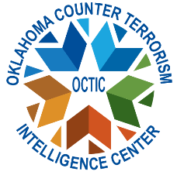

Class: Threat Liaison Officer (TLO) course
Location: High Plains Technology Center
3921 34th Street Woodward, OK, 73801

Parking can be found in the front of the building in the south lots, and students must enter and check in with the receptionist.
Classroom: Harper Meeting Room

Dates: Monday, March 23rd, 2026. Start time 08:30 AM
Course length: 8 hours
Target audience: A TLO is any peace officer, firefighter, state investigator, federal agent, military investigator or security services, or anyone working closely within the public safety/homeland security community. If applicable, 8 hours of CLEET credit awarded.
Description: The Basic TLO Certification Course will train individuals in suspicious activity reporting, intelligence collection requirements, and provide a basic understanding of threats nationwide and current threat patterns to Oklahoma. During the TLO course, the students receive an overview of the program and core capabilities of certified TLOs. The capabilities introduced throughout the class are Suspicious Activity Report (SAR), Special Even Threat Assessments, Behavioral Threat Assessment Program, Criminal Analysts Roles, Role of the Fusion Center.
Costs: Course is provided free by OCTIC. For further information, contact Fusion@dps.ok.gov. Additional questions, email Radeana.rumpl@dps.ok.gov

