Staff
The instructional staff of Accident Consulting Services are accident reconstructionists with over 25 years of law enforcement and training experience

They have taught accident investigation on a national and international scale.

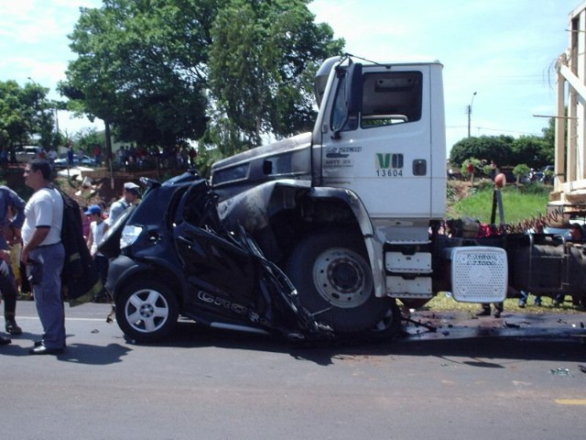

MVA; The Nuts and Bolts of It

Accident Consulting Services
7612 NW 26th St., Bethany, Ok. 405 506-4057 or 405 401-6979
MVA; The Nuts and Bolts of It

October14th and 15th, 2025 8:30AM-4:30PM

Where: Warr Acres City Hall
4201 N Ann Arbor, Warr Acres, Ok

Hosted by the Warr Acres Police Department

Accident Consulting Services
Ed Johnston, Owner
7612 NW 26th St., Bethany, Ok 73008
Phone: 405 506-4057
Cell: 405 401-6979
Fax: 405 495-4565
Email: acs7612@yahoo.com

CLEET #25-2139
Mark your calendar and enroll your officers now to assure seating!!!!!!
“This class has been cataloged by the Council on Law Enforcement Education and Training for 16 hours of mandatory continuing education credit. Regarding any law enforcement concepts, practices, methods, techniques, products, or devices as might be taught, promoted, or otherwise espoused in outside schools or seminars, there is no intent, expressed or implied, that listing the course in the CLEET Course Catalog indicates or in any way conveys ‘CLEET approval’ of such concepts, practices, methods, techniques, products, or devices, unless such approval is explicitly stated by CLEET.”

MVA; The Nuts and Bolts of It
This two (2) day course is designed to provide the on-scene accident
investigator with the knowledge and skills to apply advanced tactics,
techniques procedures and critical factors in an effective accident
investigation.

Course Objectives and Purpose
Identify and assemble the necessary equipment to conduct an investigation
Evidence From The Vehicle: To develop an awareness in the
student of the various forms of physical evidence left in and on
vehicles after a collision; and to establish an awareness of how to
properly locate, interpret, collect and preserve all the various forms of
evidence.
State the importance of post collision vehicle examinations and
inspections.
List the two major types of vehicle damage and the causes of each.
Coefficient Of Friction: To develop awareness in the student of
the concepts and principles involved in the study of coefficient of
friction. Further, to develop an understanding of the applications
involved in determining coefficient of friction values for given surfaces.
Discuss the concepts and principles involved in the studies of
coefficient of friction.
Identify and apply the equations recognized in the applications of
coefficient of friction in determining values of given surfaces.
Center Of Mass Braking Percentages and Equation Worksheets:
To develop an awareness in the student of the concepts and principles
involved in considering an objects center of mass and a vehicles
braking efficiency and percentages. Further, to develop an
understanding of the applications involved in determining “field”
approximated center of mass for vehicles and braking percentages.
Grade and Superelevation: To introduce the student to the concepts
of grade and super elevation and their application to speed estimates
from skid marks.
Define the terms grade and super elevation as they apply to roadways and accident scenes.
Obtain the proper measurements and determine grade and super elevation at an accident scene.
Adjust drag factors (Coefficient of Friction) to account for differences in
grade from a test site to an accident site.
Minimum Speed From Skids: To develop a working understanding of
and abilities in the applications of minimum speed equations.
Identify the equations required to solve minimum speed
Properly list the application and steps involved in the process of
problem solving for minimum speed and basic time and distance problems. Determine vehicles minimum stimated speeds using identified equations.
Radius and Critical Curve speeds: Correctly determine the radius of a curve, curb line and a YAW and determine the critical curve speed of the vehicle leaving the mark
Cost $300.00 per officer, payment must be received no later than 10 days prior to class date.
Travel, lodging and meals are not included.
3 Ways to Register for a Seminar!

1.Fill out Registration & email to:
acs7612@yahoo.com or
2. Fax Form to E. Johnston LLC & Associates Investigations
FAX: 405-495-4565
3. Mail Form to:
E. Johnston LLC & Associates
7612 NW 26th St, Bethany, Ok. 73008
Names of Attendees & Class Number attending
1.

2.

3.

4.

Agency
Address
Telephone number
Fax number
PO#

Registrations must be received 10 days prior to the class date!!!

