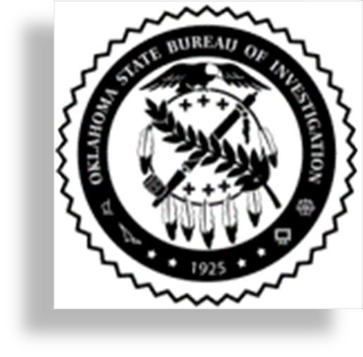

OSBI Sexual Assault Response and Investigation Academy

Registration is required. To register, please send your Name, Agency Affiliation, and CLEET number to the listed registration contact email address.

REGISTRATION CONTACT

EMAIL: saki@osbi.ok.gov

Host: Oklahoma State Bureau of Investigation
Alaunna Raffield Fund: Scholarship available: To request assistance with lodging and expenses associated with this training, please visit: https://oklahoma.gov/osbi/newsroom/alaunna-raffield-fund.html.

Location: Northeastern State University Broken Arrow Campus. Liberal Arts Building (Far North Campus Building) Room: 126
Dates: March 2, 2026 – March 13, 2026

Start: 08:00 – 17:00
The Oklahoma State Bureau of Investigation (OSBI) will be facilitating an 80-Hour Sexual Assault Response and Investigation Academy. This intensive training is designed to strengthen law enforcement response to sexual assault calls and ensure a trauma-informed approach to investigations.
The following topics will be covered:
- Trauma-Informed-Victim-Interviewing Response to Sexual Assault Investigations
- Sexual Assault Prosecutions
- Patrol Response and Investigations
- Utilizing Controlled Calls for Investigations
- DNA Collection and Rapid DNA Lead Program
- Neurobiology of Trauma and Victim Advocacy
- ICAC and Digital Evidence
- Sexual Assault Crime Scene Investigations
- FBI and NDOK: Sexual Assaults in Indian Country
- Child Crisis Investigations presented by Tulsa PD
- Mindset of the Offender presented by Owasso PD
- Special Presentation by News On 6 Lori Fulbright: Media Relations

This training has limited seating and will ONLY be offered to any Active Law Enforcement Officers. This training is designed for Patrol Officers, SRO’S, and Investigators who may interact with survivors of Sexual Assaults
This training is FREE.

