
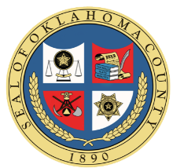
Oklahoma Civil Asset Forfeiture Training

Oct. 3rd, 2025
Metro Tech South Bryant Campus
4901 S. Bryant Ave, Oklahoma City, OK 73129

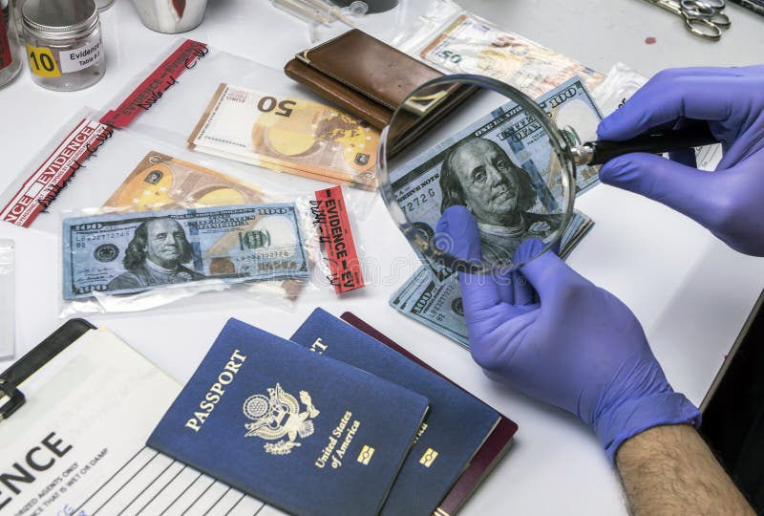

Register at: colt.orman@oklahomacounty.org

