
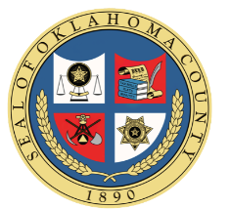
Oklahoma Civil Asset Forfeiture Training

Jan. 9th, 2026
9:00 am to 5:00 pm
Metro Tech South Bryant Campus
4901 S. Bryant Ave, Oklahoma City, OK 73129

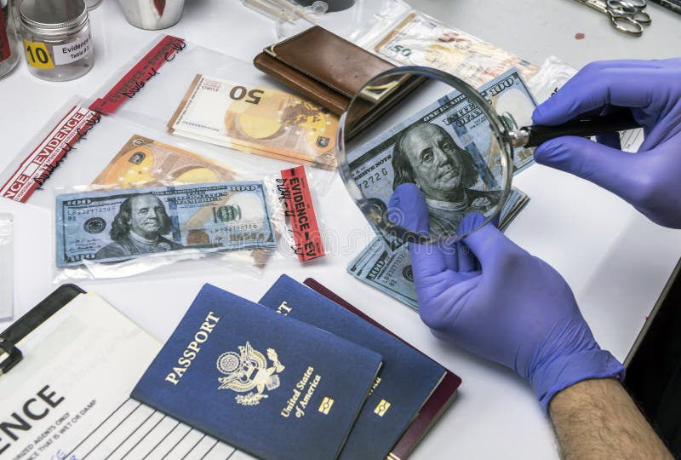

Register at: colt.orman@oklahomacounty.org

