The IAFCI OK-AR Chapter has been hosting the SW BSA & Financial Crimes Forum almost every year since 2008. This forum brings together representatives from law enforcement, financial institutions, government/tribal agencies, retail, and service providers for a full day of education and networking. This event focuses on benefit to the attendee, not profit for the organization.
2026 SW BSA & Financial Crimes Forum
Monday, October 26, 2026
8:15 am to 3:45 pm
$100 - IAFCI members and Tribal/Government/Law Enforcement agencies
$150 - Non-member, non-government
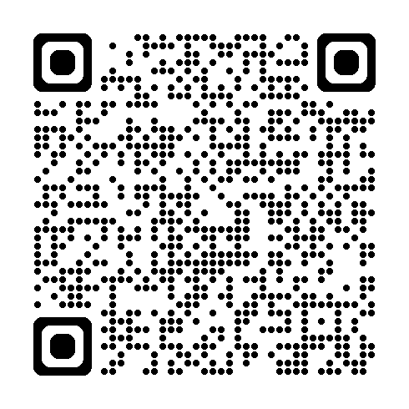 | 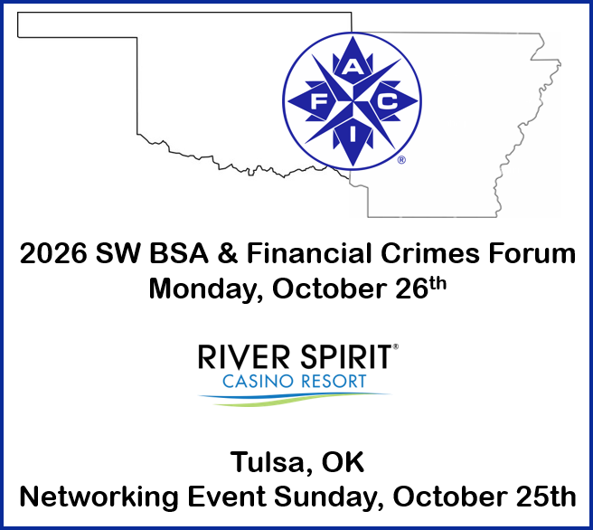  (click image for registration)
Registration Deadline is October 22, 2026
Refunds available if cancelled by October 15, 2026
Breakfast, Lunch and Refreshments provided
A networking event will be held Sunday, October 25th from 6:00 to 9:00 pm in The Locker Room, River Spirit Casino Resort. Cash bar. Appetizers will be provided.
For hotel room rate information/reservations IAFCI OK-AR Chapter - River Spirit Casino Resort. This group rate expires 9/25/2026. There are a limited number of rooms reserved at this rate so please make your reservations as soon as possible.
For questions, please email sharon@oba.com.

