Western Technology Center’s Back to School Plan for 2020-2021
INTRODUCTION
The effectiveness of this plan relies strongly on everyone’s personal responsibility to monitor his or her health. WTC has the pleasure of serving 14+ communities; therefore, students and staff may be exposed to the COVID-19 virus. WTC strongly encourages routine, daily self-assessment of individuals to include temperature and symptoms check. Symptoms that need to be monitored: Cough, shortness of breath or difficulty breathing, chills or repeated shaking with chills, loss of taste or smell, or a fever greater than or equal to 100.4. Other items for consideration: In the last 14 days, if one has been diagnosed with, tested positive for, or recovered from COVID-19 and/or has in the last 14 days, had a known exposure to a person suspected/confirmed case of COVID-19? If one is exhibiting symptoms, staying home is the best practice.
Disruption to life has occurred and school life could be vastly different than normal. WTC is establishing protocols for staff and students to help provide stability and peace of mind under the guidance of health professionals. However, this pandemic is unprecedented territory and plans may have to be altered to protect the health of people. As the situation changes, WTC will reassess the plan and communicate to all effectively.
FOCUS OF THE PLAN
The WTC Back to School Plan was developed through collaboration with teachers, parents, administrators, board members, partner schools, Oklahoma State Department of Education, Oklahoma State Department of Career and Technology Education, and health professionals. The collaboration was intended to provide insight into concerns about re-opening school considering the ever- changing COVID-19 conditions.
Two guiding principles on which this plan was based:
- Exposure will be limited wherever possible
- Valuable, quality instruction must be continually delivered.
WTC programs are unique. Hands-on learning is vastly important in skills training; therefore, face to face teaching and learning are the most valuable for students. WTC must also prepare for the possibility that remote learning may need to occur temporarily or for an extended period of time. Instructors have been working on plans that will deliver rich instruction in the event of a disruption to the face to face learning environment.
The plan is organized into four areas:
- School Operations
- Academics and Growth
- Student and Family Support
- School Personnel
SCHOOL OPERATIONS
Communication
All communication with students, parents and stakeholders will be delivered through School Messenger, WTC Facebook page (westtechcenter) school email and a variety of platforms that will connect students with instructors. The importance of having correct phone numbers for contact information cannot be stressed enough. One can always communicate with any of WTC’s five campuses: Burns Flat ( 580 562 3181), Sayre (580 928 2097), Hobart (580 726 8400), Elk City (580 225 4982) and Weatherford (580 774 0224). Our website address is : www.westtech.edu
School Calendar
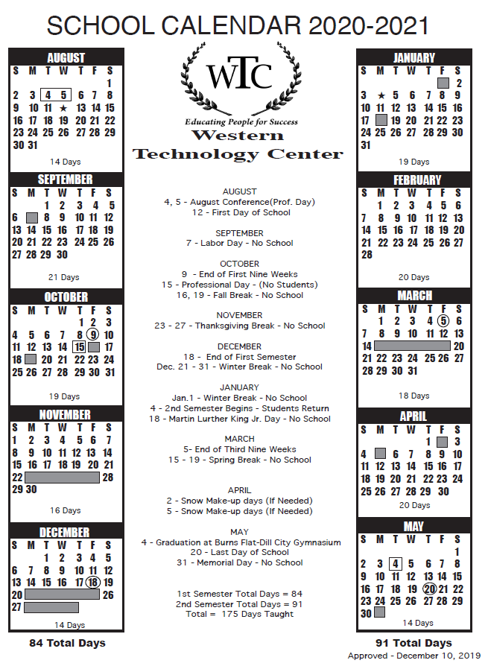
The calendar for the 2020-2021 school year is board approved. WTC will adhere to this calendar. In the event of necessary remote learning, school days will remain as scheduled to accommodate instructional hour calculations.
General Operations
Recommended best practices to limit the spread of the virus include routine handwashing and social distancing (6ft apart), also the wearing of masks or face coverings will be required when social distancing is not possible.
Staff – Staff will self-assess each time at clock-in according to the screening questions.
Partner school buses – Temperature checks will be taken at the point of entry for students.
Students arriving by personal transportation – Temperature checks will be taken at the point of entry.
Visitors – Screening protocol will be provided.
Self-assessment checklist: Due to the highly infectious nature of the COVID-19 virus, each student and employee should complete a daily self-assessment before arriving to school for class or work. This self-assessment is not to take the place of talking with health professionals. This assessment is based on the guidance provided by the CDC.
- Exposure- In the last 14 days, have you had a known exposure to a person with suspected/confirmed COVID-19? Yes or No. If Yes, DO NOT COME TO CAMPUS (Students communicate with instructor, staff with administrator)
- Symptoms – In the last 24 hours have you experienced a cough, shortness of breath/difficulty breathing, chills or repeated shaking with chills, loss of taste or smell or a fever greater than or equal to 100.4? If you are experiencing any of these symptoms, DO NOT COME TO CAMPUS (contact a health care provider, communicate with instructor, staff communicate with administrator) Suggestion: Dial 211 for information/resources related to COVID-19.
Transportation – Social distancing on buses may or may not be an option, assigned seating will be necessary to attempt distancing. Measures will be taken to ensure the safety of students and drivers. Temperatures will be taken of students prior to boarding. Ventilation can be increased by lowering windows when weather permits. Masks/face coverings will be required. Buses will be cleaned and disinfected daily.
Breaks – A 10-minute break will occur for students per session within their building to avoid a large social gathering.
Cafeteria – Lunch will be served to staff and full-time students. Masks/face coverings will be required to be worn in the serving line and social distancing will be observed in the cafeteria. This is applicable to the Burns Flat campus.
Outside groups – While WTC strives to continue to serve our communities, safety considerations must be met. One can place a call to the campus of interest for scheduling. Please be advised that capacity limits and screening protocols will be strictly enforced.

ACADEMICS and GROWTH
Face to face instruction will be delivered according to the approved school calendar. Should a disruption of school occur, students will continue to receive instruction/assignments remotely. Students will be held accountable for assigned class times (AM or PM). Instructors will outline expectations for remote learning and rehearse such practices with students within the first two weeks of school.
Attendance – policies will be in place for all classes. It is the goal that learning is continual whether a student is at school or home for a period of time. Grades and attendance will be taken.
STUDENT AND FAMILY SUPPORT
Our mission is to ensure that all students, staff and stakeholders feel welcomed and safe at school. School counselors, instructors, and administrators are available to assist students and families with resources that may include, but are not limited to enrollment, information, community resources and referral options, and assistance with distance learning. For emotional and mental well-being assistance one can contact the National Distress Hotline (1 800 985 5990) OR text (66746) for Talk with Us OR dial (211) for Oklahoma Hotline.
SCHOOL PERSONNEL
The safety of our school staff is a priority. Taking care of all employees during the COVID-19 crisis will require flexibility and understanding in the event of a positive diagnosis. WTC staff can refer to the Back to School Personnel Plan for further information.
This plan is subject to revisions as new information about COVID-19 becomes available. Please review the next few “what if’s” to know what WTC will do in the event it becomes necessary to react to certain situations.
What if…..
A student or staff member begins to exhibit symptoms of COVID-19 during the school day? Student and/or staff member will be isolated, sent home and encouraged to be tested. Families will be called to come and pick up the sick student.
A student or staff member who tests positive for the virus or think they have COVID-19 should stay home and not be around others until all the following conditions have been met:
- 24 hours no fever
- Symptoms have improved
- 10 days since symptoms first appeared
A student or staff member has had close contact (within 6ft for more than 15 minutes) with an individual who has tested positive? Student or staff member should stay home, self-monitor for symptoms and it is recommended they be tested. Student or staff member should not return to school until they have been tested and/or have completed a 14-day quarantine period.
A positive diagnosis is determined among students or staff? That does not necessarily mean a shut down of school. WTC will be working with health officials and administration to determine the next steps.
Be assured, WTC will be taking strong measures to keep buildings, rooms and buses disinfected on a regular basis for the safety of everyone!!!
