Table Setting - Revised 8/19/2019
Table Setting, an individual event*, allows the participant to demonstrate the ability to set tables quietly and with maximum efficiency in a specific amount of time.
ELIGIBILITY
- A chapter may submit three secondary and three post-secondary entries in this event.
- Open to active SkillsUSA members enrolled in career and technical programs with entry-level job skills as the occupational objective. A letter from the appropriate school official on school letterhead stating that the contestant is classified under the provisions of Public Law 105-17, Individuals with Disabilities Education Act, 1997 is required for participation. State/school associations having restrictions on the release of this information may submit a letter on school letterhead of eligibility which simply states: ‘I certify that (student name) meets the eligibility requirements for the SkillsUSA Championships Table Setting contest. Signed (school official).” The eligibility letter is to be presented to the contest chair at the contest orientation meeting.
- Each participant must submit a personal resume during sign-in.

CRITERIA FOR EVALUATION
Participants will be evaluated on:
- Proper dress/grooming
- Proper hand washing technique
- Sanitary handling techniques
- Table setting procedures
- Speed and silence
- Answers to evaluator’s questions

PROCEDURES AND TIME REQUIREMENTS
- Participants must attend the event orientation session where they will:
- Receive a nametag and contestant number
- Be given an overview of the event and the participant’s responsibilities
- Participants will remain in the holding area until the assigned time.
- The following equipment/supplies will be furnished:
- Two dinner plates
- Two coffee cups and saucers
- Two water glasses
- Two dinner forks
- Two dinner knives
- Two spoons

- Participants will be dressed in professional attire consisting of a uniform top or apron, long pants, hair cover (a cap or hair net), and close-toed shoes.
- Each participant will set a 34” x 34” card table for two using the table setting procedures outlined in this packet. The two settings shall be across from each other.
- Participants will be stopped at the end of 10 minutes.
- Times will be used as a tiebreaker.
- When participants have completed their assigned tasks, they will answer oral questions from the judges.
- All judges’ decisions are final.

SAMPLE QUESTIONS
- Why should knife blades be placed facing the plate?
Knife blades are placed facing toward the plate for convenience and safety purposes.
- Why are glasses and cups placed on the right side of the cover?
Glasses and cups are placed on the right side of the cover for convenience purposes, as more people are right handed.
- At what clock position should the handle of the coffee cup be placed?
The handle of the coffee cup should be placed at the five o’clock position.
*Students who communicate through an interpreter may use their interpreter during the skills demonstration. Students who require reading assistance may request to have any written tests read to them.

Table Setting Information Sheet
Each participant will have 10 minutes to complete set-up, assembly, and cleanup.
Table Setting Procedures
- Wash hands properly
- All items on table (napkin, dinner fork, dinner plate, dinner knife, and spoon) should be one inch from the edge of the table.
- Place all dinner plates on the table.
- Place all flatware at each setting. Always use both hands. Do NOT lay all teaspoons then all knives.
- Hold spoons in your right hand and knives in your left hand.
- Lay down both pieces of flatware at the same time, on the right side of the plate, then repeat at the second setting.
- The cutting edge of the knife should be placed toward the plate.
- Place the dinner fork on the left side of the plate.
- Place napkins to the left of the forks. The napkin’s loose edges should be toward the plate and the edge of the table.
- Place a saucer at each setting.
- Place the coffee cups on the saucers. The handles should be placed at the five o’clock position.
- Place a water glass at each setting.
- Signal the judges when you are finished.
- Answer question(s) from the judges.
- Clear the table for the next participant.
Table Setting Information Sheet Cont.
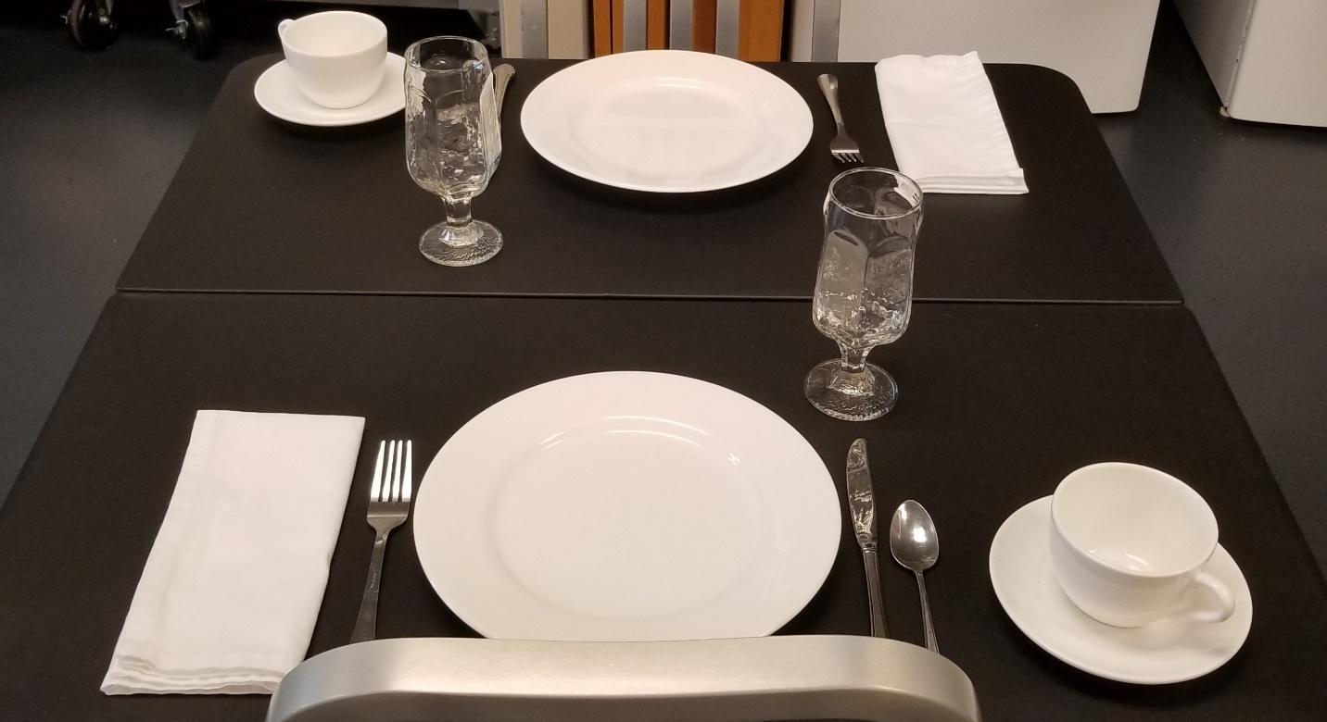
You will be provided with the following:
- Two dinner plates
- Two coffee cups and saucers
- Two water glasses
- Two dinner forks
- Two dinner knives
- Two spoons
- Two unfolded napkins

Table Setting Information Sheet Cont.

The participant will be responsible for its final placement.
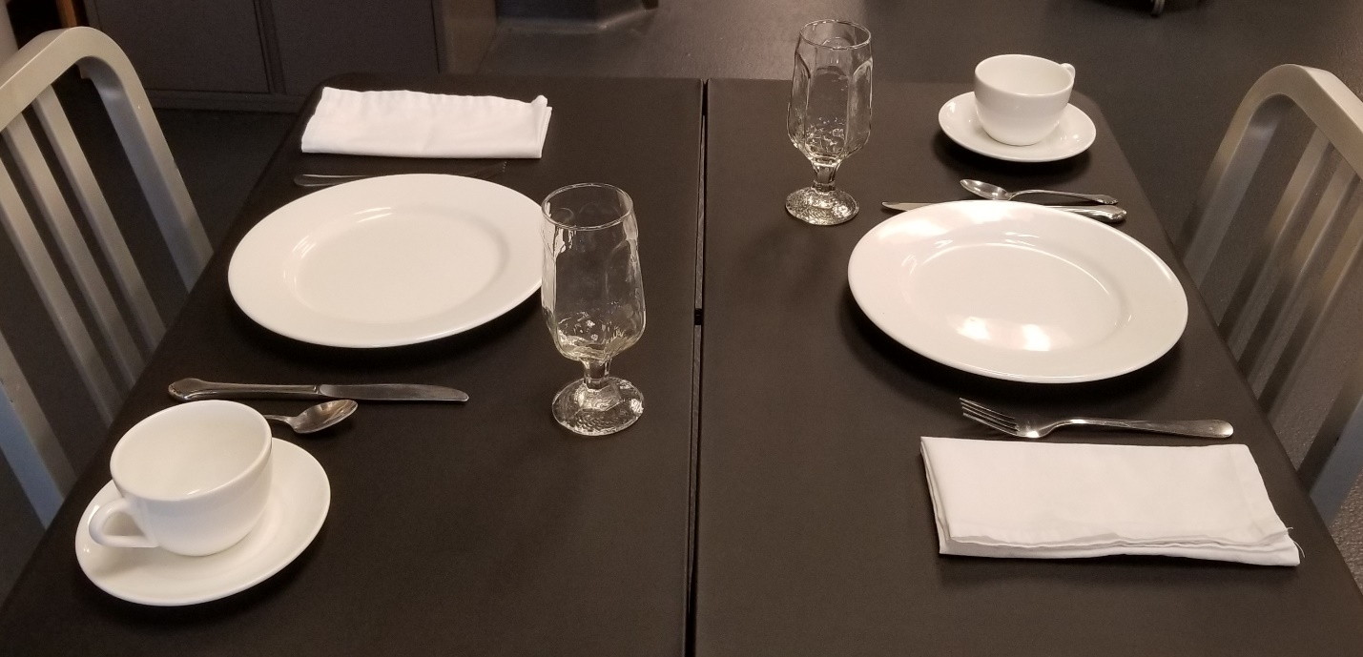

Table Setting Information Sheet Cont.
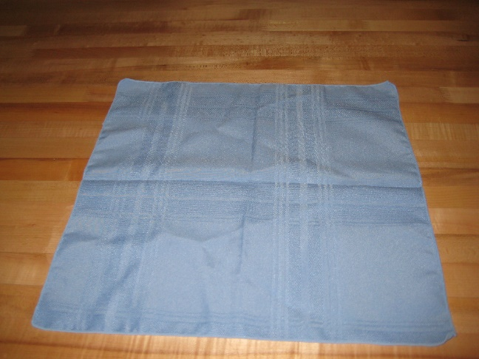  Lay the napkin flat on the work surface. Grab the upper left and upper right corners of the napkin. | 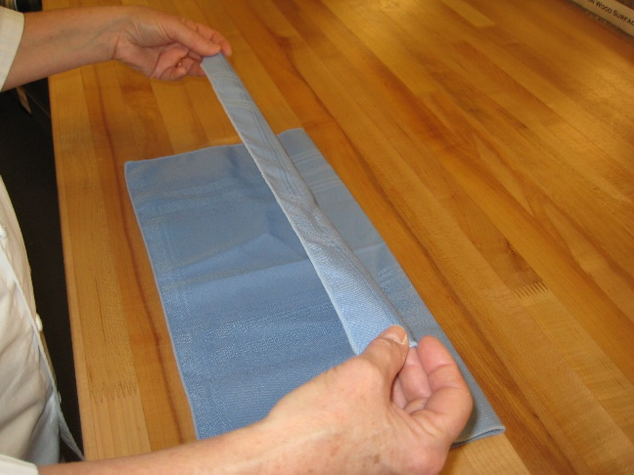  Fold the napkin toward you lining up the top edge with the bottom edge.
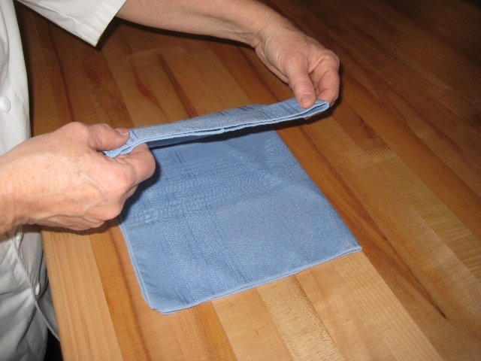  Grab the upper and lower left corners of the napkin and fold in half to the right. Make sure the edges line up. | 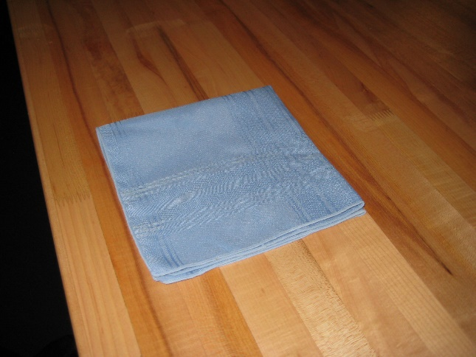  Grab the upper and lower right corners of the napkin and fold in half to the left.
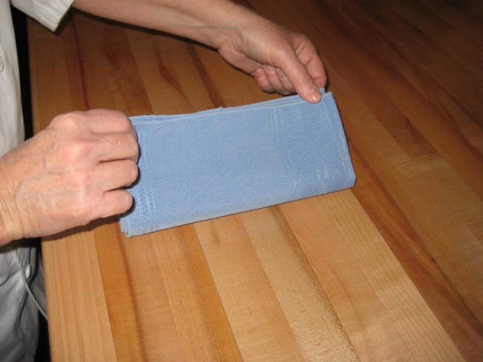 | 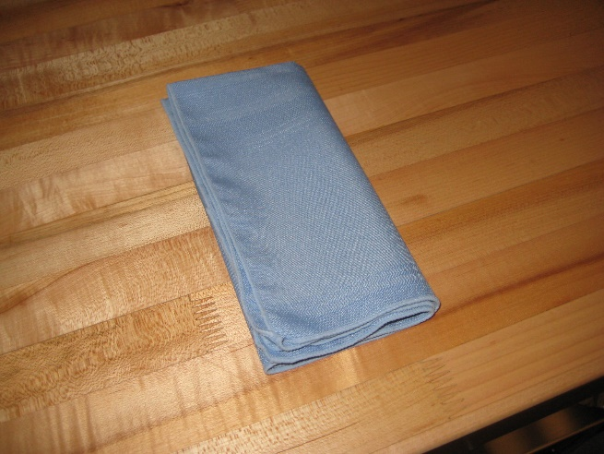  When you are finished, the open edges of the napkin should be on the left and along the bottom.

Table Setting Rubric

Participant Number: ________
Handwashing |  |  |  |  |  |  | Points
Followed Steps  0-5 points | 0  Missed all of the handwashing steps | 1-3  Missed two or more of the handwashing steps |  | 4  Missed one of the handwashing steps |  | 5  Followed all of the handwashing steps
Time  0-5 points | 0-1  Washed hands for less than ten seconds | 2  Washed hands for 10- 14 seconds |  | 3-4  Washed hands for 15-19 seconds |  | 5  Washed hands for full 20 seconds
Appearance
Proper Dress/grooming  0-5 points | 0-1  Non-professional appearance, attire, and/or grooming |  | 2-3  Neat appearance, attire, and grooming but lacks polish |  | 4-5  Professional appearance, attire, and grooming
Performance Evaluation
Sanitation  0-10 | 0-3  Frequently touched eating surfaces of dishes, glassware, and flatware |  | 4-7  Minimal touching of eating surfaces when handling dishes, glassware, and flatware |  | 8-10  Proper sanitation methods used
Table Setting Procedures  0-45 points | 0-3  Disregard of one inch spacing of cover from edge of table |  | 4-7  Some pieces more or less one inch from edge of table |  | 8-10  Cover one inch from edge of table
 | 0-3  Disregard placement of dishes and glassware |  | 4-7  Some dishes and glassware not properly placed |  | 8-10  Dishes and glassware properly placed
 | 0-3  Disregard placement of flatware |  | 4-7  Some flatware not properly placed |  | 8-10  Flatware not properly placed
 | 0-1  Both hands not used when placing flatware around table |  | 2-3  Inefficient movements during placement of flatware |  | 4-5  Both hands used when placing flatware around table
 | 0-1  Disregard placement of remainder of cover on table |  | 2-3  Some cover placed on table in appropriate manner |  | 4-5  Remainder of all cover placed on table in appropriate manner
 | 0-1  Poor attitude, shows minimal interest in and pride in work |  | 2-3  Shows some interest and pride in work |  | 4-5  Has nice attitude, shows interest and pride in work

Work Standards  0-5 points | 0-1  Worked slowly with unnecessary noise | 2-3  Worked slowly but quietly or quickly with unnecessary noise | 4-5  Worked quickly and quietly
Followed Table Setting Procedures  0-5 points | 0-1  Failed to follow procedures in proper sequence | 2-3  Followed some procedures in proper sequence | 4-5  Followed all procedures in proper sequence
Responses to Judges’ Questions  0-10 | 0-3  Did not answer judges’ questions or unable to answer some questions | 4-7  Responded to all questions, but without complete accuracy | 8-10Responses to questions were appropriate and given without hesitation
Cleanup  0-5 points | 0  Did not clear table for next participant | 1-4  Partially cleared table for next participant | 5  Table cleared and ready for next participant
Time: ___________ |  | (100 points possible) TOTAL

Judge’s initials: ___________
Contest Chairperson’s initials: ___________

Judge’s comments:

