Uploading Certificates
- Go to Manage Student Records, click Search (it’s easiest to search by DOC#)
- Type the Doc number into the Search By box and click Search.
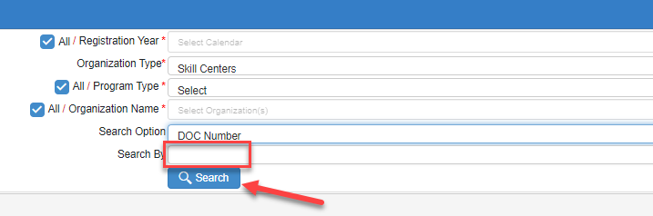
- Click on the little blue man.
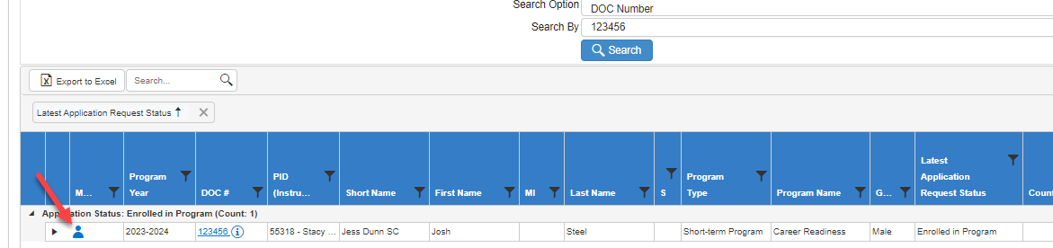
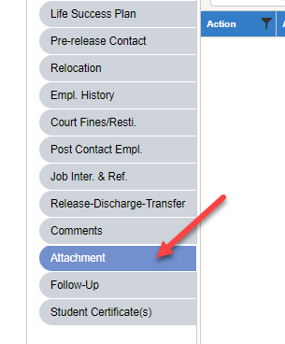
- Select the gray Attachment tab on the left.

- Put in the Date of Entry and choose Certification in the dropdown menu for the Attachment Type.
- Click the Select Files button.
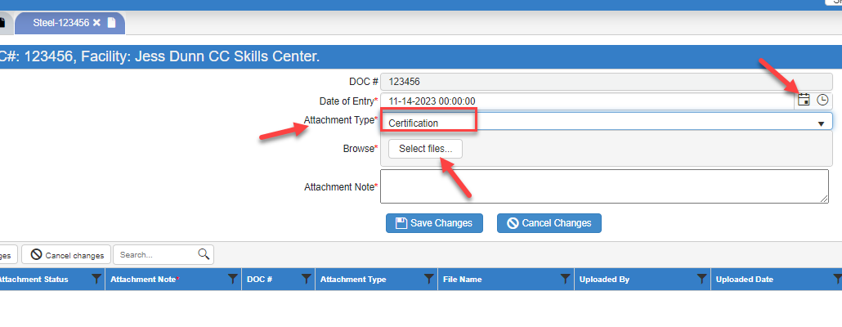

- The you will find the certificate on your computer and click the Save Changes button. You will see the certification entry in the middle of the page under the header.

To find certifications, they will be in the Attachments grey tab.

