Finding a student when you do not know what facility they are/were at.

There are two ways to do a search for a student
- Go to the Manage Student Records
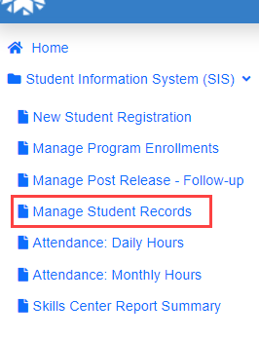
- Make sure all three boxes are checked, change the Search Option to DOC Number in the dropdown box.
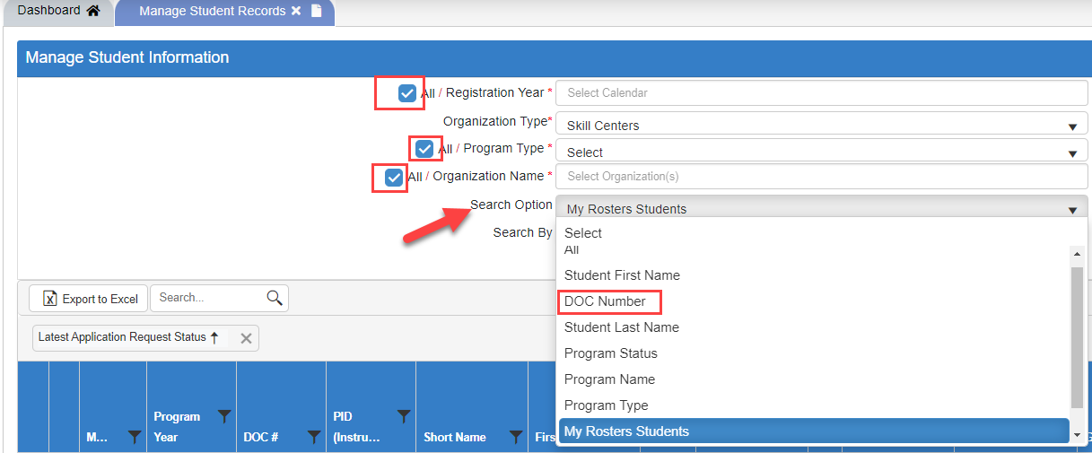

- In the Search BY box, enter the student’s DOC# and click Search.

Or

Go to the New Student Registration page.

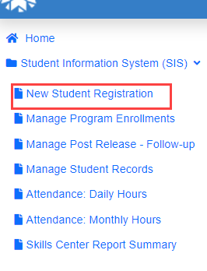
- Enter the DOC# in both boxes and hit your enter button.
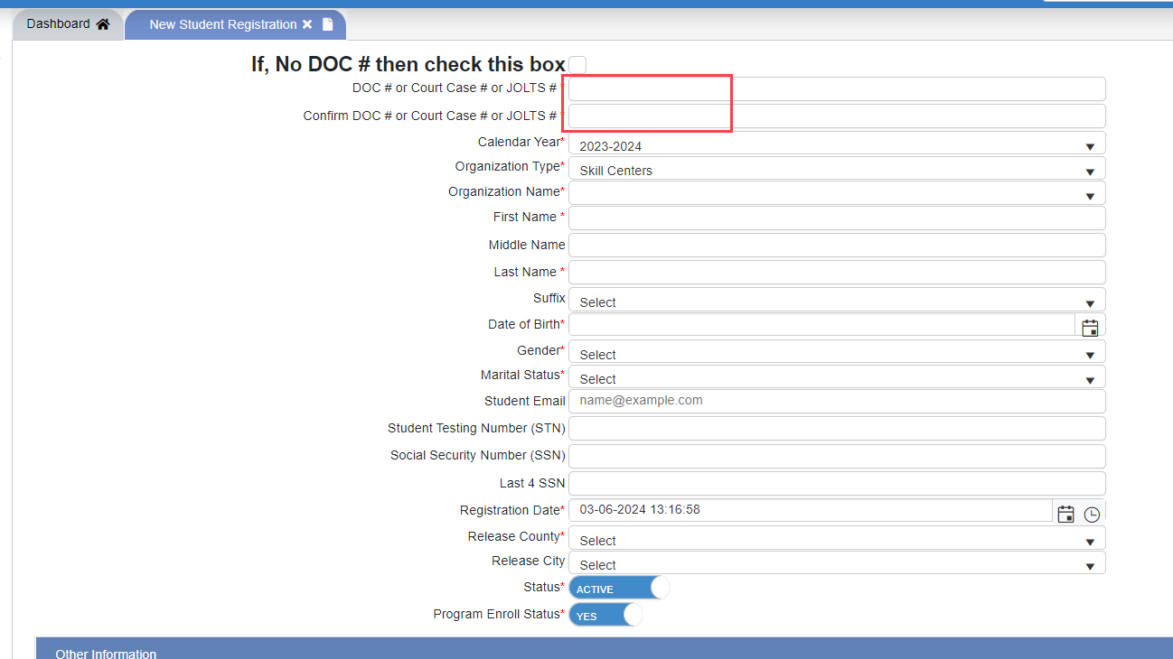

- A box will pop up that says Are you sure? – Click Yes
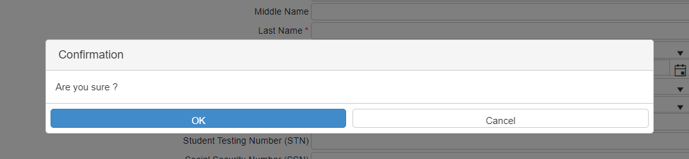
- A pop-up box will show the student’s DOC#, Name, and the facility they were in previously.
- Click Yes, Continue next to the Are you sure you want to review/continue with this student?
- Make sure the Yes button next to the “Is student currently enrolled in the selected program request number?
