May 16, 2023
MEMORANDUM
TO: All New Trade and Industrial Education Teachers
FROM: Krissy Miller, T&I Program Specialist, and NTA Coordinator
Trade and Industrial Education
SUBJECT: T&I New Teacher Academy, July 18-20, 2023
All new teachers, including CareerTech Teacher Institute participants, are required to attend their respective division’s New Teacher Academy.
We are finalizing the Trade and Industrial Education (T&I) New Teacher Academy plans. The academy will be held July 18th – 20th at Francis Tuttle Technology – Danforth Campus at 3841 E Danforth Rd, Edmond, OK 73034. This is a tentative agenda and is currently being updated. Please follow this link to see updates. Once the agenda has been finalized, it will be posted to the website.
ACADEMY OVERVIEW
The T&I New Teacher Academy is a three-day event to provide the necessary information and skills to support new teachers. During this academy, teachers will have a variety of presentations and activities put together by peers, university educators, and state program administrators.
JULY SESSION REGISTRATION
Teachers may register online at https://www.eventbrite.com/e/trade-industrial-new-teacher-academy-tickets-636564400257. Registration should be completed prior to July 07, 2023. Registration fee of ($100.00) may be paid on the registration link above using a credit card or by purchase order.
PARKING
Parking and the main entrance are located towards the back of the campus. The T&I Academy will meet in the Seminar Center beginning at 8:30 am. If you have any special needs while attending the academy, please contact Krissy Miller (405)743-5517/ krissy.miller@careertech.ok.gov or Stephanie Evans (405)743-5400 / stephanie.evans@careertech.ok.gov

MEALS
Light refreshments and lunches will be provided each day. Refreshments and meals will be included in the registration fee.
DRESS
The dress code for the academy is business casual. The idea is to be comfortable while maintaining a professional workshop atmosphere. It is difficult to keep the temperature comfortable for everyone, so attendees may want to bring a sweater or jacket.

TEACHER PROFESSIONAL DEVELOPMENT FOLLOW-UP SESSIONS
Professional development sessions will be open to all teachers during the 2023-2024 school year (Careertech Educator Conference), focusing on professional teacher competencies within career and technical education. The professional development will be centered on instructional delivery strategies, classroom assessment, instructional planning, and classroom management. There will also be sessions around student organizations, blending technology into instructional experiences, and specific divisional sessions. The dates for the sessions: (TBA on Date) (locations TBA).

HOTEL
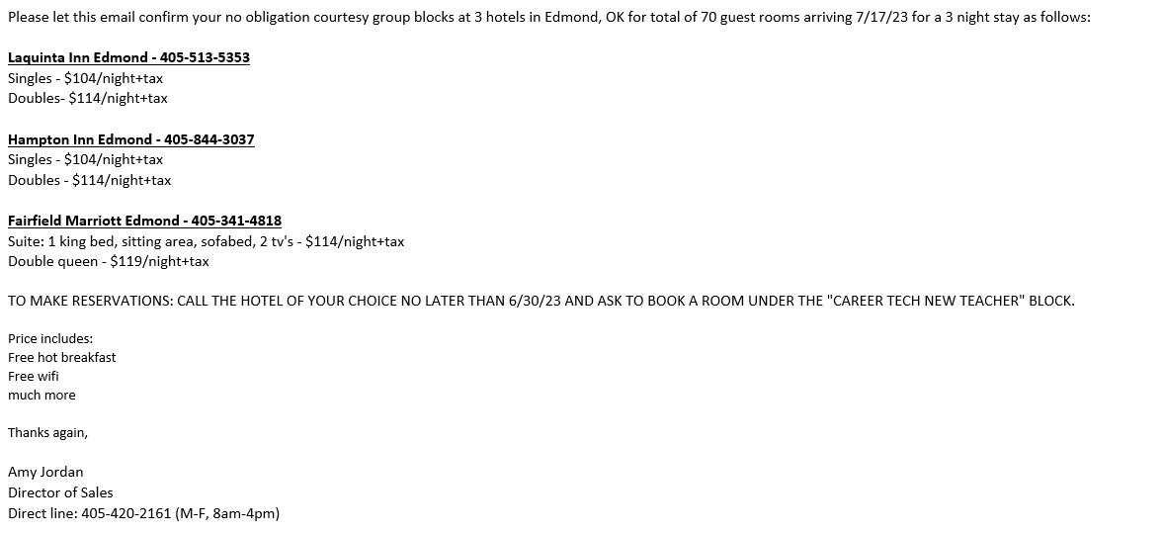
THANK YOU IN ADVANCE
Managing the details of being away from home and school can be difficult, so we appreciate your special efforts. We also appreciate your school’s support in making this opportunity available. We believe these workshops will be an investment in your future as a T&I Education teacher. You will receive material and build relationships with presenters and other new teachers that will help support your teaching efforts in the future.

If you have questions, please contact the T&I New Teacher Academy team:

Krissy Miller 405-743-5517 krissy.miller@careertech.ok.gov
Stephanie Evans 405-743-5400 stephanie.evans@careertech.ok.gov

Oklahoma Department of Career and Technology Education
1500 W. 7th Avenue
Stillwater, OK 74074

