CareerTech Academic Information for Counselors Updated Fall 2026

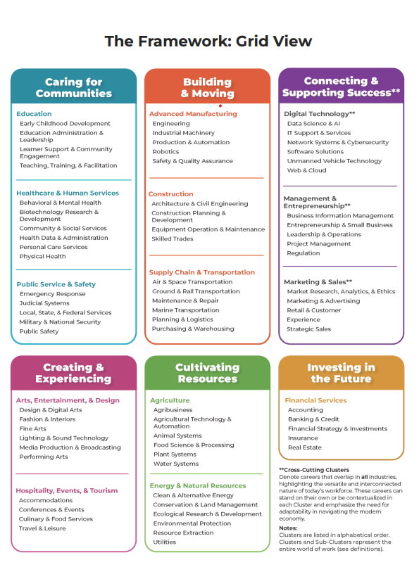

ABOUT THE GUIDE: The Counseling and Career Development Division is part of the Oklahoma Department of Career and Technology Education (ODCTE). This guide is intended to serve as a quick reference for common topics discussed in the counseling or student services office.

General Information

Carnegie Units (credits)
Academic courses offered in technology centers and local schools must adhere to the SDE requirements for awarding Carnegie units of credit. A unit of credit is given for successful completion of a course that meets a minimum of 40 minutes a day, 5 days a week, for 36 weeks, or the equivalent of 120 clock hours within the school year.

OCAS Codes
OCAS Codes are the state’s way of tracking the courses a school offers, who teaches the course, and which courses a student takes.
- The two sources for OCAS Codes (Academic) are the Oklahoma State Department of Education (OSDE) and the Oklahoma Department of Career and Technology Education (ODCTE).
- There are additions, deletions, and name or credit changes every year.
- Your Student Information System (SIS) may need to be updated yearly.
- The instructional level appropriate for the course is crucial in data collection.

Beginning in the 2024-2025 school year, the instruction level code will be 73044 for all 8000 courses and 9000 programs. Middle school courses taught for high school credit should be coded with 00579.

Teaching a CareerTech Course or Program

Course codes (8000) and program codes (9000) can only be taught by teachers who are properly certified in an appropriate area of certification approved by Oklahoma CareerTech. Program codes should only be used when a student attends a program (see above).

Courses
(8000) are 60 or 120-hour worth .5 or 1 unit of credit toward graduation. CT courses may be worth elective, math, science, or computer credit. Please remember the CT Course Code or CT Program Code Guides on the website for the appropriate academic credit. Additionally, some courses will satisfy the competencies of the media arts or other graduation requirements.

Programs
Programs are a 3 or 4-hour-long 9000-coded set of courses ending in the ability to gain industry-recognized certification. Programs are typically taught at technology centers (TC). Programs are usually electives; however, in the 25-26 school year, 9323 Licensed Practical Nurse was approved as an Oklahoma Promise science credit for high school seniors.

CTIMS Course Codes
CTIMS course codes are what ODCTE uses to report classes at all levels of CareerTech for the federal government. They can be found in most divisions' instructional framework on the ODCTE website.

Students Withdrawing from CareerTech
780:15-3-6 (a)(3) states that a procedure must be established, and both the technology center and the sending school must agree for a student to withdraw from the technology center.

Oklahoma Parent Bill of Rights
Regarding instructional delivery in progress in Career Tech and public schools:
- parents shall be informed regularly of student progress;
- parents shall be given handbook and the behavior code developed with parents;
- parents should have the opportunity for parent involvement.

Transcripts

A transcript is an official record of a student's work, showing courses taken and grades achieved. (Oxford)

“(5) Certified coursework. Units of coursework earned by a student in a technology center in Oklahoma shall be certified by the technology center to the sending school in which the student is regularly enrolled. These units of coursework shall be counted toward meeting local and state requirements for graduation. The technology center is considered to be an extension of the sending school curriculum and shall be subject to the regulations thereof.”

The High School Transcript

The technology center should not be listed as a separate school on a student's transcript.
Technology Centers issue grades as part of the student’s home high school transcript. High school students who complete their career plans of study shall be awarded competency/completion certificates by the technology center.

Sending Grades to High Schools
Technology centers are encouraged to send grades to their sending schools in a manner that reduces transcript errors.
Common errors:
- Wrong OCAS code
- Wrong Course names
- Improper amount of Credits

Best Practice for Grades:
- All program and course information should be communicated yearly at a time of the year that allows both schools to check OCAS codes and plan for student graduation needs.
- List the academic credit separately for all courses embedded in a Careertech Program

Example:
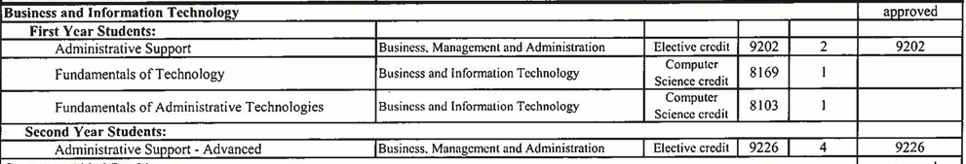

780:20-3-2(b)(3). CareerTech course offerings must have the same titles as listed on the Standards for Accreditation of Oklahoma Schools. There should be no distinction made to indicate where a course was taught. (This includes courses without 8000 or 9000 OCAS Codes that are taught at a technology center.)

Embedded Arts Competencies
In 2023, the State Department of Education released a new set of arts standards for the “media arts”. Following the release of these standards, seven CTE courses were identified as satisfying the content necessary to meet the competencies fulfilling the arts graduation requirement. Those courses are designated in the ODCTE Course Codes.
- These courses, designated as meeting the competencies of Media Art, require a certified art teacher, a teacher with a micro-credential, or a teacher meeting the adjunct requirements.

Certifications

HB 3218 (2016) requires all Industry Aligned (IA), Industry Endorsed (IE), and Industry Required (IR) certifications to be transcribed on a student's high school transcript. Certifications are often tied to Prior Learning or Cooperative Agreements.

Example: name of certification, location certification taken, date taken

OSCHA 10, __technology center, April 2024

Statewide Articulation Agreements
The ODCTE and several Colleges and University have Prior Learning Credit agreements covering the state. Please note that these agreements are based on the student’s transcript reflecting the proper name of the program or course along with the certifications earned while enrolled in the program or course.
Go to: Oklahoma.gov/careertech, Educators, College Credit, and select an institution.

Oklahoma’s Promise Approved Courses (Program)
It is critical to name and transcribe the courses(program) that count for Oklahoma’s Promise exactly as they are listed on the Oklahoma Promise website. These courses (8000) have undergone a statewide approval process by ODCTE, the Oklahoma State Department of Education, and the Oklahoma State Regents for Higher Education (Regents).
For a list of CTE courses that have been approved for Oklahoma’s Promise, go to the Oklahoma Promise Website.

Many changes have taken place during the recent Legislative sessions.
- 11th and 12th graders can now apply for Oklahoma Promise.
- Students on the Core Curriculum can now meet the requirements for Oklahoma Promise and attend a technology center. (Ends with the class of 2029)
- Children of classroom teachers with 10 years of service may now be eligible for Oklahoma Promise. An income cap applies. Please see the Oklahoma Promise website for details.

ICAP and Additional Post-Secondary Information
Individual Career Academic Plan (ICAP)
Beginning with the class of 2023, students shall fulfill the requirements of individual career academic plans before graduating. (House Bill 2155) The Oklahoma Department of Career and Technology Education supports ICAP implementation.

“(1) All students in accredited programs have individual career academic plans developed and updated to identify and document career and academic services, as well as technical and academic courses to help maximize career success and employability” (ODCTE Book of Rules)

Additionally, Oklahoma CareerTech:
- Offers OKCareerGuide, a robust online career planning system available to all Oklahomans at no cost.
- Technology center student services staff members are encouraged to coordinate and partner with their sending schools to ensure all students complete their ICAPs.
- In partnership with the Oklahoma State Department of Education, an enhanced version of Connect 2 Business (C2B) to track Work-Based Learning (WBL) and encourage community partnerships is available at no cost.

NCAA and CareerTech

For Courses (8000) embedded in technology center programs:

A local high school should submit the syllabi from individual courses at technology centers for NCAA approval. Courses listed for computer credit in the OCAS Course Guide can be submitted to the NCAA with a syllabus emphasizing the science or math content; this is a local school decision.

For Courses (8000) taught at the K-12 school:

The local high school should submit the syllabi from the individual courses taught at the local school for NCAA approval. Many CT courses have standardized syllabi that can be utilized by the local instructor and have academic standards aligned to either national or state standards. This is a local school decision.

Ag, BMITE, and FCS have example files with document samples to assist a high school in submitting CT courses for the local high school. Contact the program specialist for your division and region.

Graduation Requirement Information Under Senate Bill 1370 (2018)

Computer Science or Computer Technology on College Prep/Work Ready
For graduation purposes, a student on the college prep/work-ready graduation (2018) plan may take either two units of the same foreign language or two units of computer science or computer technology. The most recently updated OCAS Codes for CareerTech have identified the courses that meet computer science and computer technology requirements.
Common questions on the current 2-plan system (2018):
Can a student have one foreign language and one computer? No

Can a student have one computer science and one computer technology? Yes

CareerTech Programs Satisfying 3rd-year Math Credit
SB 1370 provides that for students on the CORE curriculum only, acceptance and successful completion of one year of a full-time, three-hour career and technology education program leading to an industry-valued credential/certificate (industry-endorsed or industry-aligned) or college credit can satisfy one of the two math credits required above Algebra I.

Q: A student on the Core Diploma Pathway has opted to take one year of a full-time, three-hour program in place of a third mathematics credit. What subject code belongs on this student’s transcript?

A: If a student is on the Core Diploma pathway and is taking a three-hour career
and technology course in place of a third math credit, the subject code for the course being taken is recorded on the transcript. A transcript note may be added to the transcript stating that the third math requirement for graduation has been satisfied by [course or program name/code].

Transcript Example to follow OSDE:
9707 Welding MN
Student satisfied the third math credit with 9707 Welding MN.

Note: S.B. 1370 is NOT the same as a student taking a pull-out math course at a technology center. Students taking a math course at a technology center should be transcribed the same way a class would be if the student were enrolled in the course at your site.
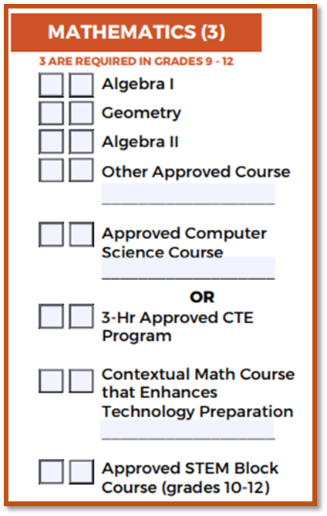
Other Approved Courses:
8711 PLTW Digital Electronics

And 3-Hr Approved CTE Programs (approved for Postsecondary Opportunity Points also qualify for 3rd Math on Core)

CORE Curriculum Requirements for Science
The current CORE curriculum allows for qualified agricultural education courses to offer the set of science competencies in the Oklahoma Academic Standards.

2. "Qualified agricultural education courses" means courses that have been determined by the State Board of Education to offer the sets of competencies for one or more science content areas and that correspond to academic science courses. Qualified agricultural education courses shall include, but are not limited to, Horticulture, Plant and Soil Science, Natural Resources and Environmental Science, and Animal Science. The courses shall be taught by teachers certified in agricultural education and comply with all rules of the Oklahoma Department of Career and Technology Education.”

For qualified agricultural education courses to satisfy the CORE curriculum requirements and count for high school graduation, the teacher must be certified in agricultural education (7550) or vocational agriculture (7511).

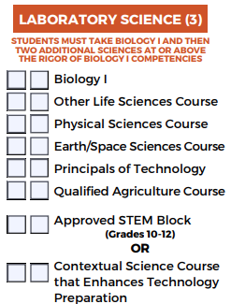
Qualified Agriculture Courses: include but are not limited to Introduction to Animal Science, Introduction to Horticulture, Equine Science, Natural Resources and Environmental Science, and Introduction to Plant and Soil Science.

Agricultural Education teacher certifications qualify for these courses.

College Prep/ Work Ready Speech Credit
In 2012, the State Department of Education approved allowing students majoring in agriculture to enroll in the course 8022 Introduction to Agricultural Communications and use the earned credit to meet (satisfy) the fine arts/speech competency required by law.
An agricultural education instructor with agricultural education certification is qualified to teach the course with a yearly agreement on file at the state office. Visit the Oklahoma CareerTech website and select “Letter to Superintendents” regarding fine art/ speech credit.
A transcript statement should be added: Student has satisfied the speech graduation requirement with 8022 Introduction to Agricultural Communications.

CareerTech Courses and the Additional Unit on College Prep/Work Ready
Under the heading “ONE OF THE FOLLOWING COURSES APPROVED FOR COLLEGE ADMISSIONS,” the courses Oklahoma Promise approved are listed in the FY 26 CareerTech “Course” Codes.

Graduation Requirements for the Class of 2030 HB 3021 (2026)

Changes:
Adds a 4th Math
“Four units or sets of competencies of mathematics, two of which shall include Algebra I and either Algebra II or Geometry. The other two units may include Algebra II, Geometry, Trigonometry, Math Analysis, Calculus, Statistics, Math of Finance, Computer Science, college courses approved for dual credit, a full-time postsecondary career and technology program that teaches math content with a real-world application, or locally approved math based application course, or any mathematics course with applied knowledge of content and rigor above Algebra I. For the purposes of this section, a full-time postsecondary career and technology program that teaches math content with a real-world application shall not include courses categorized as Arts, A/V Technology and Communications, Education and Training, Hospitality and Tourism, or Human Services, including, but not limited to: Barbering, Cosmetology, Culinary Arts, Esthetician, Event Management, Horticulture, or Hospitality Management;”

The programs for Math credit are listed on the ODCTE website in the CCD section, under 2030 Graduation Requirements.

Adds emphasis to the interest a student has in future work through Pathway Units
“Six pathway units or sets of competencies approved at the discretion of the school district board of education which align with each student's Individual Career and Academic Plan (ICAP) and may include, but are not limited to, any additional units or sets of competencies as provided in paragraphs 2 through 5 of this subsection, world language, indigenous language spoken in North America, or non-English language, computer technology, Junior Reserve Officers' Training Corps (JROTC), internship or apprenticeship programs, career and technology education courses, concurrently enrolled courses, Advanced Placement courses, International Baccalaureate courses, music, art, drama, speech, dance, media arts, or other approved courses;”

Allows the local school board to designate 3 courses that each student must take to graduate
Three units or sets of competencies of elective courses locally approved by the school district board of education; and

Requires 2 of the units not already designated from English, Math, Science, Social Studies, Pathways, PFL, or the 3 locally approved courses to meet college admissions requirements.
At least two additional units or sets of competencies from paragraph 2, 3, 4, 5, 6, 7, or 8 which are required to be approved for college admissions by the State Regents for Higher Education when the student is enrolled in the eighth grade, or at any time thereafter when the student completes the course, but prior to graduation.

The CT courses and CT program meeting this requirement are listed on the Oklahoma Promise website.

CareerTech Division Requirements - All CareerTech academic divisions have a CareerTech student organization. Participation is mandatory in some instructional areas. The integration of a CTSO into a course or program’s curriculum is a contributing factor in the difference between the Careertech curriculum and the curriculum for similar non-CTE electives.

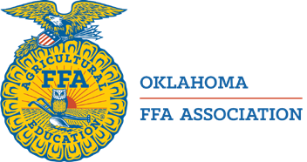
Agricultural Education -- FFA

“FFA prepares students by helping them develop leadership and life skills that will shape their decision-making and values for the rest of their lives.” Agricultural Education courses are offered in grades 8-12 at public schools and follow strict guidelines for participation in courses and extracurricular activities.

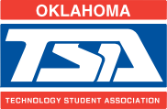
Science, Technology, Engineering, and Math -- Technology Student Association

“TSA is an organization dedicated to promoting STEM and leadership through competitions for every student in the United States.” STEM courses are offered at public middle schools, high schools, and technology centers.

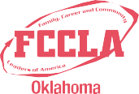
Family and Consumer Science --
Family, Career and Community Leaders of America
“Family and Consumer Sciences Education students are prepared to make informed decisions about consumer education, financial literacy, nutrition and wellness, relationships, housing, and textiles.” FCS courses and programs are offered at public middle schools, high schools, and technology centers.


Business, Marketing, and Information Technology Education -- Business Professionals of America and DECA

“Our mission at Business Professionals of America is to develop and empower student leaders to discover their passion and change the world by creating unmatched opportunities in learning, professional growth, and service.”

DECA enhances the co-curricular education of members through a comprehensive learning program that integrates into classroom instruction, applies learning, connects to business, and promotes competition. BMITE courses and programs are offered in middle schools, high schools, and technology centers.


Health Science Education - HOSA
“The purpose of the HOSA organization is to develop leadership and technical HOSA skill competencies through a program of motivation, awareness, and recognition, which is an integral part of the Health Science and Biomedical Science Education instructional program.”


Health Careers courses and programs are offered at public high schools and technology centers.

Trade and Industrial Education -- SkillsUSA
“Preparing Leaders For A World Of Work” Trade and industrial education programs and courses are designed through cooperation with industry partners to provide foundational learning in specific career paths while providing an avenue for industry-recognized and endorsed credentials. T&I programs and course offerings are available in public middle schools, high schools, and technology centers.

If you have questions or need additional information, please contact:
The Office of Counseling and Career Development, 405-743-5162 or Julie Childers, Academic Coordinator: julie.childers@careertech.ok.gov

