## Submitting Rebuttals and Partial Rebuttals

**1.** **Notifications of Rebuttal Phase Sent –** When the Rebuttal Phase opens, notifications will be sent to all registered Permissible Challengers to provide formal notice that the challenges are open for rebuttal. All permissible challengers will be notified of the opportunity to submit rebuttals to open rebuttal challenges, which includes any challenge not submitted directly against a provider. In addition to the standard notification the Broadband Providers notification will include a notification of whether challenges were received against them. The formal notice will initiate the 30 day rebuttal window.

**2.** **Log-in to the Challenge Portal –** Users can log-in using email/password combo, or use a “Magic Link” which sends an email with a link to log-in directly without password.

**3.** **Expand “Challenge” Item in the Navigation Menu –** There are a range of options in the sidebar navigation menu. When clicking on the Challenge menu item, the sub-menu will expand to display two options: “Dashboard” and “Challenge Map.” To view the challenges available for rebuttal, click on the “Dashboard.”

**4.** **Go to “Dashboard” –** During the Rebuttal Phase, the Dashboard is your portal to review the challenges for which you are eligible to submit rebuttals. In the dashboard,

you will have two tabs available to review challenges: “Challenges Received” (Providers Only) and “Open for Rebuttal.”

a. **Challenges Received (Providers Only)** – The Challenges Received tab will display the challenges that you’ve received against your reported service. The challenges will be grouped by submission and include details, including the challenging entity, challenge type, number of challenged locations, and other details.

b. **Open for Rebuttal –** The Open for Rebuttal tab will display all of the challenges that are not directed at a specific broadband provider, such as Planned Service, Enforceable Commitment, or CAI challenges. The challenges will be grouped by submission and include details, including the challenging entity, challenge type, number of challenged locations, and other details.

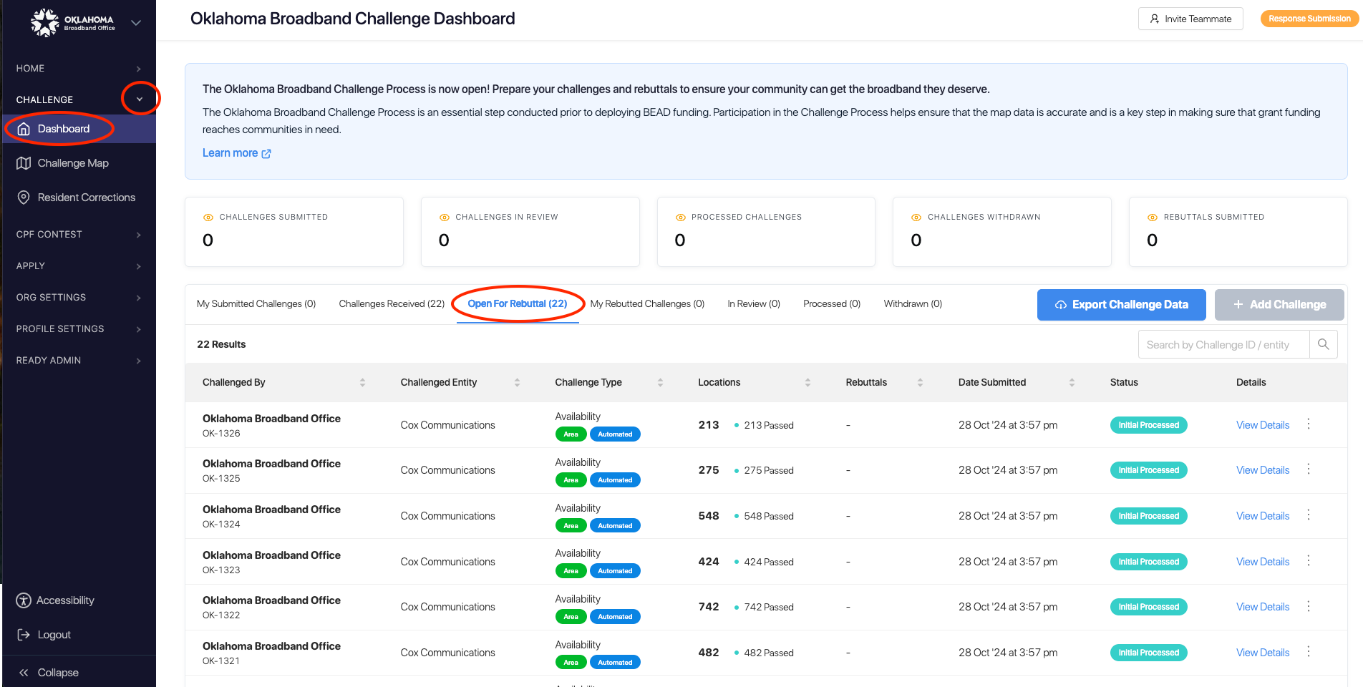

**5.** **Click View Details –** To begin the Rebuttal Process, click “View Details” on the challenge that you want to submit a rebuttal against. This will pull up an interface with a map displaying the locations and details on the challenged locations included in the submission. The information on the challenge submission will be available in the right panel, which has two tabs: Details and Locations.

a. **Details:** The challenge details will be similar to those provided in the Dashboard, but will include an expanded description of the challenge type.

b. **Locations:** The locations tab will provide a full list of locations that were challenged under the selected submission.

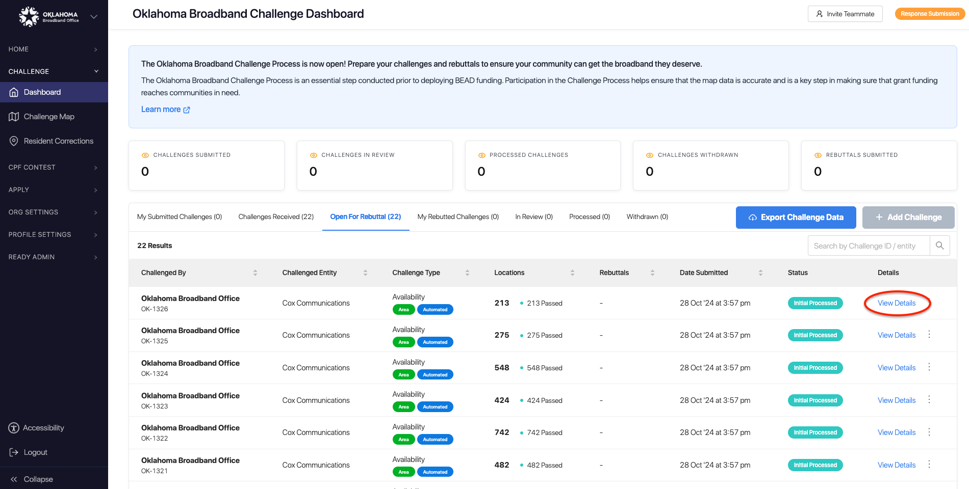

**6.** **Rebut or Accept Challenges –** Using the locations tab, you can choose which individual location challenges you want to Rebut and which location individual location challenges you want to accept. If you want to submit or accept all of the challenges, you can do so using the Rebut All/Accept All button. Note that accepting challenges is only an option for providers reviewing challenges against them, since they are the only ones eligible to rebut those challenges. Open challenges can be rebutted by multiple entities, so they will remain open for the entire 30-day window.

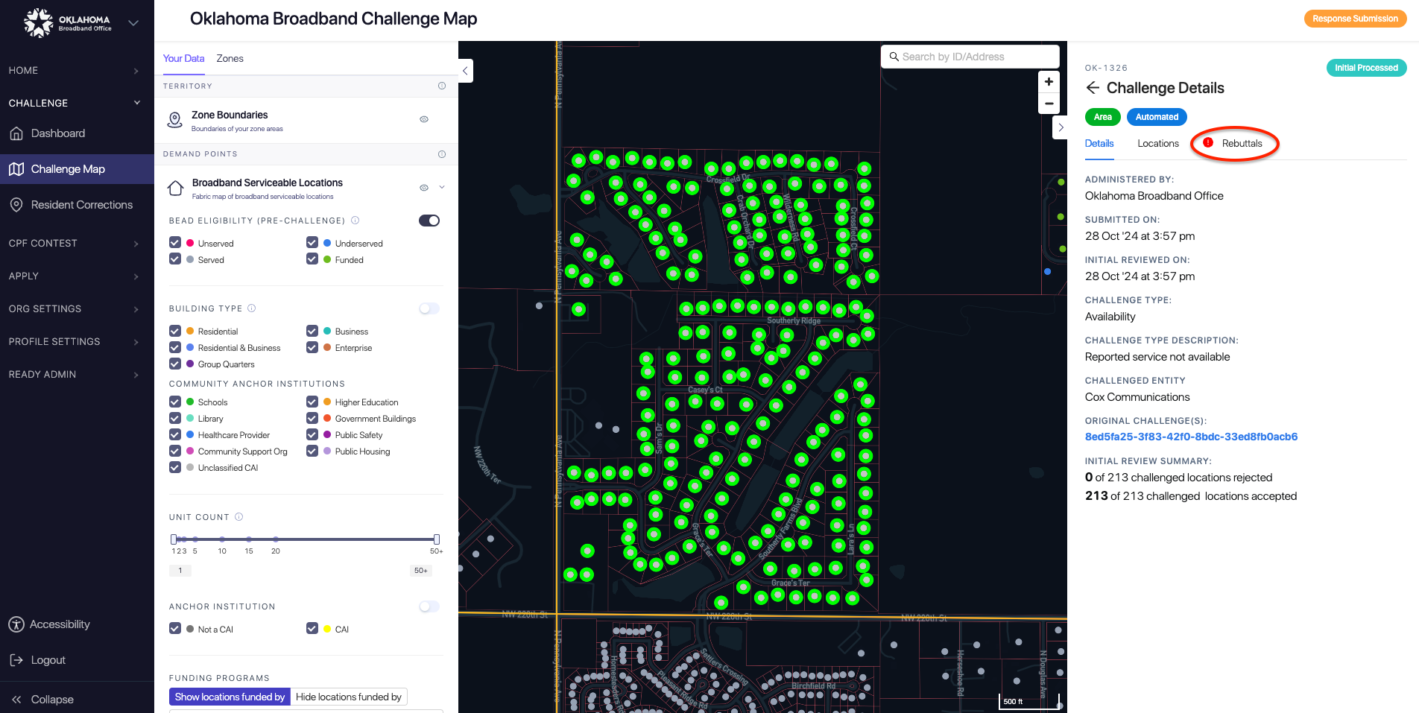

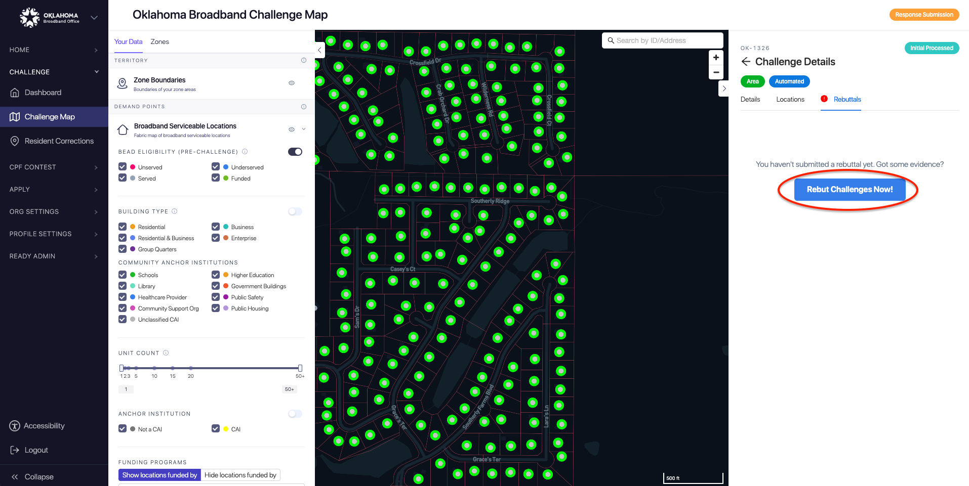

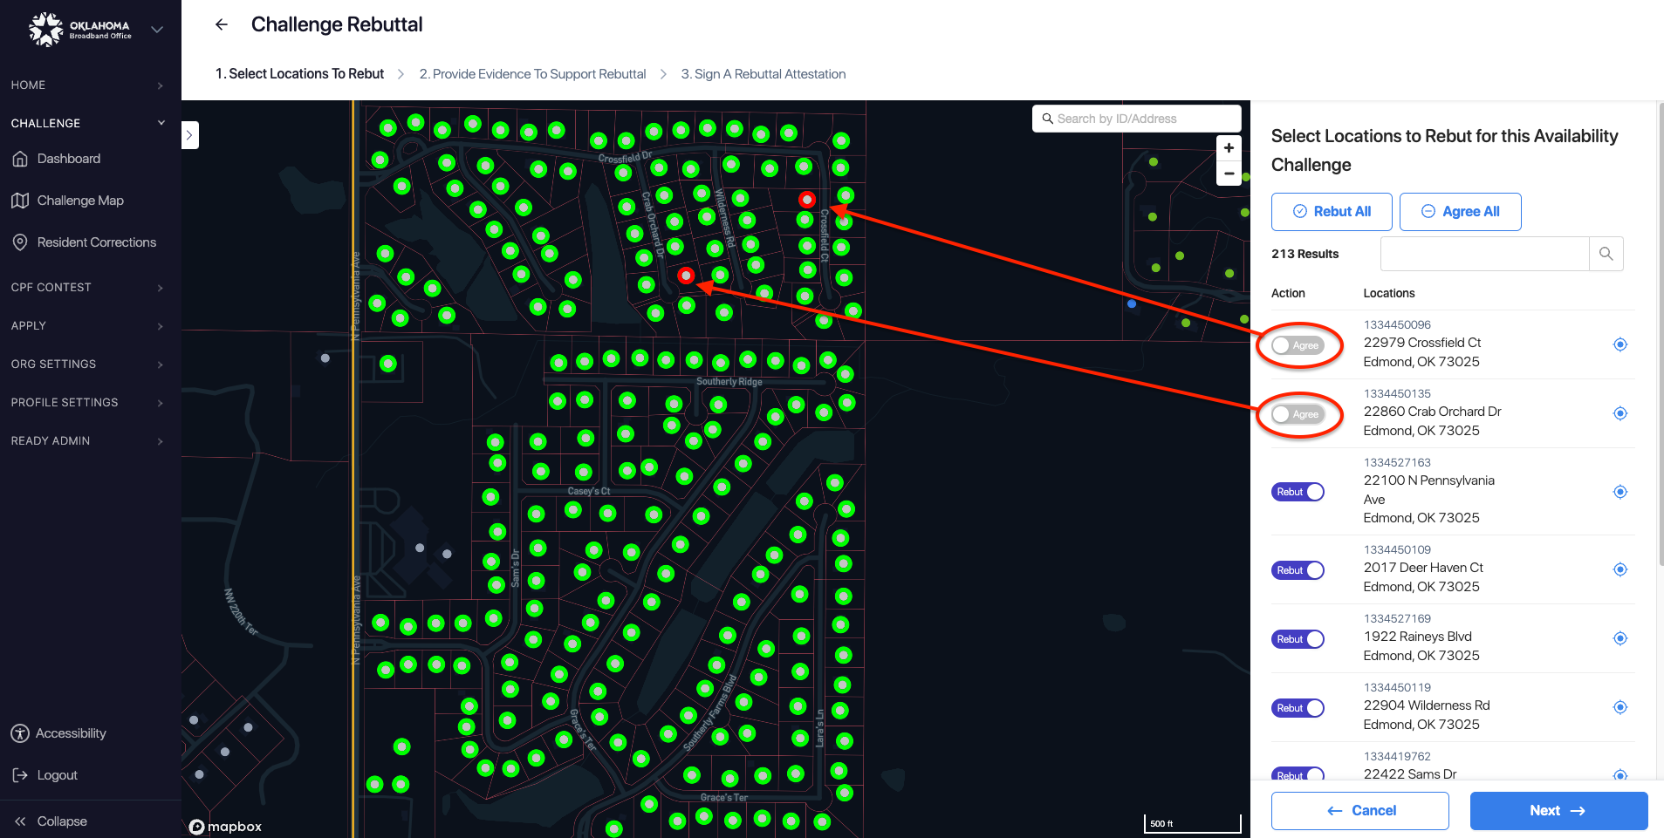

**7.** **Upload Evidence and Documentation –** Once you’ve finalized the location(s) that you want to challenge you will be asked to provide any evidence and documentation that you want included in the review of your challenge.

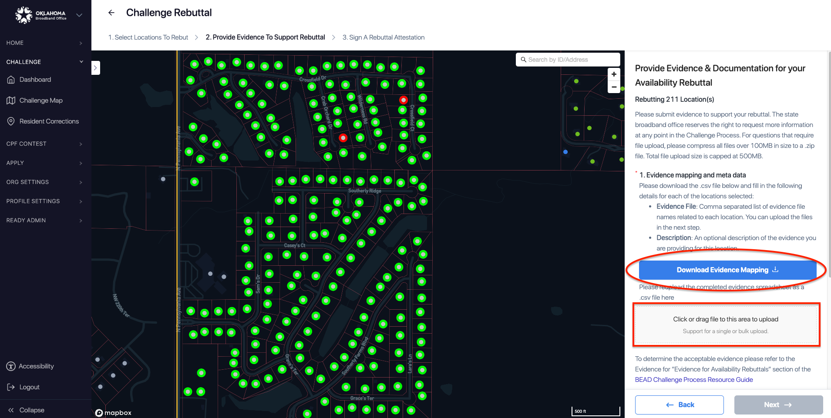

**8.** **Attestation –** After you’ve uploaded your evidence, you will be required to accept and complete an attestation that, to the best of my knowledge and belief that the challenge is true, complete, and accurate, subject to potential civil or administrative penalties.

