State Fiscal Recovery Funds
Capital Expenditure Written Justification

Background
U.S. Treasury has requirements for Capital Projects funded with State & Local Fiscal Recovery Funds (SLFRF). To guide analysis of whether capital expenditures over $1 million meet eligibility standards, Treasury requires the completion of a written justification. For large-scale capital expenditures, as well as most capital expenditures for non-enumerated uses of funds, the State of Oklahoma must submit the written justification to Treasury as part of regular reporting. Specifically:
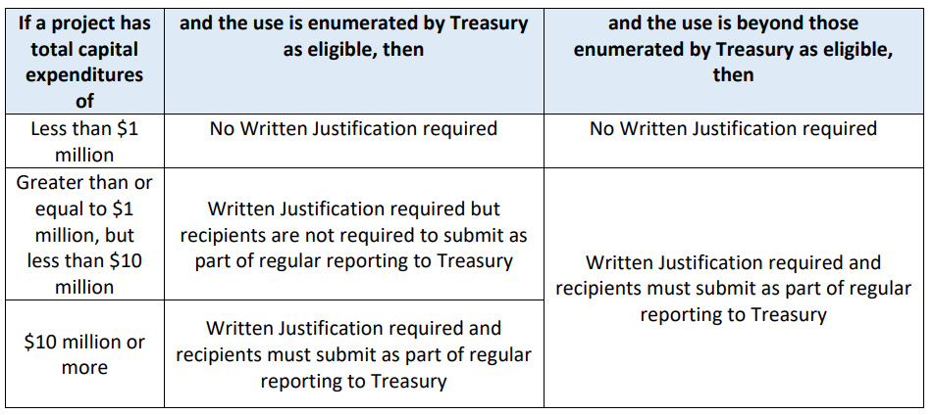

Definitions
Capital Expenditures are “expenditures to acquire capital assets or expenditures to make additions, improvements, modifications, replacements, rearrangements, reinstallations, renovations, or alterations to capital assets that materially increase their value or useful life.”
- Capital assets are “tangible or intangible assets used in operations having a useful life of more than one year which are capitalized in accordance with Generally Accepted Accounting Principles (GAAP).” These include lands, facilities, intellectual property, and equipment.
- Equipment means “tangible personal property (including information technology systems) having a useful life of more than one year and a per-unit acquisition cost which equals or exceeds the lesser of the capitalization level established by the non-Federal entity for financial statement purposes, or $5,000.”
Procurement, Use, and Disposition Considerations for Capital Expenditures
Prior to issuing any bid documents for contracts to be funded with SFRF, subrecipients should carefully review all applicable state and federal rules and requirements, including federal procurement rules outlined in the Uniform Guidance (2 CFR 200.318-200.327)
Further, any purchase, use, or disposition of equipment or real property must be consistent with 2 CFR 200.310 – 200.316.

Project Information
Organization Name:
Click or tap here to enter text.

Capital Project Name
Click or tap here to enter text.

Capital Project Estimated Value of SLFRF Funds
Click or tap here to enter text.

Enumerated Use: Medical equipment and facilities designed to address disparities in public health outcomes
Enumerated Use: Job and workforce training centers
Enumerated Use: Schools and other educational facilities or equipment to address educational disparities
Enumerated Use: Installation and improvement of ventilation systems in congregate settings, health facilities, or other public facilities
If Other, specify:

Written Justification Required Questions
- Describe the harm or need that this capital expenditure addresses, and why that harm was exacerbated or caused by the public health emergency.

Click or tap here to enter text.

- Explain why a capital expenditure is appropriate to address the specified harm or need. This should include an explanation of why existing capital equipment, property, or facilities would be inadequate to addressing the harm or need and why policy changes or additional funding to pertinent programs or services would be insufficient without the corresponding capital expenditures. As part of this explanation, it is helpful if you can show that other interventions would be inefficient, costly, or otherwise not reasonably designed to remedy the harm without additional capital expenditure.

- Compare your proposed capital project against at least two alternative capital expenditures that are potentially effective, reasonably feasible, and demonstrate why the proposed capital expenditure is superior. Where relevant, you should compare the proposal against the alternative of improving existing capital assets already owned or leasing other capital assets. If possible, use quantitative data when available. If you cannot use quantitative data, please include an explanation why.
  - In assessing whether the proposed capital expenditure is better than the alternatives, you should address two factors:
    - A comparison of the effectiveness in addressing the harm identified; and
    - A comparison of the expected total cost.

Click or tap here to enter text.

Capital expenditures noted as ineligible:
- Construction of a correctional facility in response to an increase in the rate of crimes or overall crime as most-correctional facilities have historically accommodated fluctuations in occupancy
- Construction of new congregate facilities isn’t a response to mitigate or prevent COVID-19 as construction is more expensive is expected to be more costly than alternative approaches that may be equally or more effective in decreasing spread of the disease
- Large capital expenditures intended for general economic development or to aid the travel, tourism, and hospitality industries, such as convention centers and stadiums

For more information, see the Final Rule, specifically, the Capital expenditures section.

Treasury Final Rule, Pg. 207-208

