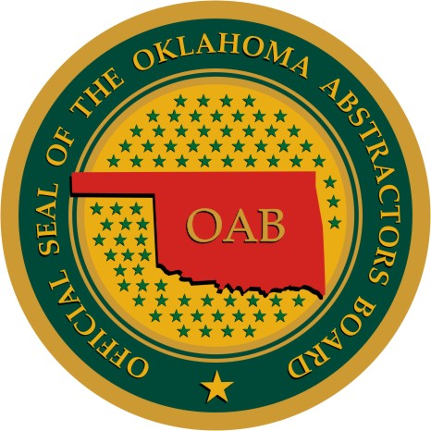

OKLAHOMA ABSTRACTORS BOARD

May 21, 2013

****BULLETIN NO. 2013-001****
Oklahoma Abstractors Board
2401 N.W. 23rd Street, Suite 60B
P.O. Box 700076
Oklahoma City, OK 73107
Phone: (405) 522-5019
Fax: (405) 522-5503

Executive Director
Glynda Reppond

Board Members:

District 1
Ralph Harrison

District 2
David Riley

District 3
Vacant

District 4
Glenda Mittasch
Chair

District 5
Charles Nichols

District 6
J. Herschel Beard
Vice Chair

Attorney
Gary Baer
Secretary

Bank Officer
Jerald Stringer

Real Estate Broker
Earl “Corky” Heard, III

Research Fee on Rate Sheets

To All Certificate of Authority Holders and Licensed Abstractors:

When the OAB was first formed there were no standardized rate sheets. The OAB gathered information for the standardized rate sheet forms by reviewing the rate sheets that had been approved by the auditor’s office. In 2010 the OAB approved a standardized “Time Base Rate Sheet” and a “Page Based Rate Sheet” for all certificate of authority holders to start using. The OAB has recently reviewed these rate sheet forms and are revising the rate sheets to remove fees that are not considered an abstract product and not regulated by the OAB.

Beginning June 1, 2013 there will be a change to the Rate Sheets, both “Time Based” and “Page Based”, on the OAB website. Listed below are the changes that will be made to the rate sheets.

Part II, G “Pre-Closing Gap Checks”. A certificate of authority may still charge this fee, but it does not have to be on the rate sheet approved by the OAB.

Part VI. “Add. Research”. The intention of the “Research Fee” being a separate item on the Rate Sheet was that this was a fee to be used when an abstracting product was not involved. The “Research Fee” shall not be charged in addition to the abstracting fee for work performed in the abstracting process. Charges for all abstracting products should always match the Rate Sheet on file with the OAB office. If, at the time of an inspection of a plant, an invoice for a charge is found under “Research Fee”, an explanation must be made to the OAB’s satisfaction as to why the customer was charged this fee.

Effective June 1, 2013, if a Rate Sheet is submitted to the OAB with the “Research Fee” and/or “Gap Check” on it, the Rate Sheet will be returned to the company so that the charge can be removed and then the Rate Sheet resubmitted. Please remember, the Rate Sheet MUST be reviewed by the Enforcement Committee before your application for renewal of certificate of authority can be approved. Title 1-25(14) and Title 1-30(C).

All Rate Sheets, as well as all other forms, submitted to the OAB office needs to be on the updated form on the OAB website. If a Rate Sheet is received by the OAB on an old form, instead of the most current, it will be returned. Updated forms can be found on the OAB website, www.abstract.ok.gov. The effective date at the bottom of the Rate Sheet form will be “June 1, 2013”.

If you have any questions, please do not hesitate to contact the OAB office or your district representative.

