# ABLE Employee Application Step By Step Process

[Click or tap to open the Accela Citizen Access site.](https://aca-prod.accela.com/ABLE/Account/RegisterDisclaimer.aspx)

After the web page opens, scroll down to the Account Registration section.

## Account Registration Step 1

You will be asked to provide the following information to open an account:  
 • Choose a user name and password.  
 • Personal and Contact Information.  
 • License Numbers if you are registering as a licensed professional (optional).

## Please review and accept the terms below to proceed.

**General Disclaimer**

While the Agency attempts to keep its Web information accurate and timely, the Agency neither warrants nor makes representations as to the functionality or condition of this Web site, its suitability for use, freedom from interruptions or from computer virus, or non-infringement of proprietary rights. Web materials have been compiled from a variety of sources and are subject to change without notice from the Agency as a result of updates and corrections.

All trademarks and service marks contained in or displayed on this Web site are the property of their respective owners. Any commercial use of the materials stored on this Web site is strictly prohibited without the prior written permission of the Agency.

The Agency is neither responsible nor liable for any viruses or other contamination of your system nor for any delays, inaccuracies, errors or omissions arising out of your use of the site or with respect to the material contained on the site, including without limitation, any material posted on the site. This Web site and all materials contained in it are distributed and transmitted "as is" without warranties of any kind, either express or implied, including without limitation, warranties of title or implied warranties of merchantability or fitness for a particular purpose. The Agency is not responsible for any special, indirect, incidental or consequential damages that may arise from the use of, or the inability to use, this Web site and/or the materials contained on this Web site whether the materials are provided by the Agency or a third party.

In addition to the preceding terms and conditions the Agency, its officers, employees, agents or representatives shall not be liable for any damages of any kind arising from your use of the online payment service. Nothing contained in this Web site constitutes or is intended to constitute legal advice by the Agency or any of its agencies, officers, employees, agents, or representatives.

**External Links**

This Web site may contain links to other sites on the Internet, which are provided for the convenience of the user. The Agency is not responsible for and makes no representation about the content or material available on such other sites. Links are not intended to imply sponsorship, affiliation, or endorsement by the Agency.

**Privacy Policy**

While the Agency does not sell any information collected and provided through this Web site, such information may be subject to disclosure as required by any federal, state or local laws, rules, or regulations, including, but not limited to, the Agency's Public Records Act (Government Code Section 6250 et seq.).

**Communications via Web Site**

Communications made through e-mail and messaging systems shall in no way be deemed to constitute legal notice to the Agency or any of its agencies, officers, employees, agents, or representatives, with respect to any existing or potential claim or cause of action against the Agency or any of its agencies, officers, employees, agents, or representatives, where notice to the Agency is required by any federal, state or local laws, rules, or regulations.

To continue you need to place a checkmark in the “I agree to the” checkbox, then click the Continue Registration button.

## Account Registration Step 2: Enter/Confirm Your Account Information

**Login Information section**

Enter your information in the required seven textbox fields:

* User Name
* E-mail Address
* Password
* Type Password Again:
* Enter Security Question
* Answer (for security question)
* Mobile Phone

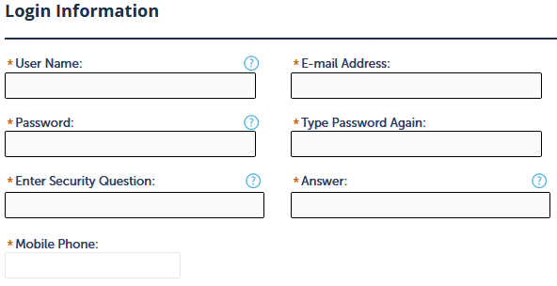

**Contact Information section**

Click the Add New button.

In the modal that opened, click to open the Type drop-down menu and select the Individual option.

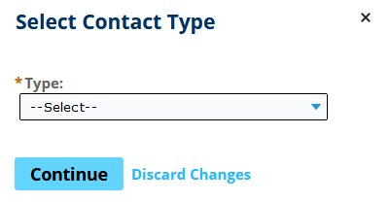

Click the Continue button.

Another modal will open, Contact Information. Complete only the required (marked with an asterisk) textbox fields in the top section.

* First (required)
* Last (required)
* E-mail (required)

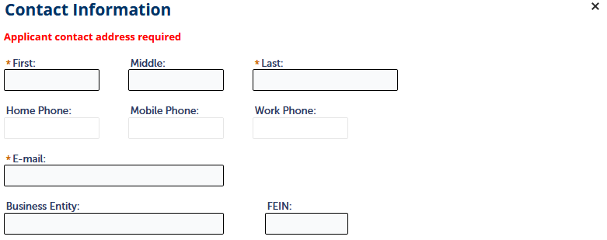

Skip the Contact Addresses section and click the Continue button.

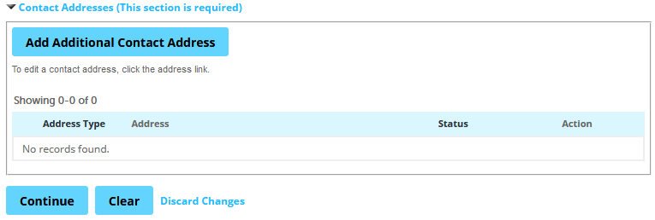

## Account Registration Step 2: Enter / Confirm Your Account Information

The screen will display the seven textbox fields. Make sure to double check your information before moving on.

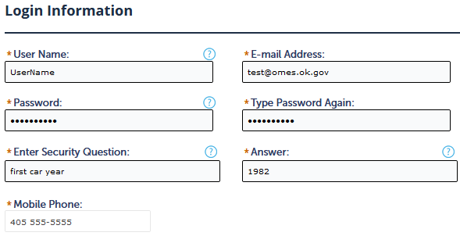

The Contact Information section should show a green checkmark with green text “Contact added successfully” with the earlier required information that was added.

* First name
* Last name
* E-mail

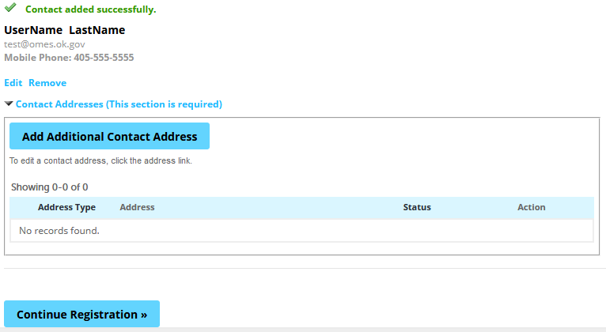

The Contact Addresses section will be empty since it was skipped.

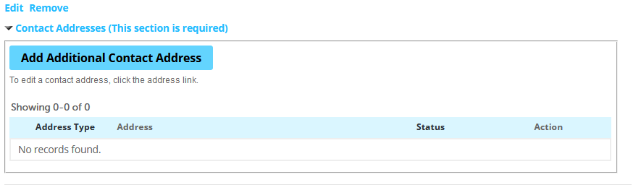

Click the Continue Registrationbutton.

blue continue registration button

The next screen will show you if your account is successfully registered or if there are errors.

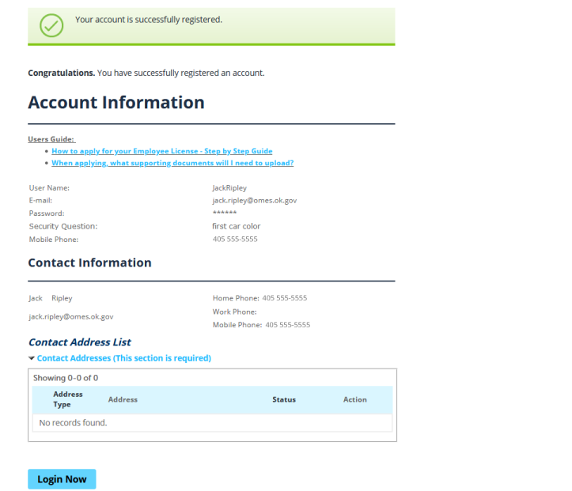

Click the Login Now button.

You’ll be taken back to the initial screen and in the bottom right is the Login box. Enter the email address and password you provided during your account set up.

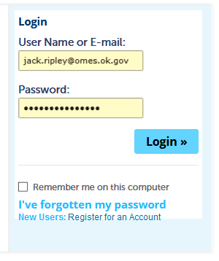

Once logged in, make sure the ABLE is selected (black box around it with white text)

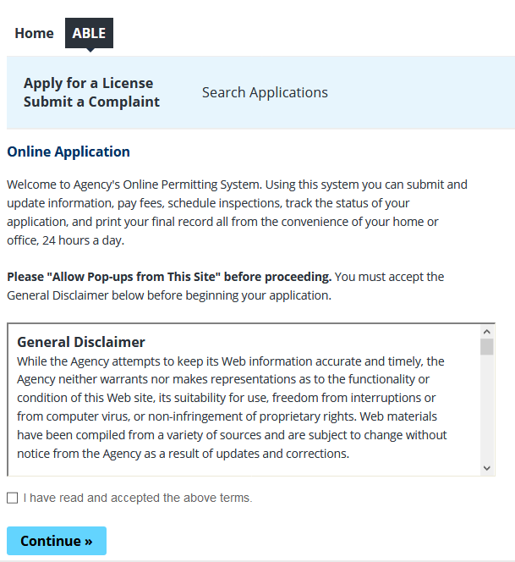

**Online Application section**

You’ll need to click the “I have read and accepted the above terms.” checkbox stating you’ve read and accepted the terms before clicking the Continue button.

**Select a Record Type section**

* Click Individual Licenses to open its six options.
* Select the radio button (bubble) for Alcohol Beverage Employee Application.

Click the Continue button.

## Alcohol Beverage Employee Application

Step 1 of 6 > Applicant  
If you work for a restaurant or bar as a waiter, waitress, server, bartender, or manager, this is the license to apply for.

If you work for a grocery store, convenience store, or liquor store as a cashier, stocker of alcohol, or manager, this is the license to apply for.  
  
You are required to complete one of the ABLE approved employee alcohol training courses within 14 calendar days of applying for this license. The approved training courses are located on the ABLE website under the link Employee Training Information. Once you have completed the training, upload your training certificate to your ACA online account as an attachment. *Failure to complete the employee alcohol training course can result in a citation from ABLE.

**Individual Section  
Click the Contact Information button.**

In the modal that opened, fields with an asterisk (*) are required.

**Contact Information section fields / textboxes**

*First: Middle: *Last:

Work Phone: *Mobile Phone: (this number is populated from the account.)

*Email:

*SSN: *Birth Date:

Gender: select the female or male radio (bubble) button.

Driver’s License state: choose the two letters for your state.

Driver’s License Number: add your driver’s license number.

Skip the business entity if it doesn’t apply to you.

Click the Continue button.

The screen should now show you a green checkmark with “Contact added successfully.”

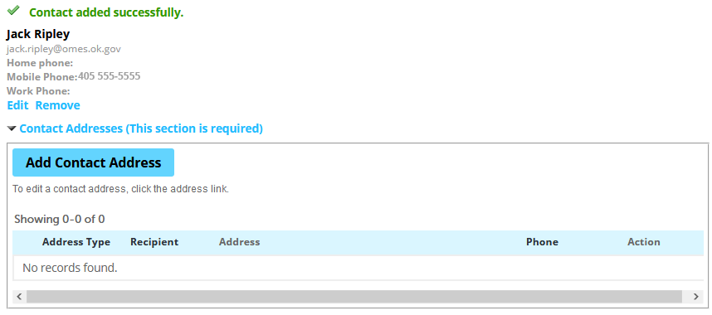

Below the Employer section (and at the bottom of the page) is the Continue button, click it.

### Step 2 of 6 > General Information

Fields with an asterisk (*) are required. There are six questions in step two.

**BACKGROUND INFORMATION section**  
ANSWER EACH OF THE FOLLOWING QUESTIONS. EACH YES ANSWER REQUIRES AN EXPLANATION.

*Have you been convicted of a felony classified as a violent crime?: Yes No

*Have you ever been convicted of or pled guilty or nolo contendere to a misdemeanor related to gambling or gaming?: Yes No

**EMPLOYEE INFORMATION section**  
ANSWER EACH OF THE FOLLOWING QUESTIONS. EACH YES ANSWER REQUIRES AN EXPLANATION.  
Are you Employed as:

*a) A judge, district attorney, or public official who sits in a judicial capacity with jurisdiction over the Oklahoma Alcoholic Beverage Control Act?: Yes No

*b) A peace officer engaging in law enforcement activities?: Yes No

*c) a Tax Commission employee engaging in auditing, enforcing, or collecting of alcoholic beverages taxes?:  
Yes No

**CITIZENSHIP INFORMATION section**

*Are you a United States Citizen?: Yes No

Click the Continue button.

### Step 3 of 6 > Supporting Documentation

**Attachment Section**

The maximum file size allowed is 100 MB.

When finished in this section, **you must click on the SAVE button** at the bottom to display the uploaded documents.

File types blocked from upload: ade;adp;bat;chm;cmd;com;cpl;exe;hta;htm;html;ins;isp;jar;js;jse;lib;lnk;mde;mht;mhtml;msc;msp;mst;php;pif;scr;sct;shb;sys;vb;vbe;vbs;vxd;wsc;wsf;wsh

Click the Add button to begin. In the modal that opened, click the Add button to select your supporting documentation file(s).

If you are not a U.S. citizen, you are required to upload a permanent resident card.

When finished, click the Continue button.

Your selected files will show near the bottom of the page.

In the Type drop down menu, select the type of file that’s closest to what you’ve attached. This is required.

**Click the save button.**

Your attached file(s) show be visible on the bottom of the page and a message at the top “The attachment(s) has/have been successfully uploaded. It ma take a few minutes before changes are reflected.”

Click the continue button.

### Step 4 of 6 > Review

Review all the information you’ve provided and make edits where needed by clicking that section’s Edit button.

When finished, click the continue button.

### Step 5 of 6 > Pay Fees

Listed below are preliminary fees based upon the information you've entered. Some fees are based on the quantity of work items installed or repaired. Enter quantities where applicable. The following screen will display your total fees.

**Application Fees section**Alcohol Beverage Employee Application Fee, quantity of 1, amount $30.00  
Convenience Fee, quantity of 1, amount $3.50

**TOTAL FEES: $33.50**Note: This does not include additional inspection fees which may be assessed later.

screenshot of step 5 of 6: pay fees

Click the Check Out button.

Your Cart will open and show step 1 of 3.

Step 1: Select item to pay

Your charge of $33.50 should be there.

Click the Checkout button.

Step 2: Payment Information

Enter your credit card and billing address information.

Click the Submit Payment button

The information of your payment will be listed.

Click the Click to Complete button.

### Step 3: Receipt / Record Issuance

Click “Print/View Receipt” to print a copy of your payment receipt and give to your employer.

When you receive the email with your license, print it or forward the email to your employer.