INSTRUCTIONS FOR OUTDOOR ADVERTISING ONLINE PAYMENT FORM

Step 1: Personal Information

Select submission type, if established then enter Owner ID, if new proceed to personal information. Fill out personal information fields.

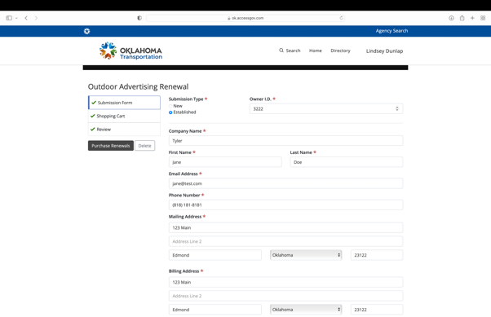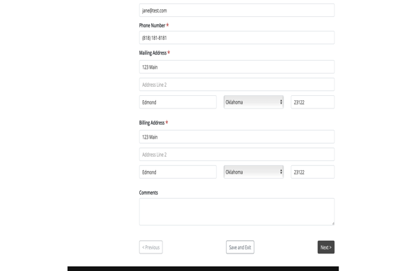

Step 2: Shopping Cart

After filling out the personal information fields, the next page will bring you to the Shopping Cart. Please choose which Renewal Types and the quantity. You may purchase more than one Renewal Type by selecting the “Add Another Renewal Type.”

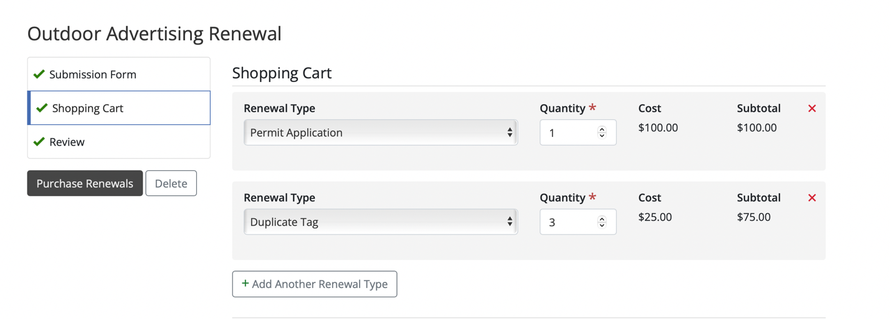

Step 3: Upload Files

Below the Shopping Cart section, you will find Upload Files, which will allow you to upload the necessary documents for submitting this application. You may add more than one file by selecting the “Upload Another File” button.

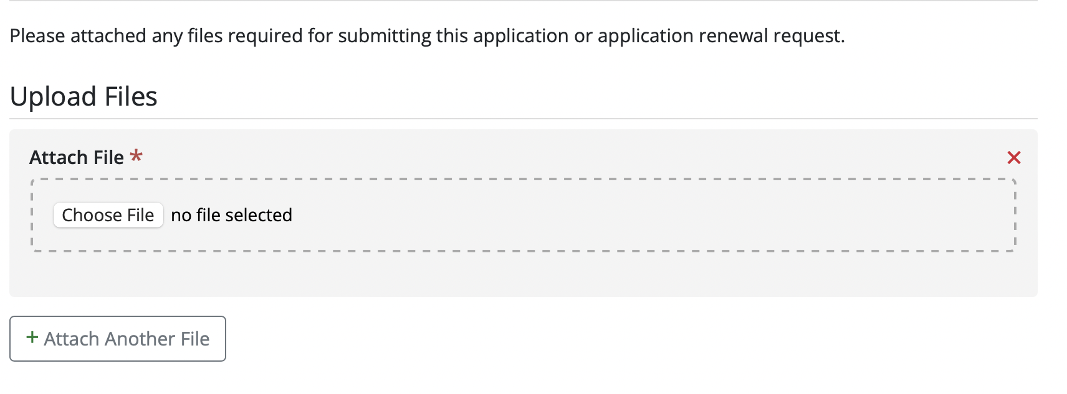

Step 4: Past Due Balance

Below Upload Files, there is a box to check if Outdoor Advertising has notified you of a Past Due Balance owed, click the box, and enter in the amount owed. The Subtotal will show at the bottom of the page.

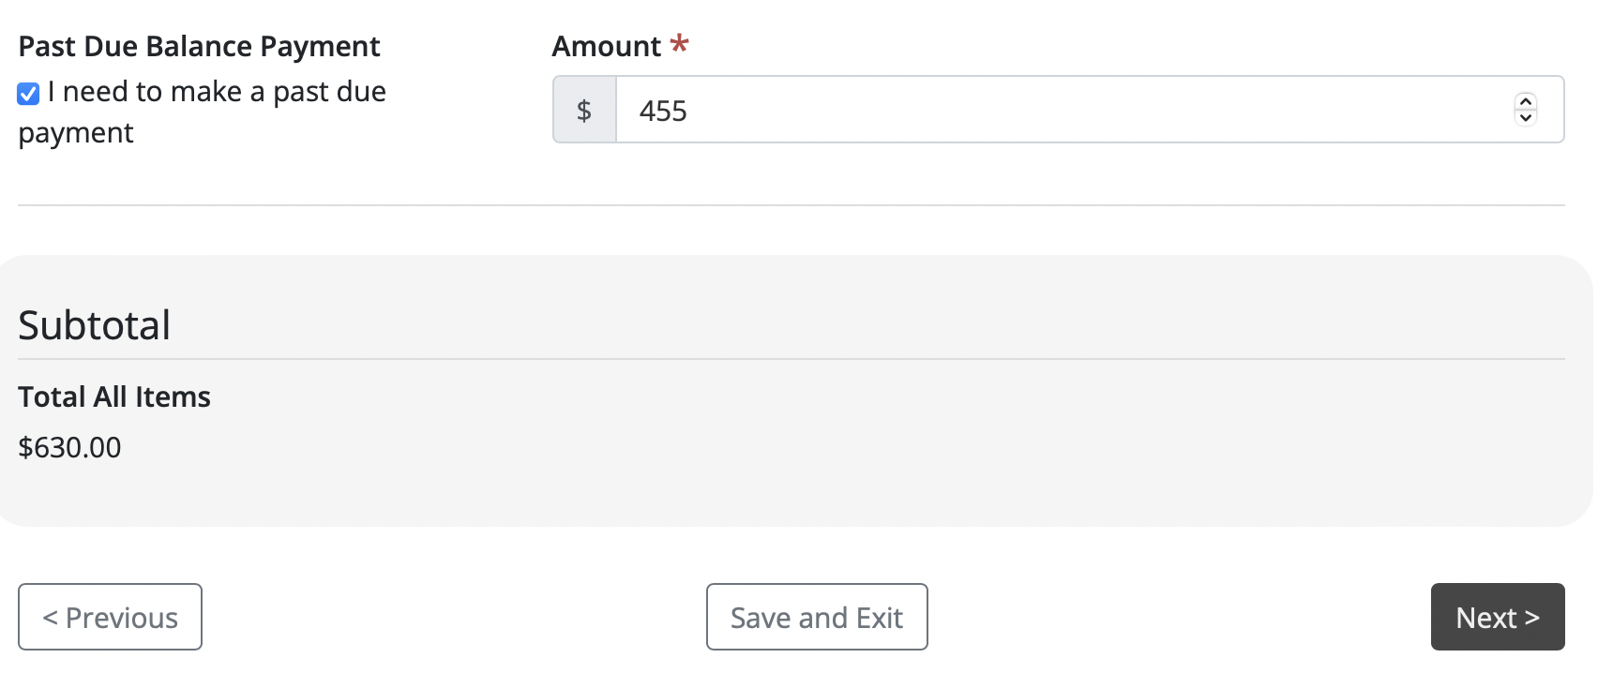

Step 4: Review Page

Please review all the information you have entered and items in Shopping Cart. If everything looks correct, click Purchase Renewals and follow the instructions to complete payment.
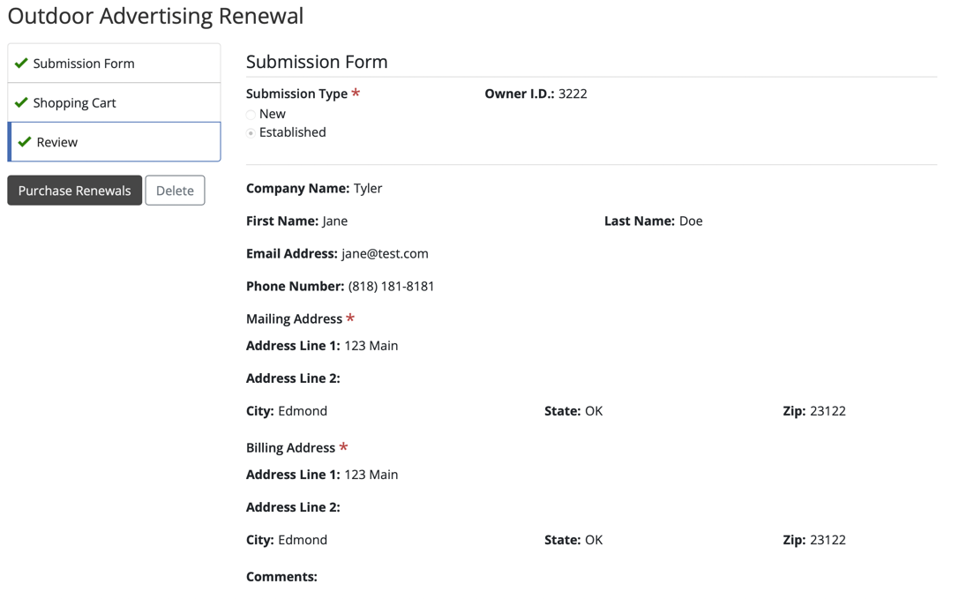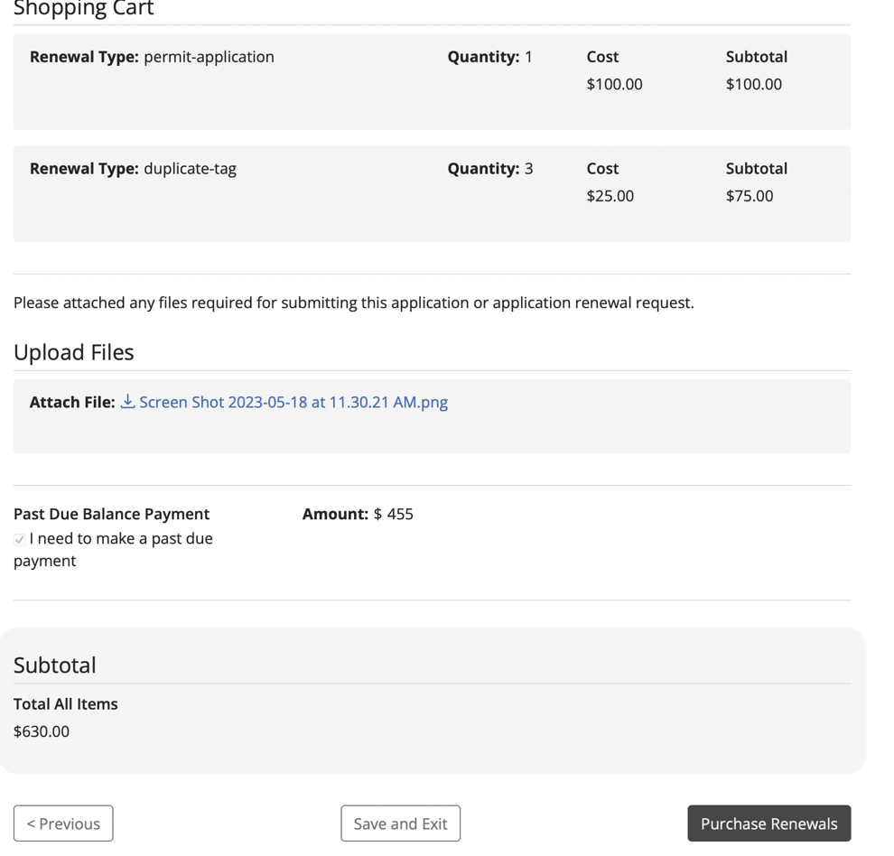

Step 5: Payment

Once clicking Purchase Renewals, the user will be brought to the payment page, in which the user will follow the prompting instructions, choosing payment type and filling out the customer and payment information accordingly.
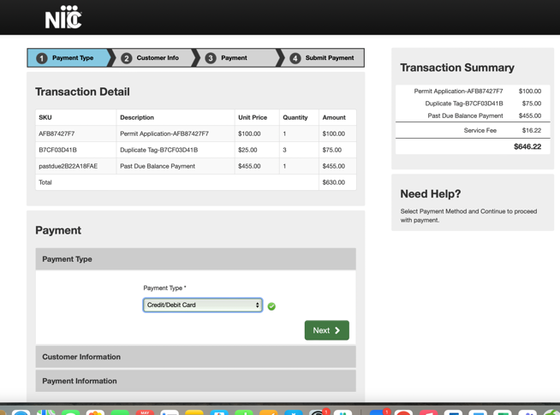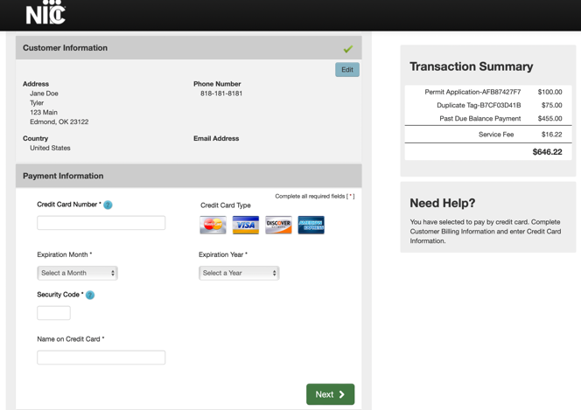

Step 6: Submit Payment

Review information then click Submit Payment. User will be directed to Payment Receipt Confirmation page where it is optional to print the receipt.

